Alistana Nutrition & Fitness Tracker (AFNT)

Ufcfxk-30-3 – Digital systems project

Ali suhail | 21072712

2024

# Notice

The project files and code can be viewed at:

<https://github.com/alisuhail-amanu2/AFNT>

The Kanban board for the project can be viewed at:

<https://trello.com/invite/b/4r2w1F7l/ATTI108ef6ba22ae857e17384de5c89ba99117B65004/project-management>

# Acknowledgements

I extend my sincere appreciation to Martin Serpell for his invaluable guidance and support during the project's initial planning phase at UWE Bristol, before his retirement.

Furthermore, I would like to express my gratitude to Dr. Eman Qaddoumi for her continuous guidance and unwavering support throughout the module, which significantly contributed to the project's success.

Contents

Notice 0

Acknowledgements 1

Table of Figures 4

Table Content 7

Abstract 9

1. Introduction 9

2. Literature Review 11

2.1. Technological Advancements and Human Lifestyle 11

2.2. Benefits of an Active Lifestyle 12

2.3. Evolution and Rise of Health and Fitness Tracking 13

2.4. Fitness and Health Tracker Varieties 14

2.4.1. Common Categories of Fitness and Health Trackers 15

2.4.2. Evolving Trends in Fitness and Health Tracking 16

2.5. Effectiveness of Fitness Trackers 16

2.6. Understanding the Risks Associated with Fitness Trackers 17

2.7. Ethical Considerations 18

2.8. Development Research Plan 18

2.8.1. Success Criteria 20

2.8.2. Technical Knowledge 20

2.8.3. AFNT Evaluation Criteria 22

2.8.4. Requirements Gathering 24

3. Requirements 28

3.1. Requirement Structure 28

3.1.1. Requirement/Objective: 28

3.1.2. Phase Component: 29

3.1.3. Number: 29

3.2. Requirement Categorization 29

3.3. Usecase Diagrams and Descriptions 30

3.3.1. Usecase Diagrams and Descriptions 31

4. Methodology 37

4.1. AFNT Phases 37

4.2. Sprint Planning 39

4.3. Gantt Chart 40

4.4. Trello Kanban Integration 41

4.5. Trello Kanban Advantages 43

5. Design 44

5.1. Phase 1: Database Design 44

5.1.1. Local Database 46

5.1.2. Servers 47

5.2. Phase 2: Admin Management Website Design 48

5.2.1. Admin Management Website Wireframes 49

5.3. Phase 3: AFNT Application Design 49

5.3.1. Application Wireframes 50

5.3.2. Kivy GUI Class Structure 51

5.3.3. Class Structure 53

5.4. Phase 4: Arduino Watch Design 54

5.4.1. TinyDuino and TinyShield 54

5.4.2. TinyScreen+ OLED Screen 55

5.4.3. Lithium Ion Polymer Battery 57

5.4.4. MicroSD TinyShield 58

5.4.5. Wireling Adapter TinyShield 60

5.4.6. Accelerometer TinyShield and Sensor Wireling 62

5.4.7. Pulse Oximeter Sensor Wireling 64

5.4.8. Bluetooth Low Energy TinyShield (ST) 66

5.4.9. Arduino Watch Modular Component Stack 69

6. Implementation 70

6.1. Phase 1: DBMS Implementation 70

6.1.1. Central Database 70

6.1.2. Local Database 71

6.2. Phase 2: Admin Management Website Implementation 74

6.3. Phase 3: AFNT Application Implementation 75

6.3.1. Kvlang Language 76

6.3.2. Kivy Material Design 76

6.3.3. Kiny Screen Manager 77

6.3.4. Major Components 78

6.3.5. Login and Registration Screens 79

6.3.6. Workout Screens 80

6.3.7. Meal and Water Intake Screens 82

6.3.8. Gym Finder Screen 84

6.3.9. Body Statistics Screens 84

6.3.10. Arduino Watch Screens 88

6.4. Phase 4: Arduino Watch Implementation 90

6.4.1. Stack Implementation and TinyShield Compatibility 90

6.4.2. Pulse Oximeter Sensor Configuration 92

6.4.3. Accelerometer Sensor Configuration and Step Calculation 93

6.4.4. Logging Data to microSD Card 95

6.4.5. Watch Main Display 96

6.4.6. Bluetooth Low Energy Functionality 97

7. Project Evaluation 99

7.1. Requirements and Objectives 99

7.2. Agile and Kanban 101

7.3. Successes and Challenges in Each Phase 101

7.3.1. Phase 1 101

7.3.2. Phase 2 101

7.3.3. Phase 3 101

7.3.4. Phase 4 101

7.4. Testing 102

8. Further Work and Conclusions 103

9. References / Bibliography 104

Appendix A: Requirements 112

1. Project Aim 112

2. Project Objectives 112

3. Functional Requirements 112

3.1. Database 112

3.2. Website 113

3.3. Application 114

3.4. Arduino Watch 117

4. Non-Functional Requirements 118

4.1. Application: 118

4.2. Performance: 119

4.3. Efficiency & Sustainability: 119

4.4. Data Storage Optimization: 120

4.5. Privacy & Security: 120

4.6. Reliability: 120

4.7. Usability: 121

4.8. Data Backup & Recovery: 122

4.9. Third-Party Service Integration: 122

Appendix B: Creating Central Database 123

# Table of Figures

Figure 1: Life Expectancy 10,000 BC - Today (Cato Institute) 11

Figure 2: Fitness app annual users 2015-2021 12

Figure 3: Fitness in-app purchase revenue by app 2021 ($mm) 14

Figure 4: Fitness App Types. 15

Figure 5: Variables measured over a 36-week study for a Type 2 Diabetic patient using Fitbit (Thomas William Miller, 2017). 16

Figure 6: Samsung Information Sharing Policy. 18

Figure 7: AFNT Initial Questions. 19

Figure 8: What I Need to Find Out. 20

Figure 9: Arduino Watch Components. 21

Figure 10: Assembly of All Arduino Watch Modules 22

Figure 11: First Version of Arduino Watch Interface (24/01/2024). 22

Figure 12: AFNT and Arduino Watch Evaluation Table. 23

Figure 13: Samsung Galaxy Watch (2018). 24

Figure 14: Fitbit Flex 2 (2016). 24

Figure 15: My Personal Workout Tracking Method Using Excel Spreadsheet. 26

Figure 16: My Personal Workout Data Using Excel – 2023 27

Figure 17: My Workout Progress Evaluation – 2023 27

Figure 18: AFNT Project Objectives. 28

Figure 19: Requirement Table Overview. 30

Figure 20: Usecase Admin Management Website. 31

Figure 21: Arduino Watch Usecase Diagram. 32

Figure 22: AFNT App Usecase Diagram. 33

Figure 23: AFNT Project Phases. 38

Figure 24: Gantt Chart. 41

Figure 25: AFNT Project Kanban Board. 42

Figure 26: Project Labels on Trello. 42

Figure 27: Central Database Schema. 45

Figure 28: Local Database Schema. 46

Figure 29: Central Database and Admin Website Class Diagram. 47

Figure 30: Admin Management Website Usecase Diagram. 48

Figure 31: Admin Management Website Wireframes. 49

Figure 32: AFNT GUI Class Diagrams. 51

Figure 33: AFNT Class Diagram. 53

Figure 34: TinyScreen+ OLED (ASD2431-R). 55

Figure 35: TinyScreen+ Dimensions. 56

Figure 36: TinyScreen+ Schematic. 56

Figure 37: TinyScreen+ Specs. 57

Figure 38: Lithium ION Battery (ASR00007) Dimensions. 57

Figure 39: Lithium ION Battery Specs. 58

Figure 40: MicroSD TinyShield (ASD2201-R). 58

Figure 41: MicroSD TinyShield Dimensions. 59

Figure 42: MicroSD TinyShield Schematic. 59

Figure 43: microSD TinyShield Specs. 60

Figure 44: Wireling Adapter TinyShield (ASD2022). 60

Figure 45: Wireling Adapter Dimensions. 61

Figure 46: Wireling Adapter Schematic. 61

Figure 47: Wireling Adapter TinyShield Specs. 62

Figure 48: Accelerometer TinyShield (ASD2511-R-A). 62

Figure 49: Accelerometer TinyShield Dimensions. 63

Figure 50: Accelerometer Wireling (AST1001). 63

Figure 51: Accelerometer TinyShield Schematic. 63

Figure 52: Accelerometer TinyShield Specs. 64

Figure 53: Pulse Oximeter Sensor Wireling (AST1041). 64

Figure 54: Pulse Oximeter Sensor Wireling Dimensions. 65

Figure 55: Pulse Oximeter Sensor Wireling Schematic. 65

Figure 56: Pulse Oximeter Sensor Wireling Specs. 66

Figure 57: Bluetooth Low Energy TinyShield (ASD2116). 66

Figure 58: Bluetooth Low Energy TinyShield Dimensions. 67

Figure 59: Bluetooth Low Energy TinyShield Schematic. 67

Figure 60: Bluetooth Low Energy TinyShield Specs. 68

Figure 61: Arduino Watch Modular Component Stack diagram. 69

Figure 62: Initialization and connection to the LDB. 71

Figure 63: Create exercise tables (LDB). 72

Figure 64: Create workout tables (LDB). 72

Figure 65: Create food item tables (LDB). 73

Figure 66: Create meal tables (LDB). 73

Figure 67: Create body statistic tables (LDB). 74

Figure 68: AM Website Login Screen. 75

Figure 69: AM Website Login Success Screen (Dashboard). 75

Figure 70: Kvlang example. 76

Figure 71: Example of MUI components. 77

Figure 72: Utilizing MUI components in AFNT. 77

Figure 73: AFNT Screen classes. 78

Figure 74: Dashboard Screen class. 78

Figure 75: Basic Popup class example. 78

Figure 76: AFNT Login Screen. 79

Figure 77: AFNT Registration Screen. 79

Figure 78: Workout Screens class diagram. 80

Figure 79: Workout History Screen. 80

Figure 80: Creating a Datatable using KivyMD. 81

Figure 81: Allocate Workout and Create Exercise and Workout Screens. 81

Figure 82: Allocate Exercise Screen. 82

Figure 83: Exercise Logs Screen. 82

Figure 84: Meal History Screen. 83

Figure 85: Plotting Water Intake Monthly Graph. 83

Figure 86: Water Intake & Plots Screens. 84

Figure 87: Implementing MapAPI for Gym Finder Screen. 84

Figure 88: Gym Finder Screen. 84

Figure 89: Body Statistics Screen. 85

Figure 90: Monthly and Yearly Average Weight Graphs. 85

Figure 91: Monthly and Yearly Average BMI Graphs. 86

Figure 92: Monthly and Yearly Average Body Fat Graphs. 86

Figure 93: Monthly and Yearly Average Skeletal Muscle Graphs. 87

Figure 94: Monthly and Yearly Steps Graphs. 87

Figure 95: Arduino Watch Screen. 88

Figure 96: Heart Rate Plot. 88

Figure 97: Blood Oxygen Level Plot. 89

Figure 98: Step Count Plot. 89

Figure 99: Body Temperature Plot. 89

Figure 100: Arduino Watch component implementation. 91

Figure 101: Implementing Arduino Watch stack. 91

Figure 102: Senor port allocations in the Wireling Adapter TinyShield. 92

Figure 103: checkPulse function. 93

Figure 104: 3D Cartesian Coordinate System (Jorge S., 2018). 93

Figure 105: Magnitude of a Vector formula (GeeksforGeeks, 2022). 94

Figure 106: Step calculation. 94

Figure 107: Log data every 5 seconds in the Arduino Watch. 95

Figure 108: logData function. 95

Figure 109: Arduino Watch display. 96

Figure 110: Arduino Watch display data code. 97

Figure 111: Arduino Watch connecting to a smartphone. 97

Figure 112: Andriod smartphone connecting to the Arduino Watch. 98

Figure 113: nRF Connect application. 98

Figure 114: Sending a message from the Arduino Watch to the smartphone. 98

Figure 115: Receiving a message from the smartphone to the Arduino Watch. 99

Figure 116: AFNT Objectives. 100

Figure 117: Test Case ID Abbreviations (Application). 102

Figure 118: Screenshot of Application Test Cases. 102

Figure 119: Screenshot of Arduino Watch Test Cases. 103

Figure 120: Create exercises table (CDB). 123

Figure 121: Create meals table (CDB). 123

Figure 122: Create users table (CDB). 124

Figure 123: Create workouts table (CDB). 124

Figure 124: Create food items table (CDB). 124

Figure 125: Create workout logs table (CDB). 125

Figure 126: Create meal logs table (CDB). 125

Figure 127: Create food item logs table (CDB). 125

Figure 128: Create exercise logs table (CDB). 126

Figure 129: Create advices table (CDB). 126

# Table Content

Table 1: Requirement/Objective Abbreviations. 29

Table 2: Phase Component Abbreviations. 29

Table 3: MoSCow Prioritization table. 30

Table 4: Admin Management Website Usecase description. 31

Table 5: Store Measured Data and the <<extend>> Usecase description. 32

Table 6: Sync Watch Data to Application Usecase description. 32

Table 7: Manage Workout and the <<extend>> Usecase description. 34

Table 8: Manage Meal and the <<extend>> Usecase description. 34

Table 9: Manage Water Intake and the <<extend>> Usecase description. 34

Table 10: Gym Finder Usecase description. 35

Table 11: Create Account Usecase description. 35

Table 12: Update Profile Usecase description. 35

Table 13: Delete Profile Usecase description. 36

Table 14: Track Workout Progress and the <<extend>> 36

Table 15: Generate Progress Graph and the <<extend>> Usecase description. 36

Table 16: AFNT Phase Descriptions. 38

Table 17: Sprint 1 – Planning & Design. 39

Table 18: Sprint 2 – Phase 1 Implementation & PIP 39

Table 19: Sprint 3 – Phase 3 Implementation. 40

Table 20: Sprint 4 – Phase 4 Implementation. 40

Table 21: Trello Kanban Column Descriptions. 43

Table 22: Trello Kanban Advantages. 43

Table 23: Central and Local Database Schema Descriptions. 45

Table 24: Local Database Schema Descriptions. 47

Table 25: Database Server Descriptions. 48

Table 26: Admin Management Website Usecase Description. 48

Table 27: AFNT App Wireframes. 50

Table 28: AFNT Main Kivy GUI Class Definitions. 51

Table 29: AFNT Workouts and Exercises Kivy GUI class definitions. 52

Table 30: AFNT Meals and Food Items Kivy GUI class definitions. 52

Table 31: AFNT Class descriptions. 54

Table 32: Arduino Watch Modular Electronic Components. 55

Table 33: Phase 3 components. 79

Table 34: TinyShield Compatibility. (‘TinyDuino Overview’, 2024) 92

Table 35: Logging watch data in `arduino.csv`. 96

Table 36: Functional Requirement Progress. 100

Table 37: Non-Functional Requirement Progress. 100

# Abstract

**Incomplete**

This research aims to address the global health challenge of high obesity rates by developing a secure fitness and nutritional tracker to assist individuals in achieving their health goals. The prevalence of obesity, particularly in developed countries, has led to widespread health and economic implications. This study seeks to raise awareness about the significance of good health, emphasizing the positive mental effects associated with fitness.

The primary objective is to create an accessible software solution that encourages health-conscious behaviour and to increase awareness about the benefits of exercising regularly which can help minimize the healthcare burden and lower the risks of diseases and illness. The relevance of this research is underscored by the urgent need to combat the obesity pandemic and understand its far-reaching consequences on both society and the economy.

The anticipated outcomes include fostering a global culture of health consciousness, where individuals comprehend the profound benefits of good health. The research also endeavours to produce an easy-to-use program, empowering users to navigate their fitness journey effectively. By promoting higher fitness levels, the research aspires to contribute to a healthier population, subsequently mitigating the risks of diseases and alleviating the strain on healthcare systems. This project serves as a comprehensive test of software development and planning skills, aimed at making a substantial impact on public health and well-being.

# Introduction

**Incomplete**

Currently, one of the biggest challenges the world is facing is a global obesity pandemic, which has become an especially acute problem in the developed world. According to The Guardian, around 38% of the global population, approximately 2.4 billion people, are currently categorized as overweight or obese. Without the widespread adoption of measures such as taxing and limiting the promotion of unhealthy foods, this trend is expected to persist. By 2035, it is predicted that the percentage of clinically obese individuals will rise from one in seven to one in four, with more than half of the total population being obese or overweight (Campbell, 2023). Having said that, the rapid increase of obesity rates will lead to higher chances of diseases and illnesses, which will have a greater burden on the healthcare sector and the overall productivity of the economy (‘Obesity Consequences’, 2012).

The key contributors of obesity and overweightness can be summarized to the consumption of high-calorie, fatty foods that are easily accessible, combined with a lack of physical activity (Wright and Aronne, 2012). This research will focus on ways to tackle this complex problem.

The main goal of this research is to develop the Alistana Fitness & Nutrition Tracker (AFNT) program, a free and inclusive application promoting health-conscious behaviour. AFNT aims to raise awareness about the benefits of regular exercise and a balanced diet, reducing healthcare burdens and lowering disease risks, including obesity. The application empowers users to track workouts, nutrition, and body progress securely, ensuring compatibility with mobile and desktop devices.

Maintaining good health and fitness is crucial as it benefits not just physical well-being but mental health as well. Engaging in regular exercise and fitness activities can elevate self-confidence, enhance attractiveness, and foster a health-conscious lifestyle, encompassing balanced nutrition and proper sleep. This holistic approach to well-being not only boosts productivity but also alleviates the financial burden on individuals and the healthcare system at large. By embodying a healthy lifestyle, individuals can inspire others to pursue their fitness goals, thereby fostering a community that values and prioritizes health and well-being.

The outcome:

The report consists of 8 chapters. Chapter 2 provides a critical review of the AFNT Project. Chapter 3 delves into detailed requirements and objectives for the Database Management System (DBMS), AFNT Application, AM Website, and Arduino Watch. Chapter 4 focuses on the Agile methodology used in AFNT development, while Chapter 5 explores AFNT's design architecture. Chapter 6 covers the project's implementation, with Chapter 7 dedicated to its evaluation. Finally, Chapter 8 concludes the report and outlines further work.

# Literature Review

## Technological Advancements and Human Lifestyle

Throughout human history, technological advancements have played a pivotal role in making daily activities more efficient and less labour-intensive. From the invention of tools by Homo habilis to the industrial revolution, innovations like the wheel, carts, and various modes of transportation have transformed the way people live and work (Woessner *et al.*, 2021). The Industrial Revolution further enhanced productivity and ushered in an era of electronic and telecommunications revolution, introducing household appliances that reduced manual labour. Simultaneously, advancements in medicine, spanning over two millennia, have significantly contributed to improved healthcare and increased life expectancy. The twentieth century witnessed breakthroughs such as vaccines, early disease diagnosis, and treatment innovations, resulting in a substantial rise in life expectancy to around 80 years.

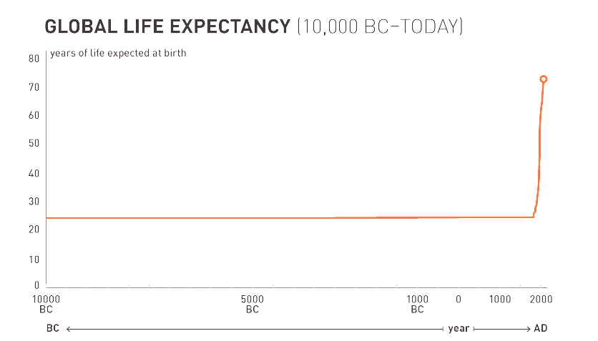

Figure 1: Life Expectancy 10,000 BC - Today (Cato Institute)

However, alongside these benefits, technological proliferation has resulted in a significant decline in incidental physical activity. Everyday activities like active transport and manual labour have been replaced or reduced by technological solutions. The advent of the internet, especially accessible through mobile devices, has further contributed to increased sedentary behaviour, with established associations between internet usage during leisure time and obesity. The overall reduction in physical activity, coupled with a surge in sedentary behaviours, has become a significant factor in the obesity epidemic. Despite technology's positive impact on healthcare and life expectancy, addressing the challenges posed by reduced physical activity remains crucial for promoting overall well-being (Woessner et al., 2021).

Another significant contributor to the rapid increase in obesity rates is the heightened caloric intake, particularly from sweetened beverages, as emphasized by Caballero (2007). These dietary changes, marked by increased consumption of energy-dense foods and a shift away from healthier options, play a substantial role in the current health crisis. The availability of low-cost, easily accessible, and energy-dense food items, combined with changes in dietary patterns, emerges as a prominent factor in the rising rates of obesity. Addressing dietary choices and promoting healthier eating habits are critical components of strategies aimed at combating the obesity epidemic (Caballero, 2007).

Fortunately, technology's ascent has spawned innovative tools for achieving a healthier lifestyle, including mobile phones, smartwatches, and a variety of health and fitness technologies. This market encompasses meditation and workout apps, wearables, connected home gym equipment, Wi-Fi-enabled bathroom scales, and more, offering solutions for weight loss, stress reduction, improved sleep, enhanced immunity, elevated mood, and better nutrition (Moscaritolo, 2024). Additionally, the COVID-19 pandemic accelerated the adoption of health and fitness apps, by gyms closing due to the pandemic, this forced individuals to maintain their well-being from the comfort of their homes. The iOS app market, as analysed by Pankush Kalgotra, Raja, and Sharda (2022), exceeded growth expectations by 29.9%, highlighting the increasing demand for health and fitness-related apps during and after the pandemic.

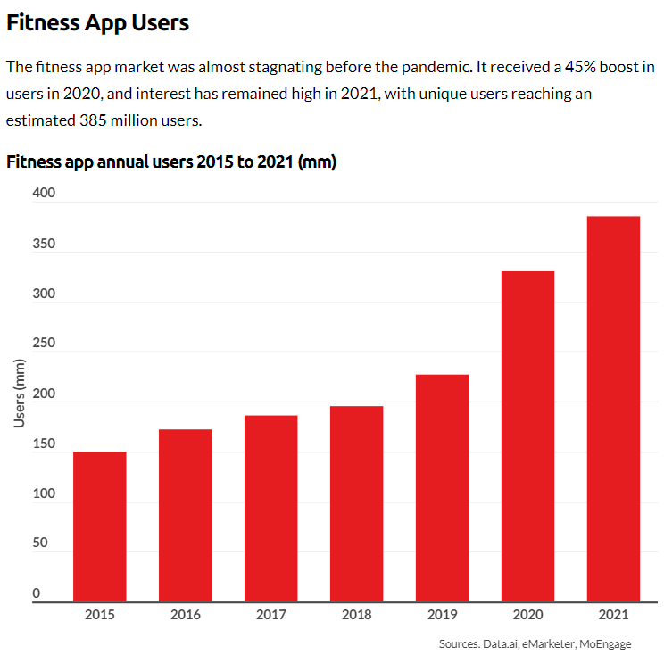

Figure 2: Fitness app annual users 2015-2021

## Benefits of an Active Lifestyle

Engaging in regular exercise not only contributes to improved mental well-being, reducing feelings of anxiety and depression, as highlighted by the Mental Health Foundation (2015), but it also plays a pivotal role in weight management by aiding in the burning of excess calories and enhancing metabolism, according to Mayo Clinic (2023). Additionally, exercise has been shown to enhance brain function, safeguarding memory, and thinking skills, thereby promoting overall cognitive health (Godman, 2014). Beyond mental and cognitive benefits, regular physical activity significantly enhances sleep quality, facilitating quicker sleep onset and deeper sleep experiences ('How Can Exercise Affect Sleep? | Sleep Foundation', 2013). Moreover, exercise positively influences the immune system by promoting optimal circulation and facilitating the efficient movement of immune system cells and substances throughout the body ('How to boost your immune system - Harvard Health', 2014). This multifaceted impact underscores the holistic benefits of incorporating regular exercise into one's lifestyle.

## Evolution and Rise of Health and Fitness Tracking

In the present era, digital and wearable health and fitness technologies seamlessly integrate into our daily lives, with smartphones acting as versatile fitness tracking devices. What sets today's technologies apart is their unparalleled personalization. Unlike the mass-oriented approaches of early 1900s entrepreneurs, modern wearables and health apps delve deep into personal tracking, monitoring everything from dietary habits and sleep patterns to movement frequency and body composition (Millington, 2018).

One of the biggest reasons for the high popularity of health and fitness tracking apps can be attributed to the preference for convenience and flexibility, diverging from traditional gym attendance. A study by Better UK (2020) identified reasons such as time constraints, low confidence, crowded gym environments, and familial obligations as factors influencing people to choose fitness apps over gym visits. Despite gyms offering various tools and fitness trainers, the associated expenses, including costly gym membership fees and personal trainers, make these options financially challenging for some (thefitnessgrp, 2023). Consequently, the cost-effectiveness and accessibility of fitness apps, coupled with the opportunity to adhere to expert guidelines, have led to a growing inclination towards utilizing virtual trainers for fitness training at home, accommodating diverse lifestyles and preferences.

Portability has been another transformative factor in the rapid popularity of fitness-tracking apps. In the late 1800s, Charles Wesley Emerson lamented the immobility of exercise equipment like dumbbells. Even in the late 20th century, health and fitness practices were confined mostly to gyms and homes (Millington, 2018). The breakthrough came with smartwatches like Pebble and Apple Watch, offering not just time-telling but also fitness tracking, app integration, and mobile payment capabilities. These multifunctional wearables evolved from niche fitness gadgets to mainstream devices, capturing consumer imagination. In 2009, James Park and Eric Friedman initiated a revolution with Fitbit, launching the Fitbit Classic—a wearable measuring steps, distance, and calories burned. By gamifying the impactful metric of daily steps, Fitbit mainstreamed the concept that anyone can measure health-affecting metrics, and technology can assist in monitoring. Over fourteen years, health and fitness apps burgeoned into a market worth over $8 billion in 2023, attracting nearly 400 million users in 2021 (‘Fitness App Revenue and Usage Statistics’, 2024).

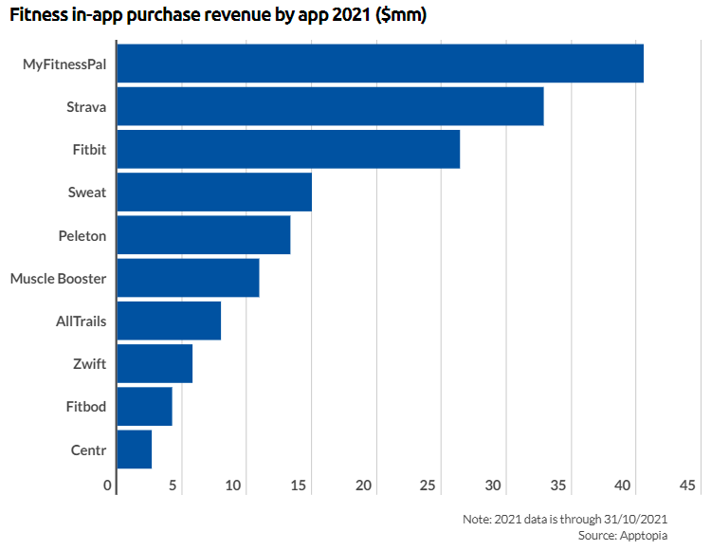

Figure 3: Fitness in-app purchase revenue by app 2021 ($mm)

Fitbit's success influenced major technology players like Apple and Google to enter the fitness app realm, propelled by the widespread adoption of iPhones and the App Store. The Apple Watch, renowned for gathering intricate biometric data, marked a transformative phase in health tracking with apps and wearables monitoring diverse health metrics, including heart rate, sleep patterns, and stress levels. Apple has extended its tracking capabilities beyond fitness to healthcare, unveiling products like the Apple Watch Series 4 and subsequent iterations. These devices not only track irregular heartbeats but also measure blood oxygen levels, have fall detection, and facilitate automatic emergency calls (‘Healthcare - Apple Watch’, 2017). These technologies demonstrate Apple's commitment to advancing technology for comprehensive healthcare solutions.

Fitness trackers, once simple step counters, have evolved into sophisticated health companions. They now feature comprehensive insights into various aspects of physical well-being, from heart rate monitoring and sleep tracking to GPS navigation. Motivating users through goal setting and progress tracking, fitness trackers incorporate gamification elements, adding fun and competition to the fitness journey. Beyond functionality, these trackers have become fashion-forward accessories, seamlessly integrating with everyday attire for constant monitoring of vital health metrics (Waghchoure, 2023).

## Fitness and Health Tracker Varieties

### Common Categories of Fitness and Health Trackers

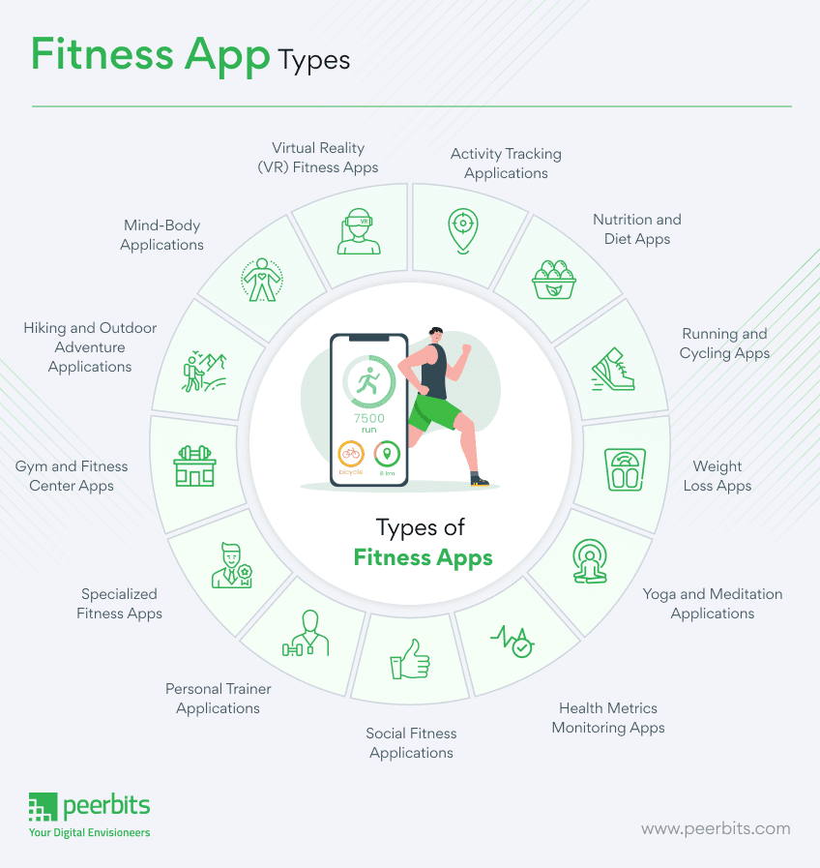

Figure 4: Fitness App Types.

**Activity Tracking: These apps utilize sensors in smartphones or wearable devices to monitor physical activities such as steps taken, distance covered, and calories burned. They provide users with real-time feedback on their activity levels and are exemplified by popular apps like Samsung Health** (‘Samsung Health’, 2023)**.**

**Workout and Exercise: Designed to cater to various fitness levels and goals, workout and exercise apps offer a wide range of routines and fitness plans. Users can choose from strength training, cardio workouts, yoga sessions, and more, depending on their preferences and objectives.**

**Nutrition and Diet: Nutrition and diet apps play a crucial role in helping users maintain a balanced diet and healthy eating habits. They enable users to track their calorie intake, plan meals, and receive nutritional guidance based on their dietary preferences and goals. Well-known examples include MyFitnessPal** (‘MyFitnessPal’, 2024) **and Lose It!** (‘Lose It!’, 2022).

**Running and Cycling: These apps are tailored specifically for runners and cyclists, offering features such as GPS tracking, route planning, and pace monitoring. Apps like Strava are popular among outdoor enthusiasts for their ability to track and analyse performance metrics during runs and rides** (‘Strava’, 2024).

**Health Metrics Monitoring: These apps integrate seamlessly with wearable devices like Fitbit** (‘Fitbit, 2024) **or Garmin Connect** (‘Garmin’, 2019) **to monitor various health metrics such as heart rate, blood pressure, and sleep patterns. They provide users with valuable insights into their overall health trends and help them make informed decisions about their well-being.**

**These categories encompass a diverse array of fitness app types that cater to different user needs and preferences. While the mentioned categories cover a broad spectrum of fitness and health-related activities, there are also specialized apps (**Figure 4**) available for specific activities or health goals, highlighting the ever-evolving nature of digital health and fitness technology.**

### Evolving Trends in Fitness and Health Tracking

**Wearable Technology: Leading fitness trackers and smartwatches, such as Fitbit and Apple Watch, utilize advanced sensors to monitor a range of health metrics, including heart rate, sleep patterns, and physical activity. These devices, equipped with GPS technology, can track outdoor activities, and measure additional factors like skin temperature and blood oxygen levels (‘Fitbit’, 2023).**

**Machine Learning and AI: My Fitness Pal employs a mobile app featuring Machine Learning (ML) algorithms for personalized workout and nutrition recommendations. Analysing users' workout history, biometric data, and relevant information allows the application to adapt and offer more effective, tailored suggestions (‘MyFitnessPal’, 2023).**

**Natural Language Processing (NLP): Virtual assistants like Apple’s Siri and Google Assistant utilize NLP technology to interpret and respond to voice commands, facilitating hands-free operation of fitness apps during workouts.**

**Computer Vision: In workout apps, Computer Vision technology ensures users maintain proper exercise form. By analysing video data, computer vision algorithms provide real-time feedback on exercise techniques, promoting correct form.**

## Effectiveness of Fitness Trackers

Wearable activity trackers have emerged as cost-effective tools to combat physical inactivity. A comprehensive review of 39 systematic reviews and meta-analyses, spanning diverse populations, demonstrated the positive impact of activity trackers on physical activity, body composition, and fitness, resulting in approximately 1800 extra steps per day, 40 additional minutes of walking, and about 1 kg reduction in bodyweight (Ferguson et al., 2022).

In a case study, the effectiveness of a wearable fitness tracker, specifically a Fitbit, was explored in a 36-week intervention program for an overweight, type 2 diabetic, geriatric subject. The integrated use of the Fitbit reported qualitative improvements in active minutes, steps taken, miles walked, calorie intake, sleep duration, and liquid consumption. The subject significantly increased daily walking distance from less than one mile to over 4.6 miles, nearing the recommended 5 miles per day goal. The technology facilitated continuous monitoring by the healthcare team, showcasing positive changes in exercise dedication and overall well-being (Thomas William Miller, 2017).

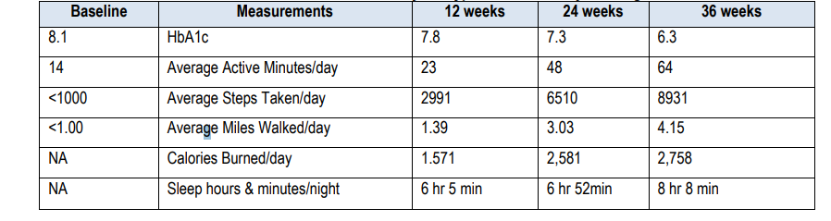

Figure 5: Variables measured over a 36-week study for a Type 2 Diabetic patient using Fitbit (Thomas William Miller, 2017).

Moreover, another case study that involves a virtual fitness trainer app, assessed through the Situational Motivational Scale (SIMS) with 54 students, demonstrated effectiveness in motivating and engaging users in fitness activities. The app's virtual trainers positively influenced students' motivation, making the activities enjoyable and beneficial for their fitness levels. Respondents found the activities interesting, fun, and essential, highlighting the app's potential to enhance engagement and motivation in fitness-related endeavours (Mokmin and Nurullizam Jamiat, 2020).

In summary, the evidence suggests that wearable fitness trackers, exemplified by Fitbit and virtual trainer apps, play a crucial role in enhancing physical activity, motivating users, and positively impacting overall health and well-being.

## Understanding the Risks Associated with Fitness Trackers

Fitness tracker apps, with their extensive data collection and sharing capabilities, introduce significant privacy and security risks. A survey of 11,000 mobile health apps, representing 5,000 developers, reveals that fitness and nutrition apps are particularly advanced in sharing user data via shared application programming interfaces (APIs) (‘Permissions on Android’, 2024). Sharing commonly occurs with data aggregators like Apple’s HealthKit, wearables, and directly between apps (Grundy, Held and Bero, 2017).

These apps serve diverse functions, accessing vast amounts of highly personal data, including location, text messages, and even camera or photo access (Olmstead, 2015). The inherent access to personal health information heightens privacy risks, with concerns about data being shared with third parties, including advertisers and data brokers (Grundy, Held and Bero, 2017)

The risks extend to information leaks, manipulation, and loss, as demonstrated by Li's privacy threat model (Li, 2015). User profiling across multiple sites can lead to aggregated user profiles, monetized for marketing, or even exploited for identity fraud (Grundy, Held and Bero, 2017).

Mobile health apps, including fitness trackers, routinely request numerous permissions, indicating a broad spectrum of data access. The most common permissions relate to internet access, with implications for data transmission and sharing (Grundy, Held and Bero, 2017).

Common fitness tracker apps like Samsung Health and Fitbit apps have encountered challenges in usability and data privacy, which have been documented in various sources. Usability issues, including complex interfaces and inconsistent user experiences, missing features have been noted by reviewers and users alike (‘Appconner’, 2021), along with inaccuracy in collected data in certain apps.

Fitbit's data collection policy outlines that personal data collected through its app, including fitness and health-related information, is used primarily for providing and improving its services, such as personalized recommendations and analytics (‘Fitbit Legal: Privacy Policy’, 2023). Similarly, Samsung Health's data collection policy states that user data, including fitness, nutrition, and biometric information, is utilized for enhancing user experience, research, and product development (‘Samsung Privacy’, 2024).

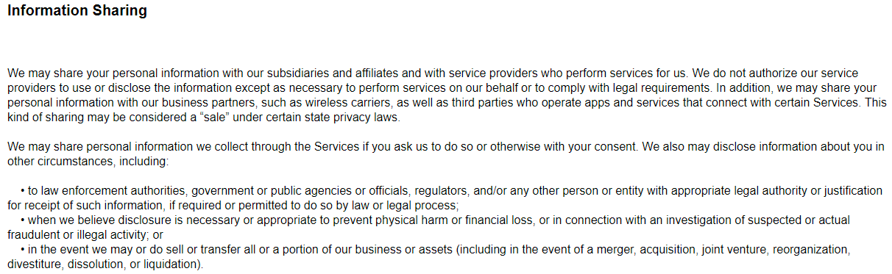

Figure 6: Samsung Information Sharing Policy.

## Ethical Considerations

In developing the AFNT app, ethical considerations play a crucial role in ensuring user trust and data security. The app must prioritize data privacy by complying with GDPR (‘Overview of UK GDPR’, 2016) and implementing secure storage and transmission measures. Intellectual property rights are respected, necessitating proper licensing for third-party content. Accessibility is a key focus, with the app designed to be inclusive and user-friendly for individuals with disabilities following WCAG guidelines (WCAG 2, 2018). Security measures are implemented for the DBMS and ensure encrypted data transfer from the Arduino watch. Hardware standards for the Arduino watch prioritize user safety and comfort. Battery optimization features guarantee prolonged operation, and both the website and app adhere to accessibility standards and offer a user-friendly interface. Compatibility across various mobile platforms and seamless integration with mapping APIs further enhance the app's ethical usability and accessibility.

## Development Research Plan

Embarking on the AFNT Fitness Tracker development necessitates a thorough grasp of technical nuances in each project component. A comprehensive understanding of challenges, tasks, and effective management approaches is crucial. Due to the extensive nature of the AFNT project, it will be initially segmented into five planning stages, as outlined in Figure 7.

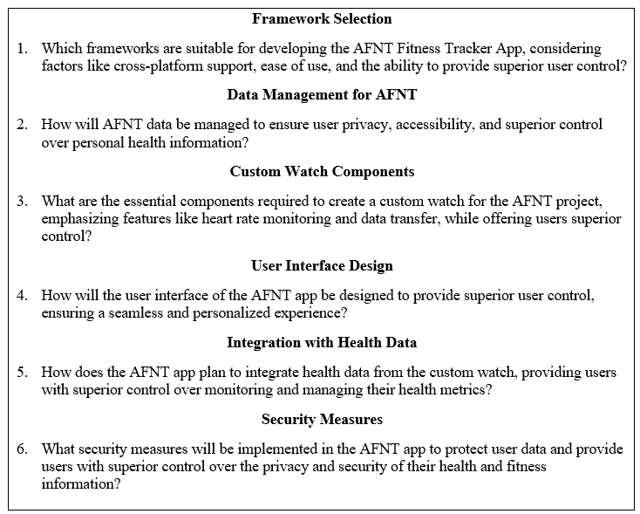

Figure 7: AFNT Initial Questions.

### Success Criteria

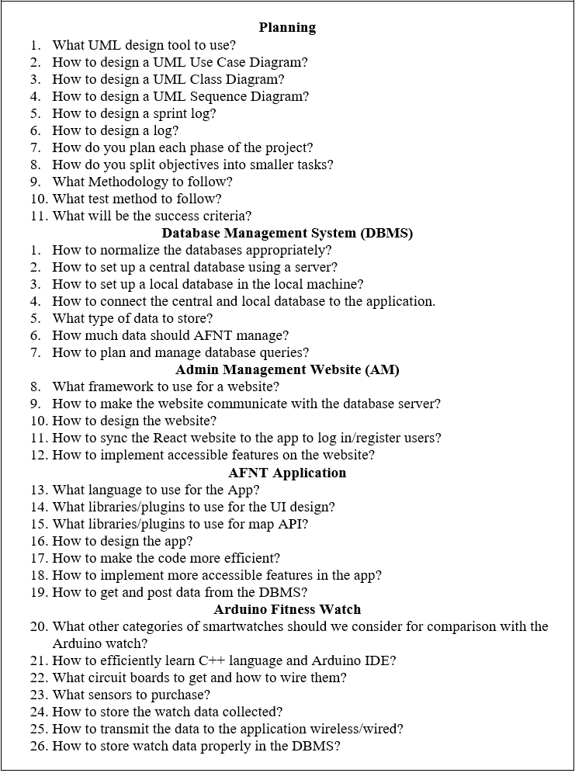

Figure 8: What I Need to Find Out.

After extensive research and consultations with supervisors, I've restructured the planning phase for AFNT into five key categories, as illustrated in Figure 8. The success criteria revolve around the development of a fully functional AFNT application compatible with both mobile and desktop platforms. It should adeptly track workouts, meals, and body data, and visualize body progress through graphs (Aiming to amalgamate multiple types of fitness apps into one, as depicted in Figure 4). Additionally, the Arduino watch should seamlessly connect and synchronize data with the AFNT app via Bluetooth, providing real-time heart rate, blood oxygen levels, and step count data.

### Technical Knowledge

To facilitate diagramming, I've opted for Astah UML for its versatility, ease of use, and popularity in industry (‘Powerful and Fast UML Diagramming Software - Astah’, 2023). Excel will be utilized for sprint, testing, and planning logs due to its spreadsheet functionality, ease of use and the wide range of planning templates it offers (‘Excel | Microsoft 365’, 2016).

The database architecture will be divided into two components: The Central Database Server (CDB) and the Local Database (LDB). In the LDB, all user personal data will be stored locally, ensuring that it remains exclusively accessible to the user. The database will be created using SQLite, a highly popular and easy to use database modelling tool (‘SQLite’, 2024). This approach aligns with AFNT's commitment to maintaining the security and privacy of user data. Conversely, the CDB will house predefined workouts, meals, and user login credentials, facilitating secure login and access to AFNT's user data. CDB will be stored in a MySQL server due to its reliability, scalability, performance, security features, cross-platform compatibility, and strong community support, making it suitable for various applications (‘SQL Server | Microsoft’, 2022).

For the AM Website, Python Flask was chosen for its simplicity and widespread use in the industry (‘Flask Documentation (3.0.x)’, 2024). Extensive online resources are available to support effective implementation. In developing the AFNT application and Graphical User Interface (GUI), Python programming language and the Kivy GUI Framework was used as it offers flexibility and cross-platform support, making it an ideal choice. It's open-source and user-friendly (‘Kivy: Cross-platform Python Framework for NUI’, 2024).

Regarding the Arduino Fitness Watch, components from Tiny Circuits were selected for their compact design and ease of assembly, resembling modular electronic components akin to Lego blocks (‘TinyCircuits - Maker of Tiny, Open-Source Electronics’, 2024). Tiny Circuits also boasts a supportive community and provides comprehensive documentation and basic examples to aid development (‘Tiny Circuit Projects’, 2022). All components were acquired at personal expense.

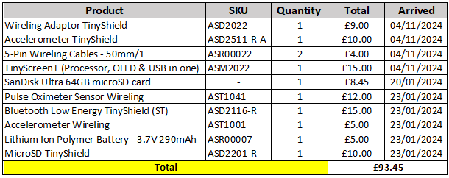

Figure 9: Arduino Watch Components.

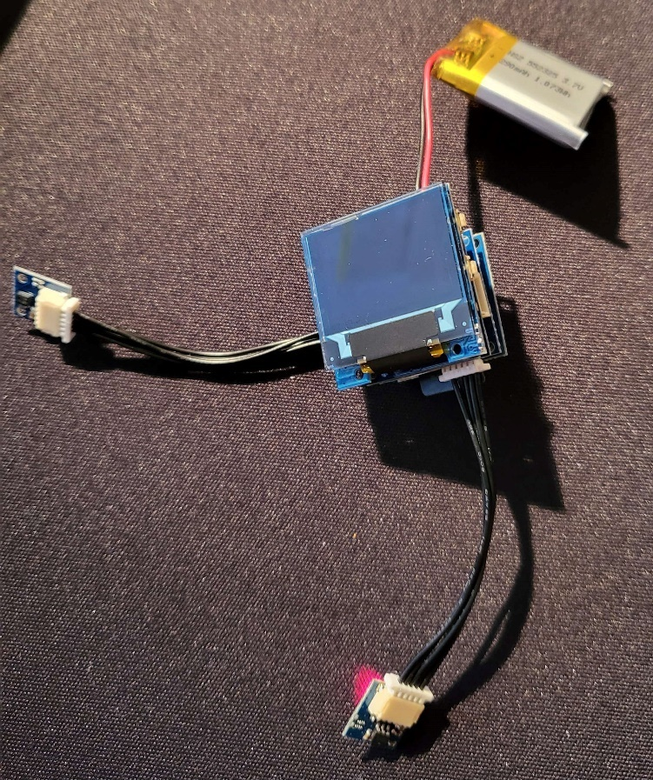

Figure 10: Assembly of All Arduino Watch Modules

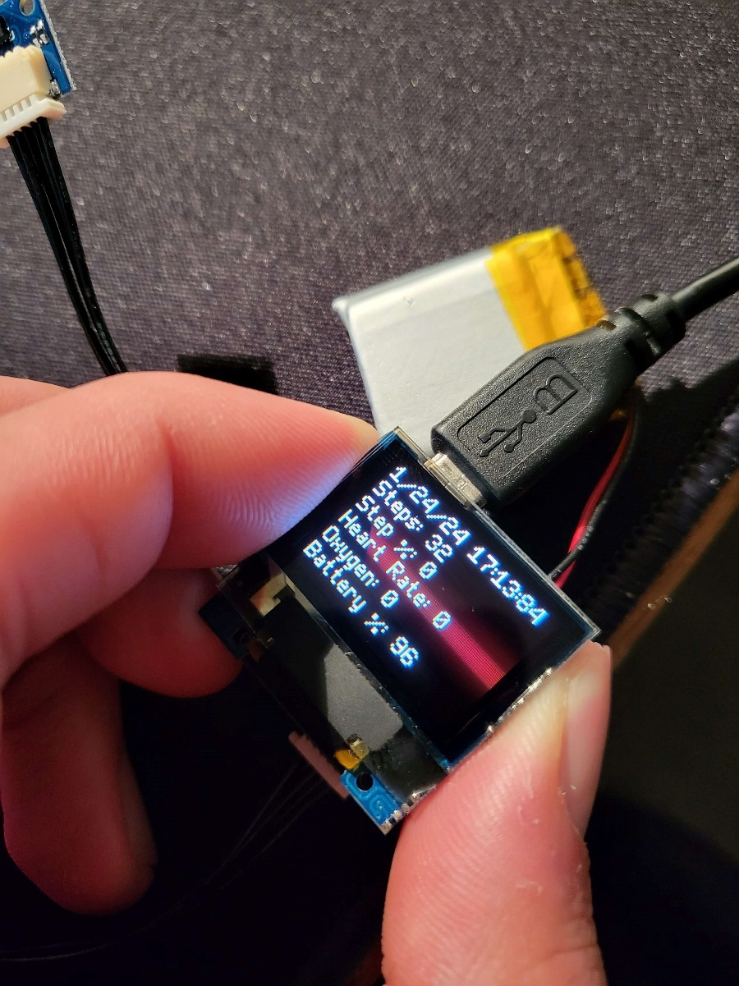

Figure 11: First Version of Arduino Watch Interface (24/01/2024).

### AFNT Evaluation Criteria

In this study, we will evaluate two widely used fitness tracker apps, Samsung Health, and Fitbit, based on their performance and features, as illustrated in Figure 9. AFNT stands out from Samsung Health (Paired with Samsung Galaxy Watch 1) and Fitbit app (Paired with Fitbit Flex 2) in several aspects:

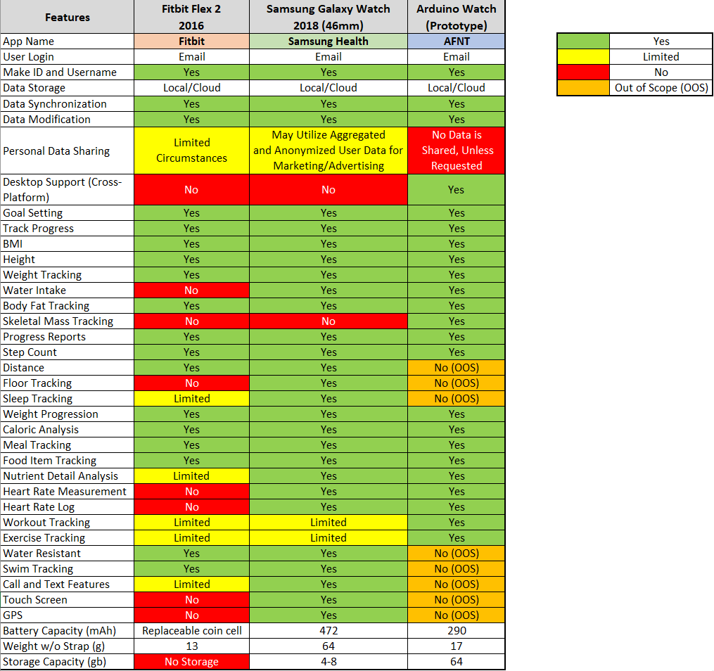

Figure 12: AFNT and Arduino Watch Evaluation Table.

**Selection Rationale for Samsung Galaxy Watch and Fitbit Flex 2**: The Samsung Galaxy Watch and Fitbit Flex 2 were chosen for practical reasons, based on my prior experience with the Samsung Galaxy Watch, which enables thorough testing of both devices. Moreover, the Fitbit Flex 2 was selected due to its fitness-focused design akin to the Arduino Watch, distinguishing it from multipurpose/flagship smartwatches like the Apple Watch or higher-end Samsung models. Its core features centre on tracking activities such as steps, distance, calories, and sleep patterns, with limited smartwatch functionalities such as call and text notifications. Moreover, Including the original Galaxy Watch allows for a comparison of the Arduino watch's capabilities against a more advanced smartwatch in terms of both hardware and software, while cost considerations also influenced the selection process.

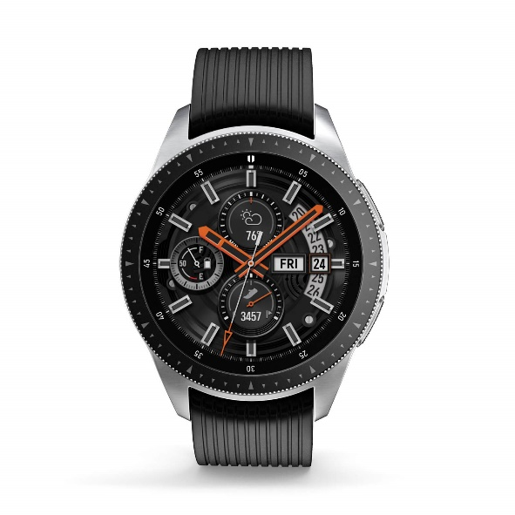

Figure 13: Samsung Galaxy Watch (2018).

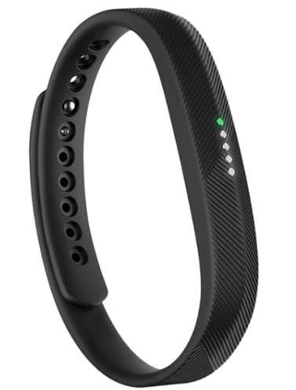

Figure 14: Fitbit Flex 2 (2016).

**Privacy Measures**: AFNT emphasizes data privacy by storing user data locally on the device (LDB), ensuring that personal information is not utilized for marketing, advertisement, or analytical purposes as AFNT has no way to access this data. It also incorporates a feedback mechanism for users to share data securely, a feature less emphasized in Samsung Health and Fitbit apps.

**Cross-Platform Functionality**: AFNT is designed to function seamlessly across both mobile and desktop platforms, providing users with flexibility in accessing their fitness and health data. This versatility contrasts with the mobile-centric approach of Samsung Health and Fitbit apps.

**Customizable Workout Plans**: Unlike Samsung Health and Fitbit apps, AFNT allows users to tailor and customize their workout plans according to their specific fitness objectives and preferences, fostering greater user engagement and motivation.

**Enhanced User Control**: AFNT offers users extensive control over their fitness, health, and nutrition data. Users can modify nutritional details of food items, rate workouts, customize exercise aspects, allocate workouts and meals, and manage data synchronization across devices. This level of control enhances the user experience and personalization, surpassing what is currently offered by Samsung Health and Fitbit apps.

### Requirements Gathering

The app aims to provide a seamless user experience with features like customizable workout plans, nutritional tracking, and real-time health data from the Arduino watch. User-friendly interfaces, security measures, and cross-platform compatibility are fundamental requirements. These requirements were gathered in the following ways:

* Regularly consulting mentors like Martin Serpell and Eman Qaddoumi for industry insights and best practices in fitness app development.
* Analysing UI, features, and functionalities of popular fitness apps like Samsung Health and Fitbit to guide AFNT app design decisions.
* Tracking personal fitness progress at the gym and understanding user expectations firsthand (Figure 15, Figure 16 and Figure 17).
* Conducting comprehensive online research to stay abreast of emerging trends and user demands in fitness app development.

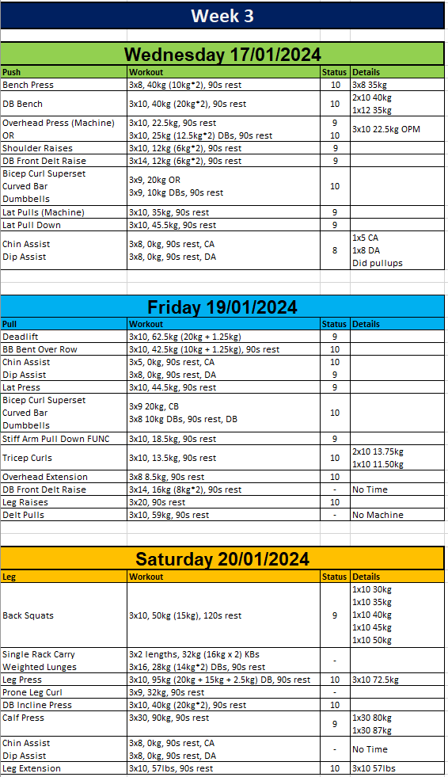

Figure 15: My Personal Workout Tracking Method Using Excel Spreadsheet.

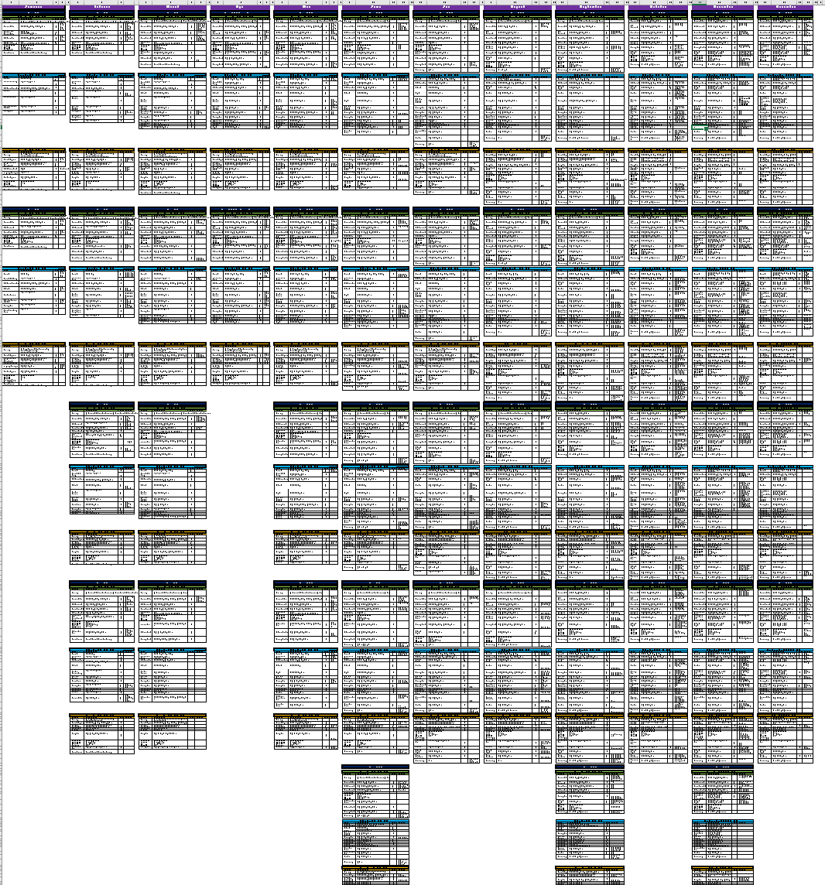

Figure 16: My Personal Workout Data Using Excel – 2023

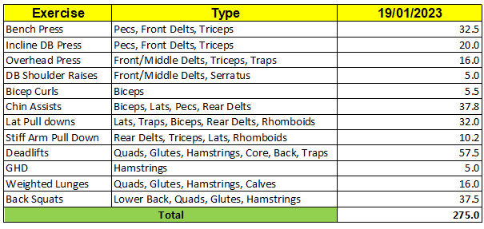

Figure 17: My Workout Progress Evaluation – 2023

# Requirements

An essential aspect crucial to the success of any project lies in defining a comprehensive set of requirements. These requirements serve as concise outlines detailing the project's objectives and the expected performance of its deliverables. They can encompass both broad and specific descriptions of the system's behaviour and functionality.

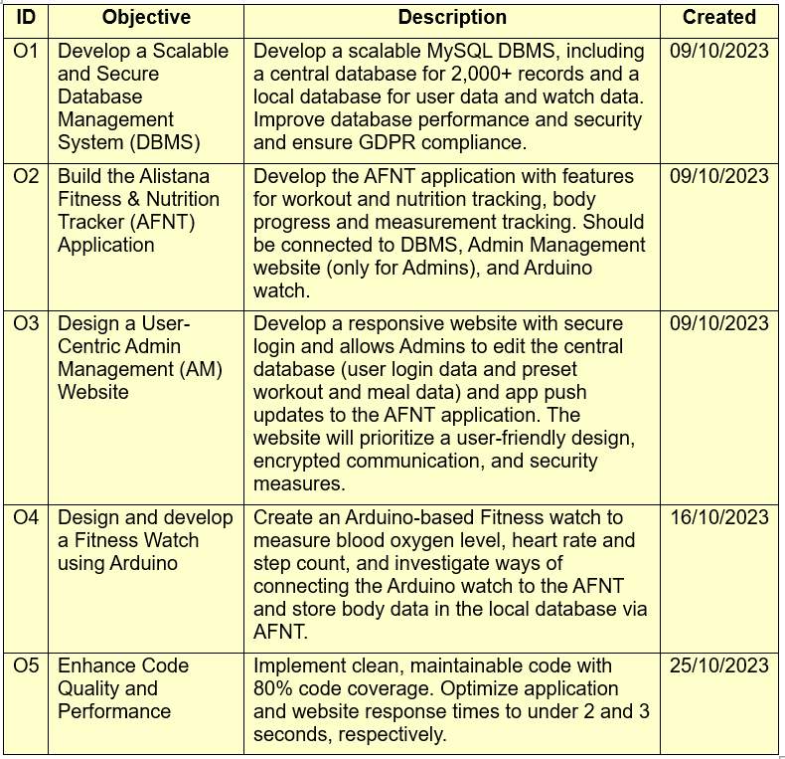

Figure 18: AFNT Project Objectives.

In refining the final list of requirements, careful consideration was given to attributes such as traceability, testability, and consistency. Some requirements may represent distinct functionalities, contingent upon the completion of others, and they are noted for their dependencies. The subsequent sections will delineate the structured format of the requirements, categorizing them into non-functional and functional requirements. Additionally, a use case diagram, use case descriptions, class diagrams and the projects overall architecture diagram will be presented.

**Note**: For the complete list of project objectives, use case diagrams with descriptions, and requirements, please refer to the Requirements file provided under /Documents/Reports Directory.

## Requirement Structure

The requirement structure is specifically crafted to ensure clarity and facilitate efficient tracing and testing of project objectives or requirements. The requirement code follows a well-defined format as outlined below:

<***Requirement/Objective***><***Phase Component***><***Number***>

### Requirement/Objective:

This component indicates whether the property is a **functional** requirement ('F'), a **non-functional** requirement ('NF'), or an overall project **objective** ('O').

### Phase Component:

It signifies the specific phase of the project to which the requirement or objective pertains. Each phase is represented by a distinct code, such as 'A' for **App** development, 'D' for **Database**, or 'AW' for **Arduino Watch** development.

### Number:

Used to differentiate between cases with the same requirement or objective and phase. It ensures unique identification within a specific phase and requirement/objective category.

For instance, adding meals and workouts are both functional requirements for the app development phase of the AFNT App. Despite being similar, they are assigned different numbers to distinguish them from each other effectively.

The table below succinctly summarizes all the codes and their meanings for easy reference and streamlined project management. The table below displays all the codes and their meanings for simplicity and easy reference.

Table 1: Requirement/Objective Abbreviations.

|  |  |
| --- | --- |
| **Requirement/ Objective** | |
| O | Objective |
| F | Functional Requirement |
| NF | Non-Functional Requirement |

Table 2: Phase Component Abbreviations.

|  |  |
| --- | --- |
| **Phase Component** | |
| A | AFNT Application |
| AW | Arduino Watch |
| D | Database |
| DBR | Data Backup & Recovery |
| DS | Data Storage & Optimization |
| ES | Efficiency & Sustainability |
| P | Performance |
| PS | Privacy & Security |
| R | Reliability |
| TPS | Third Party Service Integration |
| U | Usability |
| W | Admin Management Website |

## Requirement Categorization

The project's requirements are distributed across various phases, with each requirement accompanied by a concise description of its purpose. Additionally, each requirement is prioritized using the MoSCoW prioritization technique (Agile Business, 2022), which enables effective planning and management throughout the project lifecycle. MoSCoW prioritization was selected for its simplicity and suitability for both pre-planning and post-planning stages.

Furthermore, each requirement is tagged with a completion status to facilitate straightforward tracking of progress. Additionally, the date of creation or last update is recorded for each requirement, providing valuable insights into the project’s development over time.

Table 3: MoSCow Prioritization table.

|  |  |  |
| --- | --- | --- |
| **Priority Level** | **Abbreviation** | **Meaning** |
| Must have | M | Task that is crucial for the project. |
| Should have | S | Important task but not vital for the final project. |
| Could have | C | Wanted or desirable but not important for the project’s overall goal. |
| Won’t have | W | Out of scope. |

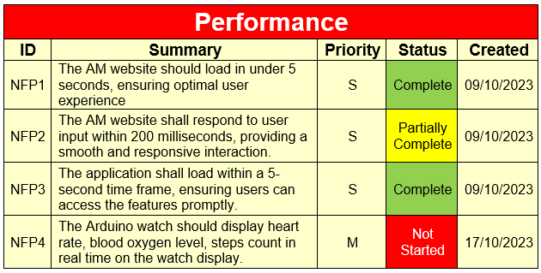

Figure 19: Requirement Table Overview.

**Note**: For further reading on project aims, objectives, and requirements, please navigate to Appendix A: Requirements.

## Usecase Diagrams and Descriptions

An effective strategy for informing and crafting a set of requirements is through the creation of a use case-driven system. Use cases offer detailed insights into how the system will be utilized, encompassing information about users, usage scenarios, and the sequences and structures inherent in its functioning. The use of UML diagrams is prevalent in this context, as they are widely recognized as an industry standard. Many software developers rely on UML diagrams to articulate software design models, making familiarity with them a common expectation among software professionals (Alam, 2022).

For this project, three UML use case diagrams have been developed, each corresponding to a different aspect of the project: one for the AFNT Application, one for the Arduino Watch, and one for the Admin Management Website. These diagrams are designed to align with the project's requirements and objectives. Given the complexity of each diagram, detailed descriptions of the use cases have been provided to offer a deeper understanding, particularly for less detailed use cases. Additionally, certain use case descriptions encompass multiple related use cases to streamline the presentation. For instance, the "Manage workouts" use case may include sub-use cases such as "Add Workout," "Edit Workout," and "Delete Workouts," which are combined into a single use case description for clarity and simplicity.

### Usecase Diagrams and Descriptions

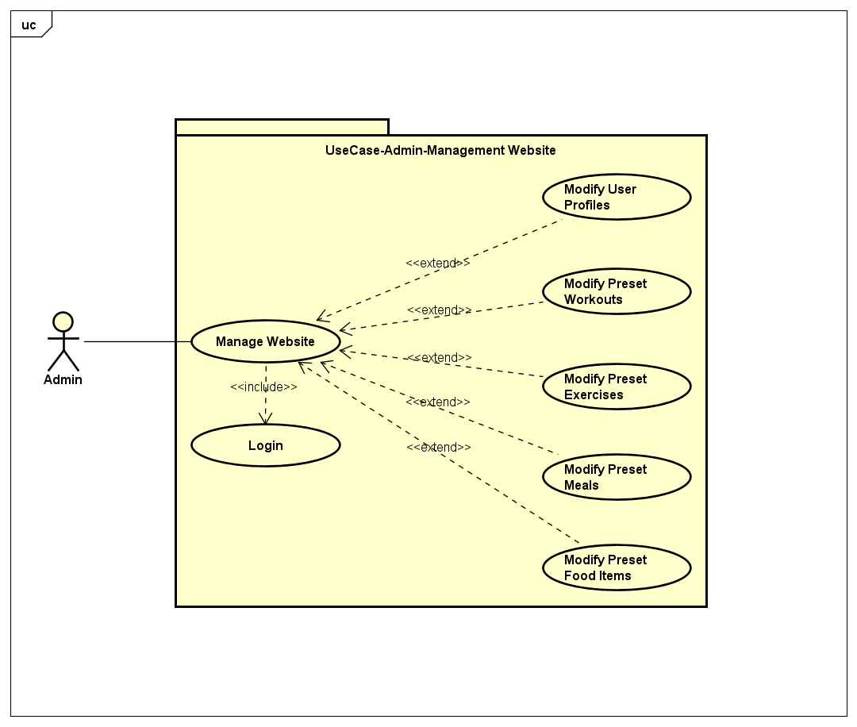

Figure 20: Usecase Admin Management Website.

Table 4: Admin Management Website Usecase description.

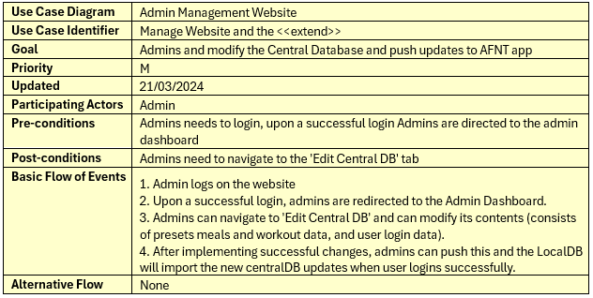

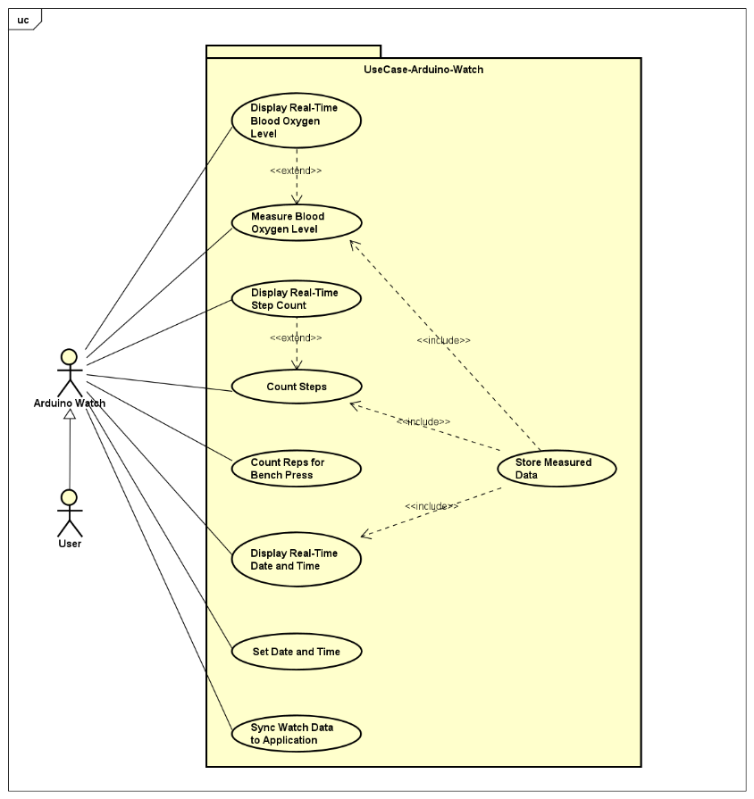

Figure 21: Arduino Watch Usecase Diagram.

Table 5: Store Measured Data and the <<extend>> Usecase description.

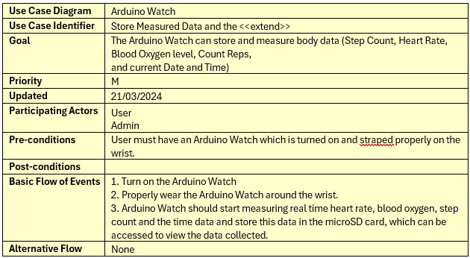

Table 6: Sync Watch Data to Application Usecase description.

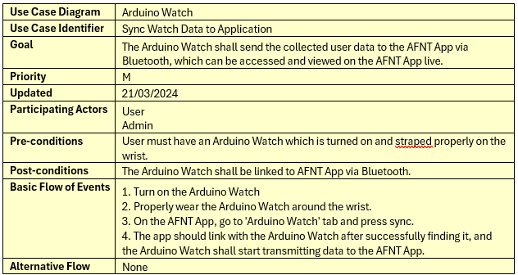

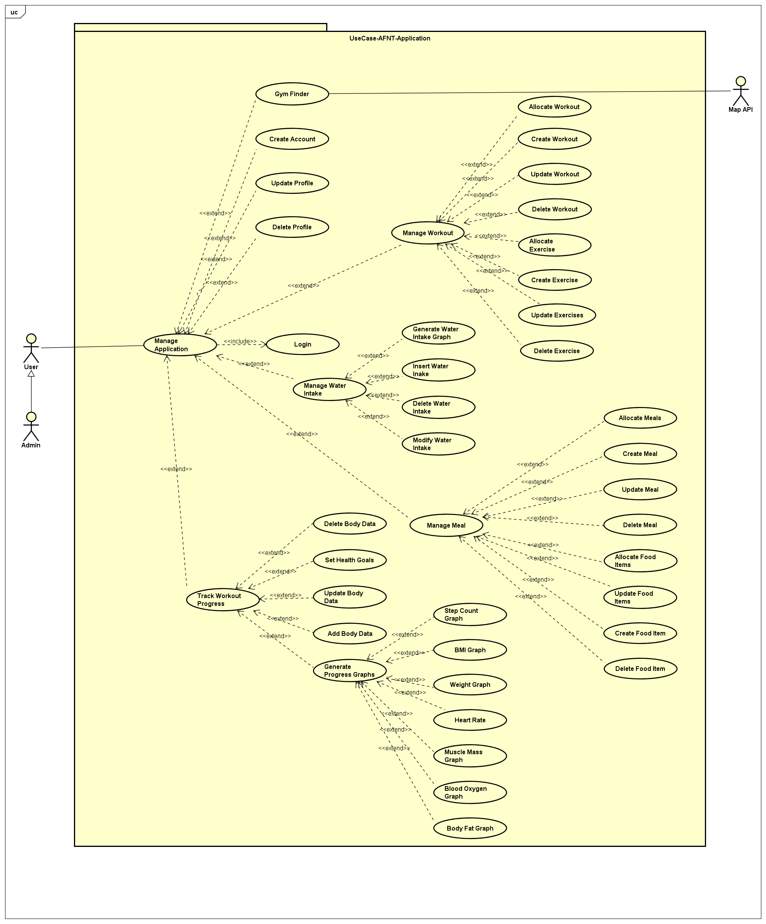

Figure 22: AFNT App Usecase Diagram.

Table 7: Manage Workout and the <<extend>> Usecase description.

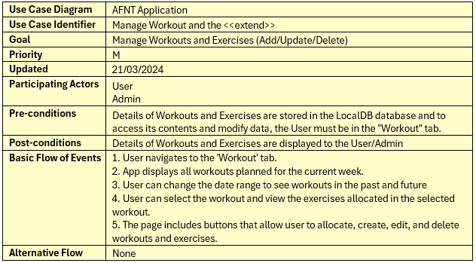

Table 8: Manage Meal and the <<extend>> Usecase description.

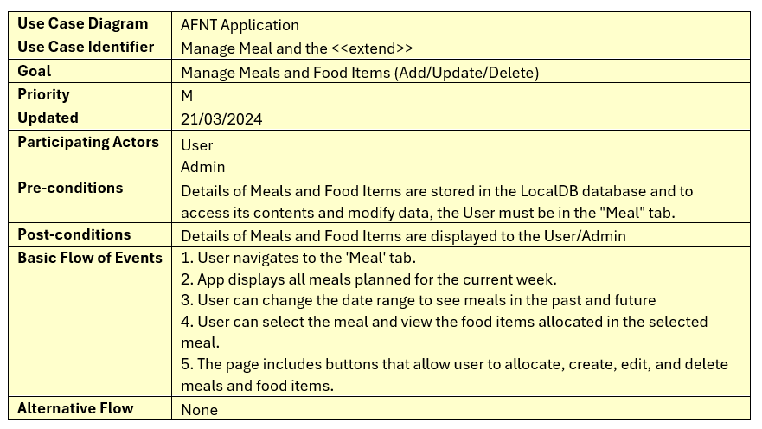

Table 9: Manage Water Intake and the <<extend>> Usecase description.

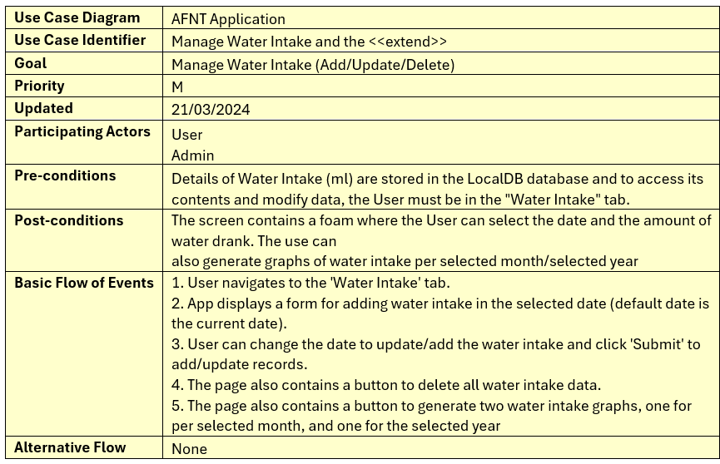

Table 10: Gym Finder Usecase description.

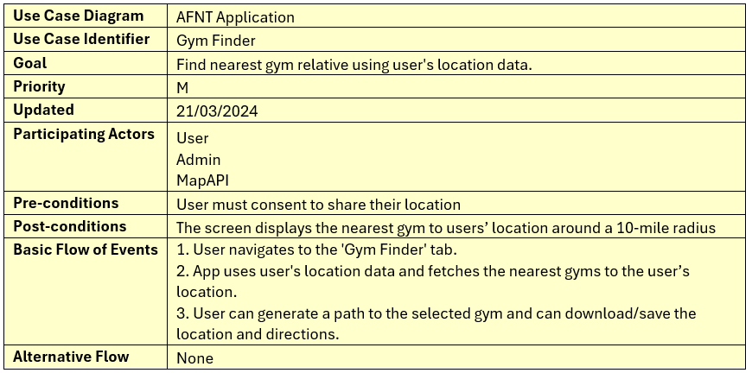

Table 11: Create Account Usecase description.

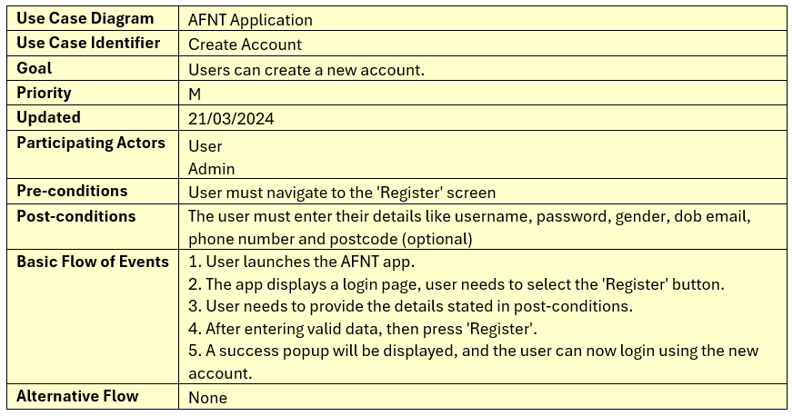

Table 12: Update Profile Usecase description.

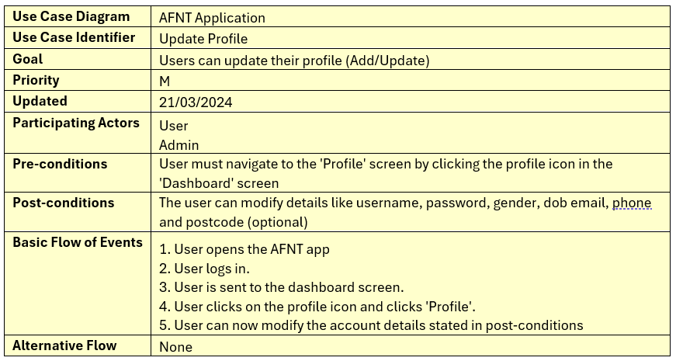

Table 13: Delete Profile Usecase description.

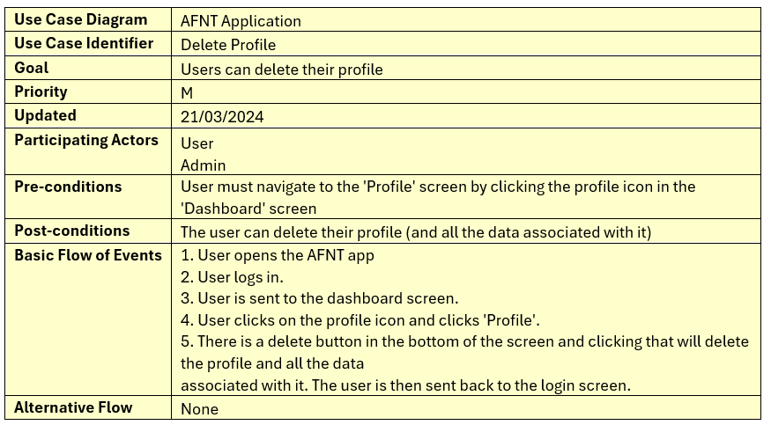

Table 14: Track Workout Progress and the <<extend>>

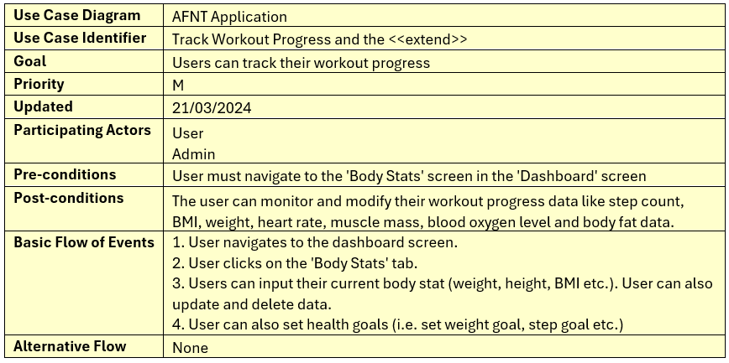

Table 15: Generate Progress Graph and the <<extend>> Usecase description.

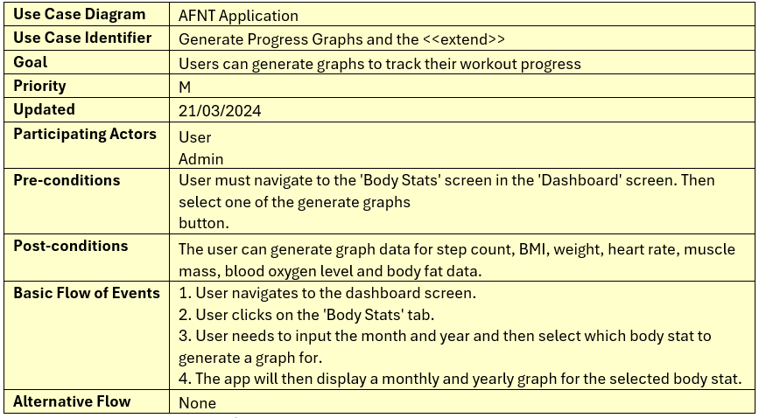

In conclusion, the Requirements chapter provides a comprehensive overview of AFNT project's objectives, functionalities, and performance expectations. By adhering to a structured format and utilizing prioritization techniques, the requirements are organized and categorized to facilitate efficient project management. The inclusion of use case diagrams and descriptions further enhances understanding and alignment with project goals. Overall, this chapter serves as a crucial reference point for understanding AFNT’s key goals and objectives.

# Methodology

In the methodology chapter, we will explore how agile principles and the Trello Kanban methodology were utilized in the AFNT project to ensure smooth development and delivery. The chapter will discuss the rationale behind selecting Trello as the project management tool and highlight the benefits of employing Kanban for project execution. It will outline the key phases of the AFNT app development and describe the division of the project into sprints, focusing on each sprint's objectives.

Additionally, the chapter will delve into the integration of Trello Kanban into the project, explaining the structure of the Kanban board and its role in organizing and tracking tasks. Lastly, it will discuss the advantages of using Trello Kanban, emphasizing its simplicity, scalability, transparency, and customization capabilities. Through these insights, the methodology chapter will provide a comprehensive understanding of the strategies and tools utilized in the AFNT project for effective project management.

## AFNT Phases

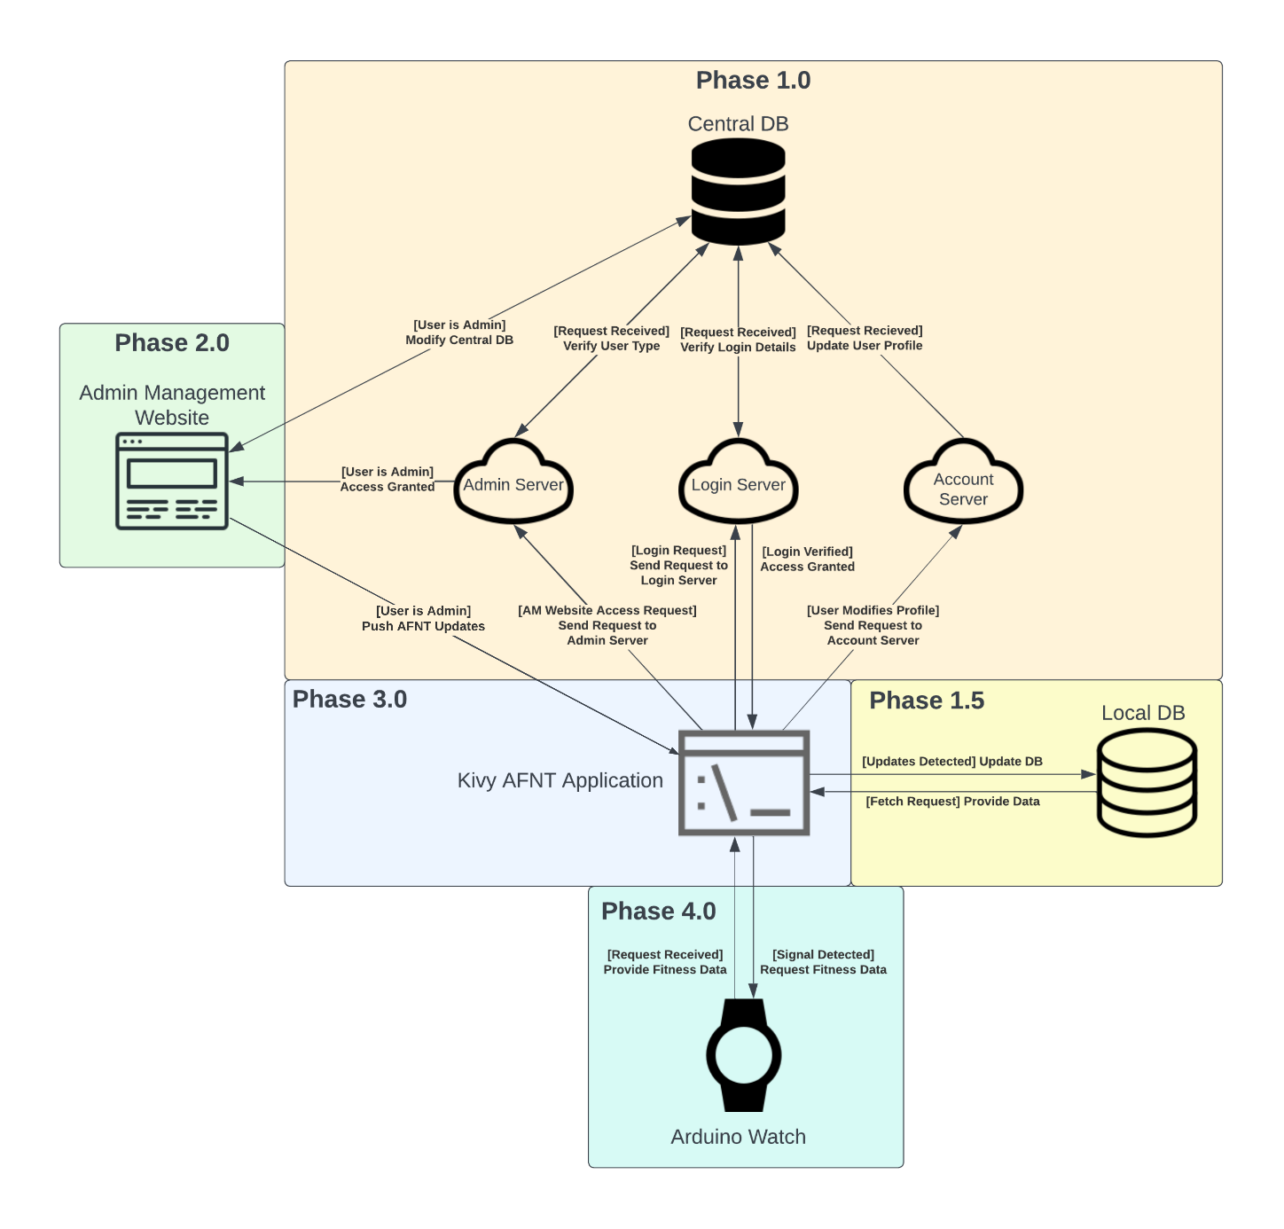

Figure 23: AFNT Project Phases.

The AFNT project is divided into four key phases:

Table 16: AFNT Phase Descriptions.

|  |  |
| --- | --- |
| Phase 1 | Phase 1 involves setting up the Central Database (CDB) within the Database Management System (DBMS). The CDB stores predefined workouts, meals, and user login credentials securely. Updates made in the CDB are synced to the user's Local Database (LDB) upon successful login. |
| Phase 1.5 | The LDB is introduced to store user-specific workout, meal, and body statistics data locally. This data remains unaffected by updates from the CDB, ensuring user customization is preserved. |
| Phase 2 | introduces the Admin Management Website (AM), allowing administrators to manage the CDB and push updates to the AFNT application. |
| Phase 3 | focuses on developing the AFNT application, enabling users to track workouts, meals, and body data. Users can also modify their profiles, with changes reflected in the CDB. |
| Phase 4 | Phase 4 extends Phase 3 by introducing the Arduino Fitness Watch, capable of monitoring health metrics and seamlessly transferring data to the AFNT application via Bluetooth or a wired connection. |

## Sprint Planning

Sprint planning is a crucial aspect of project management, especially in agile methodologies like the one employed in the AFNT Project. It involves breaking down the project into smaller, manageable chunks known as sprints, each focusing on specific objectives.

In the case of the AFNT Project, sprint planning has resulted in the division of the project into four distinct sprints, with each sprint dedicated to a particular phase of development. However, it's important to note that due to time constraints and priority considerations, Phase 2 of the project will be largely disregarded. Below are the details of each sprint and its corresponding focus:

Table 17: Sprint 1 – Planning & Design.

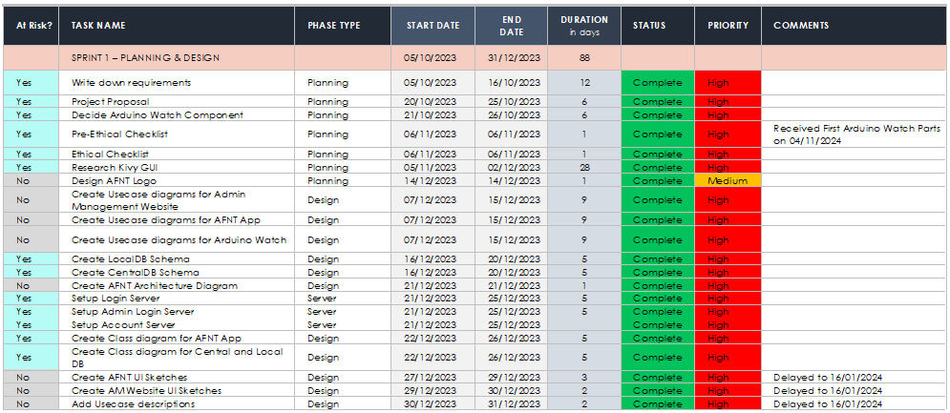

Table 18: Sprint 2 – Phase 1 Implementation & PIP

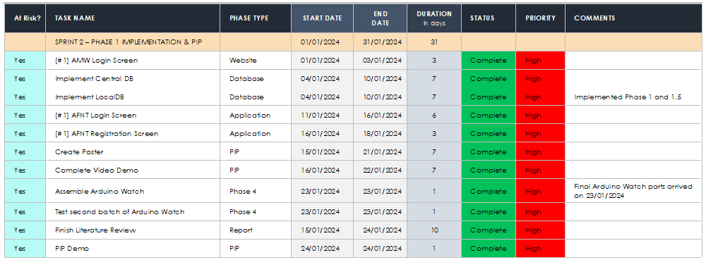

Table 19: Sprint 3 – Phase 3 Implementation.

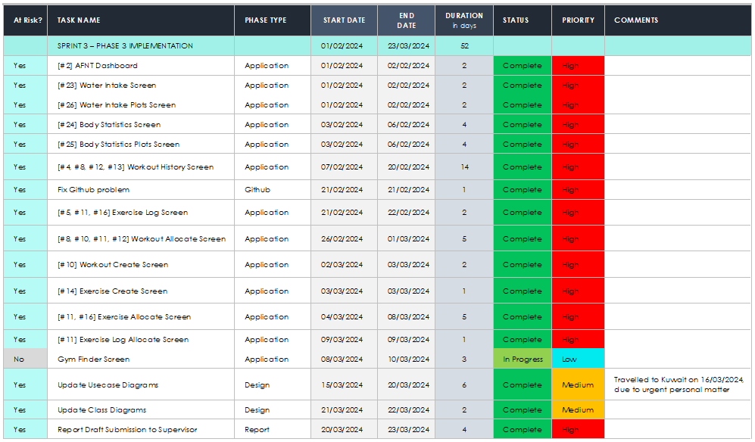

Table 20: Sprint 4 – Phase 4 Implementation.

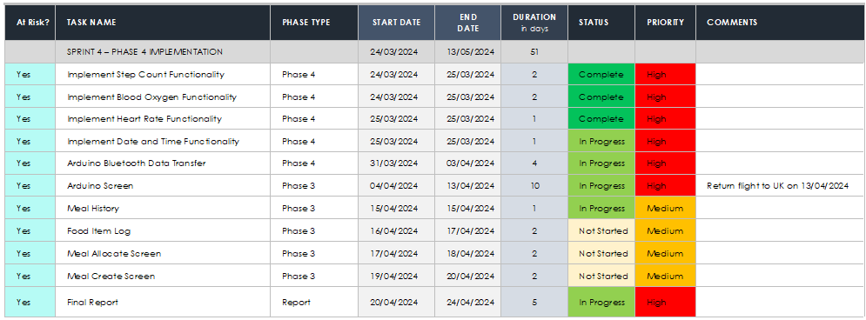

**To access the sprint file, navigate to:**

<https://github.com/alisuhail-amanu2/AFNT/blob/main/Documents/AFNT%20Sprints.xlsx>

## Gantt Chart

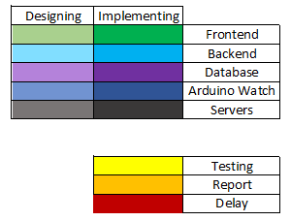

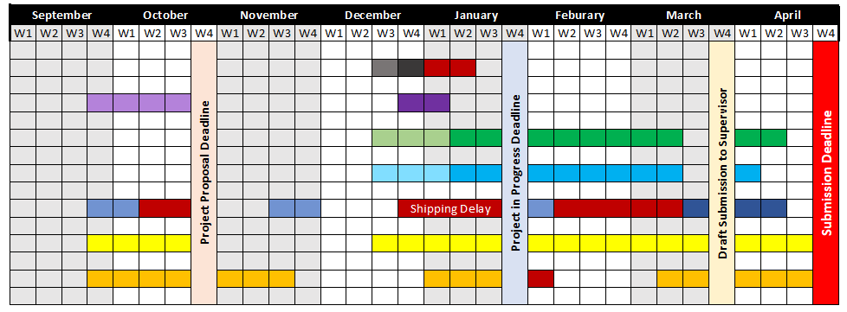

Figure 24: Gantt Chart.

**To access the Gantt chart file, navigate to:**

[https://github.com/alisuhail-amanu2/AFNT/blob/main/Documents/Sprint%2Planning/Gantt%20Chart.xlsx](https://github.com/alisuhail-amanu2/AFNT/blob/main/Documents/Sprint%252Planning/Gantt%20Chart.xlsx)

## Trello Kanban Integration

Trello was chosen as the project management tool for its alignment with agile principles and its user-friendly interface, facilitating seamless tracking of tasks, progress, and priorities (Atlassian, 2019). This chapter explores the benefits of Trello Kanban methodology, its incorporation into the AFNT project, and its pivotal role in managing the project's advancement. Additionally, it outlines the essential phases of AFNT app development, providing an in-depth overview of the project's progression. Through the integration of agile methodologies, well-structured project phases, and proficient utilization of Trello Kanban, the AFNT project demonstrates a systematic and organized approach to software development.

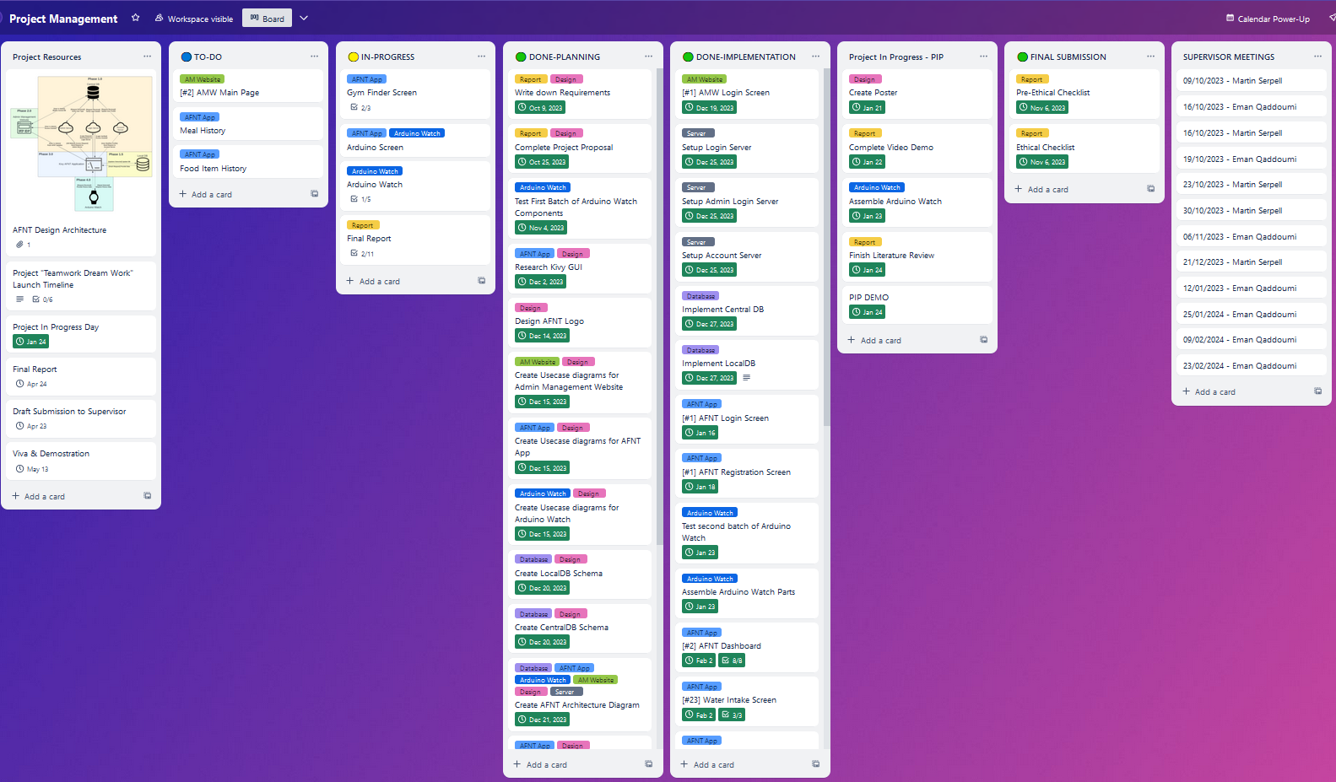

Figure 25: AFNT Project Kanban Board.

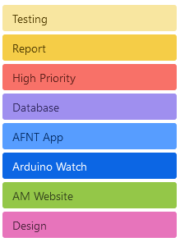

Figure 26: Project Labels on Trello.

To access Trello dump data please navigate to <<>>

The Kanban methodology operates on the fundamental principle of visualizing tasks and workflow on a board. This board is typically divided into columns representing different stages of the project. Each task or "card" progresses through these columns from initiation to completion. Trello, as a Kanban tool, provides a digital platform for teams to create boards, lists, and cards, facilitating collaboration and transparency in project management. Cards can be assigned to team members, labelled with priorities, and updated in real-time as progress is made.

In the case of the AFNT project, the Trello Kanban board consists of eight main columns with four columns specifically allocated to each sprint, as outlined in section ‎4.2 each serving a specific purpose:

Table 21: Trello Kanban Column Descriptions.

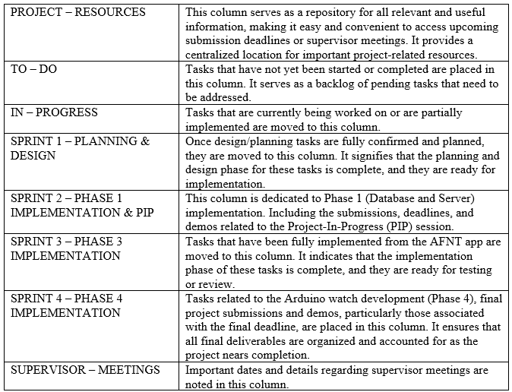

By utilizing these specific columns, the Trello Kanban board effectively organizes and tracks the progress of tasks throughout the project lifecycle, ensuring clarity, accountability, and efficiency in project management.

## Trello Kanban Advantages

The decision to utilize Trello Kanban for the AFNT app was based on several factors:

Table 22: Trello Kanban Advantages.

|  |  |
| --- | --- |
| Simplicity | Trello's user-friendly interface and intuitive design make it easy for team members to adopt and use effectively, without extensive training. |
| Scalability | Trello is highly scalable and can accommodate projects of various sizes and complexities. As the AFNT app project evolved, Trello could easily adapt to changing needs and requirements. |
| Transparency | Kanban methodology promotes transparency by providing visibility into the status of tasks and progress made. This transparency enhances accountability and ensures everyone is on the same page. |
| Customization | Trello allows for customization to fit the specific needs and preferences of the team. Boards, lists, and cards can be tailored to reflect the unique workflow and requirements of the AFNT app project. |

The integration of Trello Kanban into the AFNT project offered an organized and effective project management strategy that aligned seamlessly with the adopted agile methodology. By leveraging Kanban boards and Trello's user-friendly interface, the project could visualize tasks, monitor progress, and prioritize activities with ease. The project's division into four distinct phases, each playing a vital role in the AFNT app's development, facilitated a structured approach, ensuring clarity and focus on every stage.

Moreover, the incorporation of use case and requirements gathering laid a solid framework for project design, aiding in the creation of wireframes and class diagrams, which will be further explored in the Desig chapter. Collectively, these elements, alongside Trello Kanban, agile methodology, and phased development, established a strong foundation for the successful implementation of the AFNT project.

# Design

As previously outlined, AFNT project is divided into four key phases: database management, website development, application development, and Arduino Watch hardware integration. Phase 1 focuses on establishing a robust DBMS. Phase 2 introduces the AM website for database administration, leading into Phase 3's development of the AFNT fitness tracking application. Phase 4 expands the project with the Arduino Watch, integrating modular components for health monitoring and data transfer to the AFNT app via Bluetooth or wired connection.

This chapter discusses detailed design documentation, including schemas, wireframes, diagrams, and specifications for each phase, providing a comprehensive overview of the project's structured approach to achieving its goals.

**Note**: To access all the design files (i.e. usecase, class, wireframes etc.). Please navigate to **https://github.com/alisuhail-amanu2/AFNT/tree/main/Documents/Design**

## Phase 1: Database Design

Phase 1 focuses on establishing a Database Management System (DBMS) featuring a Central Database (CDB). The CDB is primarily tasked with storing predefined workouts, meals, and user login credentials to ensure secure access. Operating as a SQL Database Server, the CDB is exclusively accessible to administrators. Updates made to the CDB are synchronized with the user's Local Database (LDB) upon successful user login. It's important to note that the Central Database solely manages predefined workouts and meals provided to users by default and does not store any user-specific workout or meal data. Custom workouts and meals created by users remain unaffected by changes pushed from the CDB.

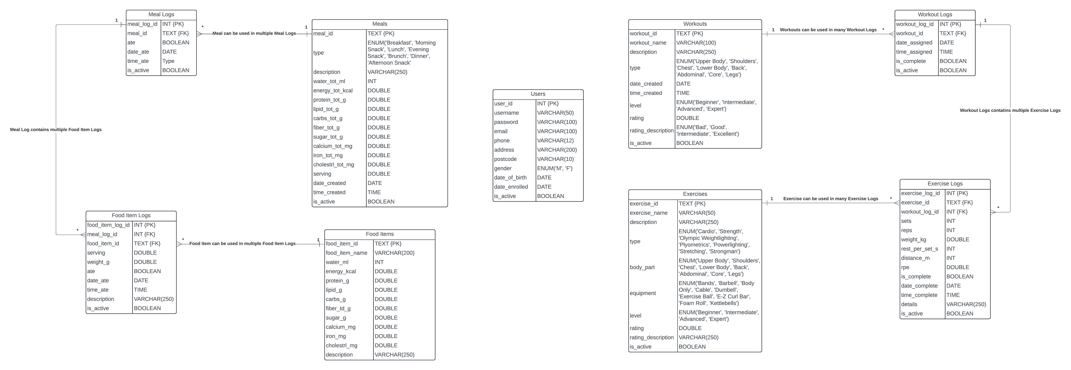

Figure 27: [Central Database Schema.](https://github.com/alisuhail-amanu2/AFNT/blob/main/Documents/Design/CentralDB%20Schema.png)

Table 23: Central and Local Database Schema Descriptions.

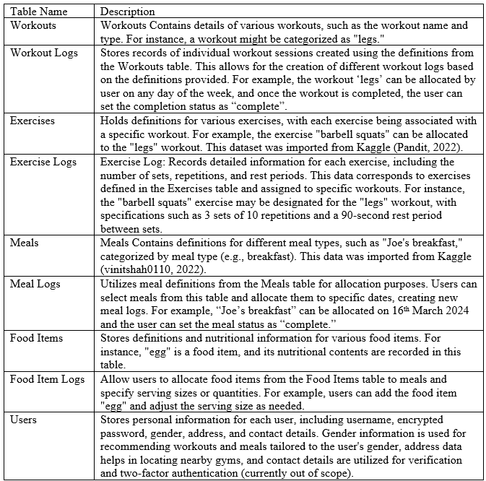

It's important to note that the deletion of any preset meal or workout does not impact existing meal or workout logs. Rather than removing the record entirely from the database, the system updates the "is_active" column of the record to 0, indicating that it is no longer active. As a result, users will no longer be able to view or access this record, but the associated logs will remain intact in the database.

### Local Database

Phase 1.5 expands the Database design by introducing the Local Database (LDB), dedicated to storing user-specific workout, meal, and body statistics data. Unlike the Central Database (CDB), LDB stores data locally, accessible only to the respective user. Utilizing SQLite, LDB comprehensively captures all user-related information, ensuring privacy and security.

Upon user login, any updates made in the Central Database are seamlessly synchronized with LDB, ensuring that users have access to the latest predefined meals and workout data. However, these updates do not impact user-specific custom workouts and meals, preserving their integrity. Even past user entries remain unaffected by CDB updates.

Furthermore, while both CDB and LDB share the same schema for fundamental components such as users, workouts, exercises, meals, and food items, LDB includes additional tables specifically tailored for collecting and managing body data. These tables will be elaborated in this section.

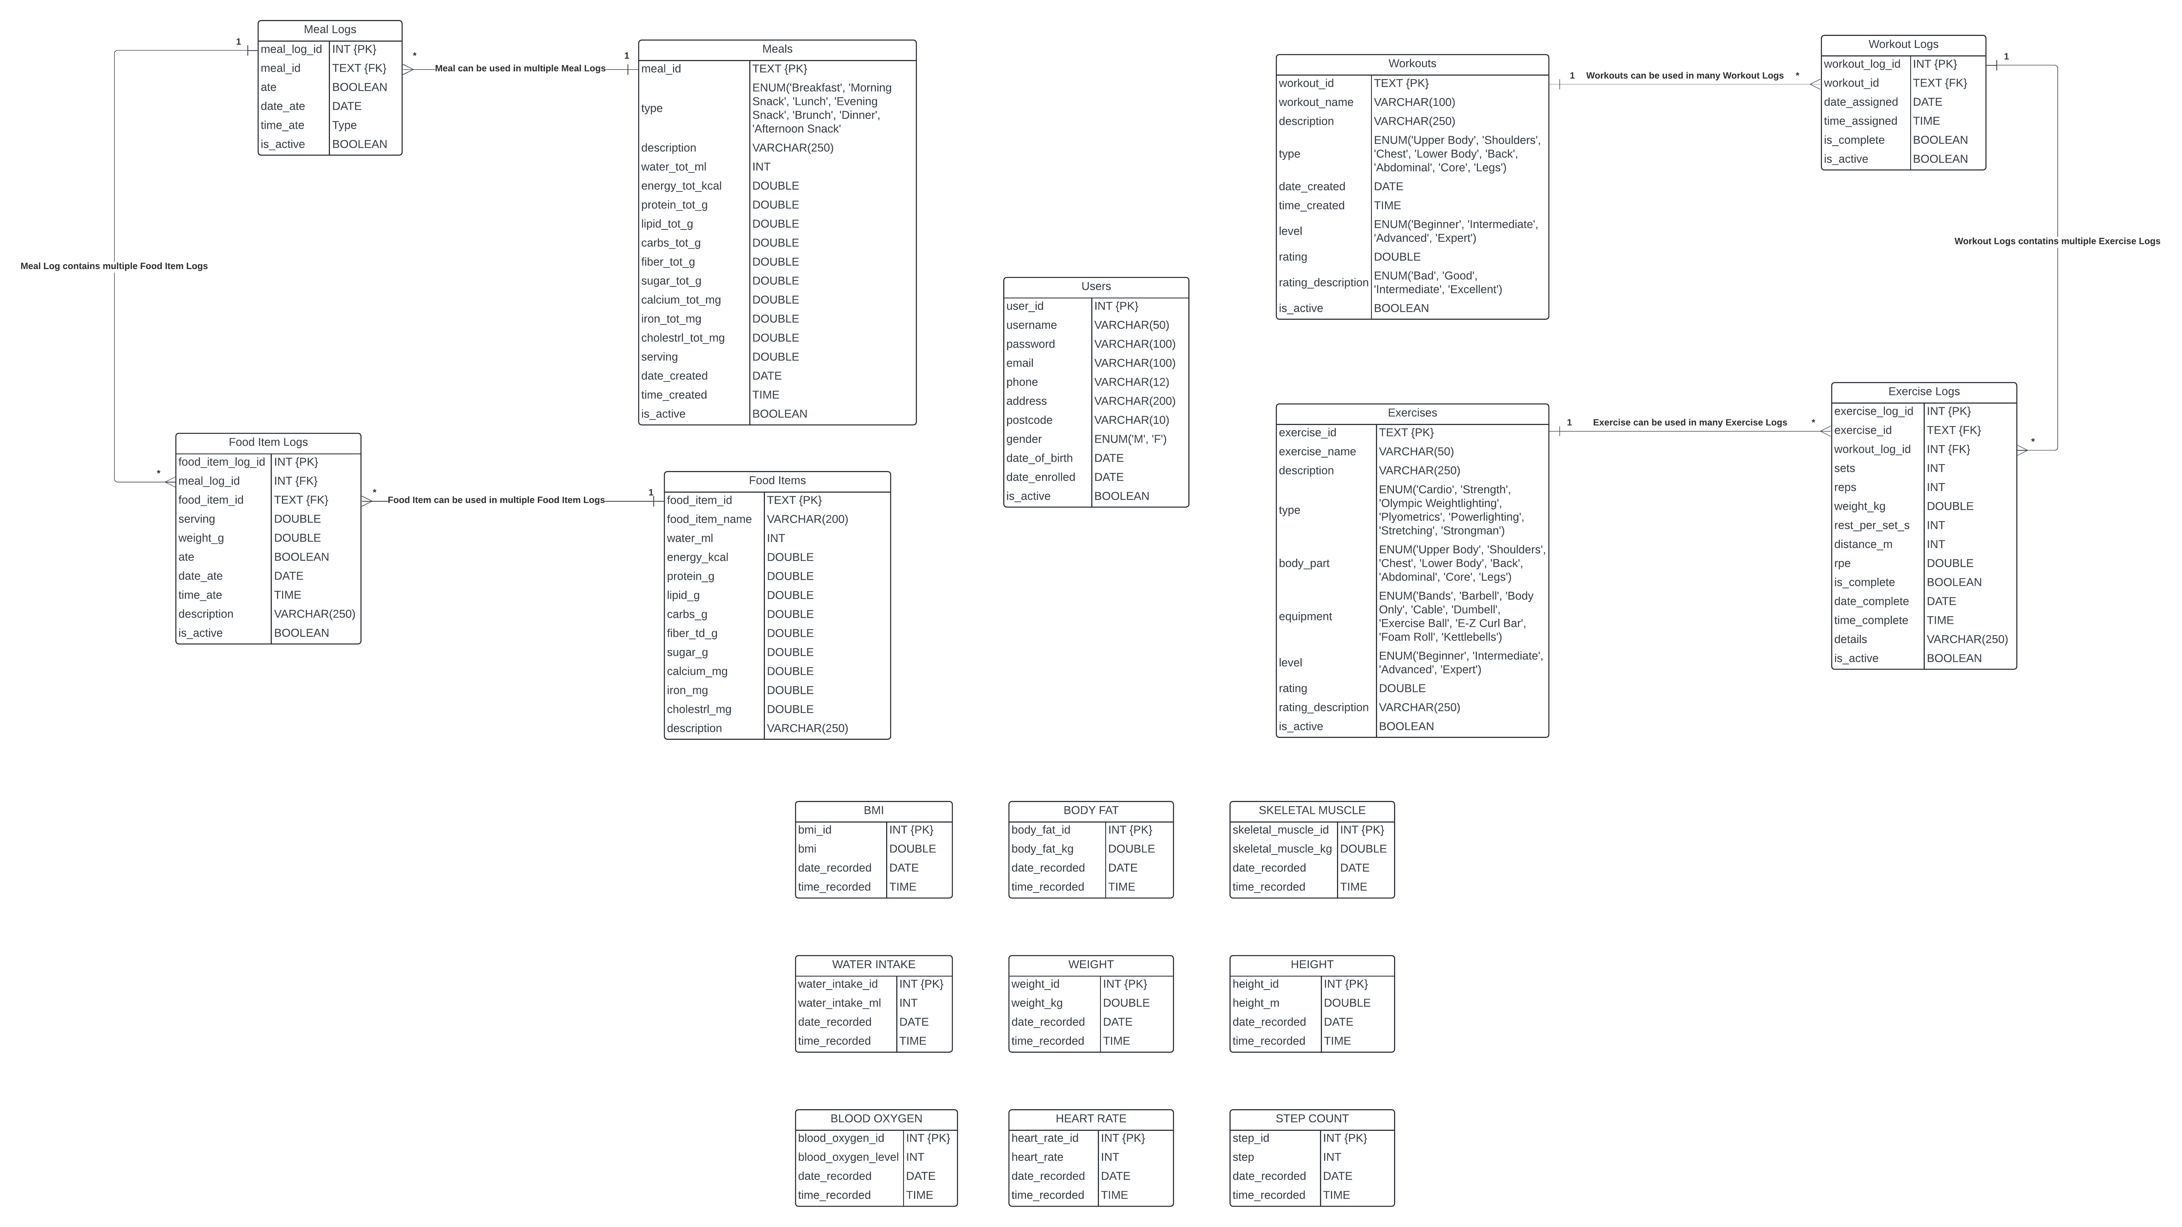

Figure 28: [Local Database Schema.](https://github.com/alisuhail-amanu2/AFNT/blob/main/Documents/Design/LocalDB%20Schema.png)

Table 24: Local Database Schema Descriptions.

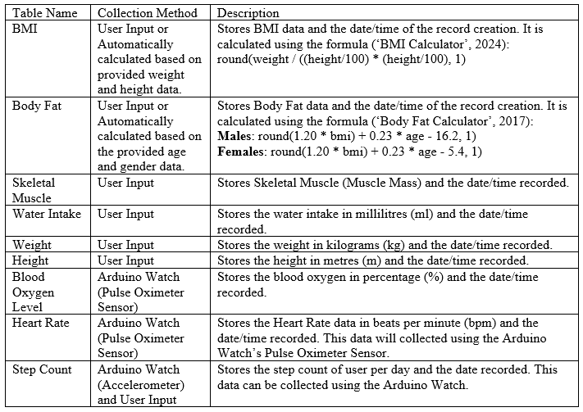

### Servers

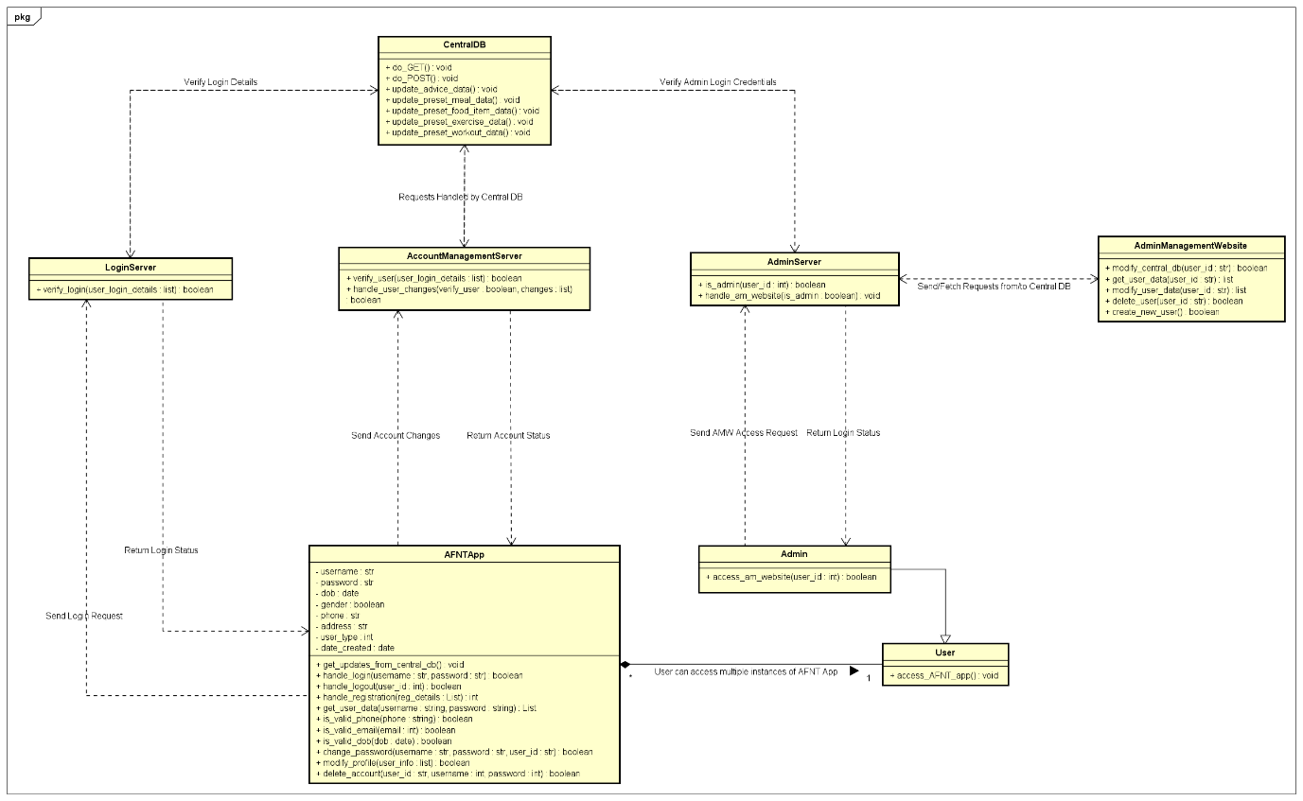

Figure 29: [Central Database and Admin Website Class Diagram.](https://github.com/alisuhail-amanu2/AFNT/blob/main/Documents/Design/AFNT%20Diagrams/Class-CentralDB.png)

Table 25: Database Server Descriptions.

|  |  |
| --- | --- |
| **Class** | **Description** |
| LoginServer | Responsible for authenticating user login credentials within the AFNT app. |
| AccountManagementServer | Manages user profile and personal details, facilitating any necessary updates or modifications. |
| AdminManagementServer | Validates admin login credentials and facilitates database changes to the Central Database (CDB). |

## Phase 2: Admin Management Website Design



Figure 30: Admin Management Website Usecase Diagram.

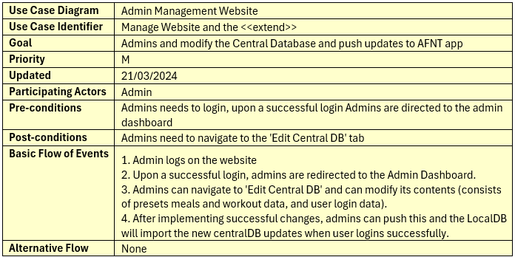

Table 26: Admin Management Website Usecase Description.

Phase 2 introduces the Admin Management Website (AM), which serves as the centralized platform for administering the Central Database (CDB) and facilitating updates to the AFNT application. This web-based interface is exclusively accessible to administrators, empowering them to manage and modify CDB content effectively. To gain access to the AM website, Admins will have to sign in, and the login details will be validated using the Admin Management server that securely communicates with the CDB. After login details are successfully validated, they can access the AM website.

### Admin Management Website Wireframes

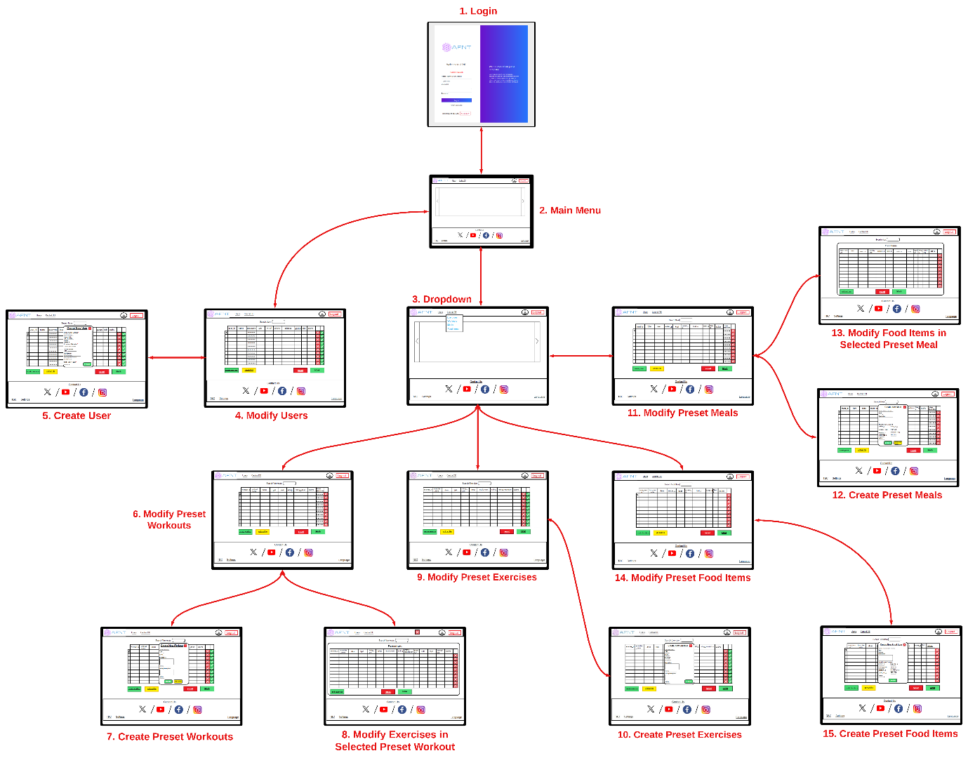

Figure 31: [Admin Management Website Wireframes.](https://github.com/alisuhail-amanu2/AFNT/tree/main/Documents/Design/UI_Sketches/AM_Website)

## Phase 3: AFNT Application Design

Phase 3 of the AFNT project focuses on developing the AFNT application, which aims to provide users with a comprehensive set of features for tracking workouts, managing meals, and monitoring body data. This section will explore three key aspects of the application's design: wireframes exploration, application structure using the Kivy GUI framework, and class definitions.

Wireframes will outline the visual layout and user interface elements, while the application's architecture implemented with Kivy GUI will ensure a dynamic and responsive user experience. Finally, class definitions will encapsulate data and behaviour into reusable components, contributing to the application's functionality and modular design. Together, these components will provide insights into the AFNT application's design and implementation process.

**Workout Data:** Workout data encompasses all workout logs/sessions generated by users, including custom workouts and associated exercise logs. Each workout log is linked to specific exercises defined within custom workouts.

**Meal Data:** Meal data includes all meal logs/sessions created by users, covering custom meals and associated food item logs. Each meal log is associated with specific food items defined within custom meals.

**Body Statistics Data:** Body statistics data captures performance, growth, and progress metrics vital for users to track their fitness goals. Key metrics initially focused on by AFNT include Step Count, BMI, Body Fat, Skeletal Muscle, Heart Rate, and Blood Oxygen Level.

### Application Wireframes

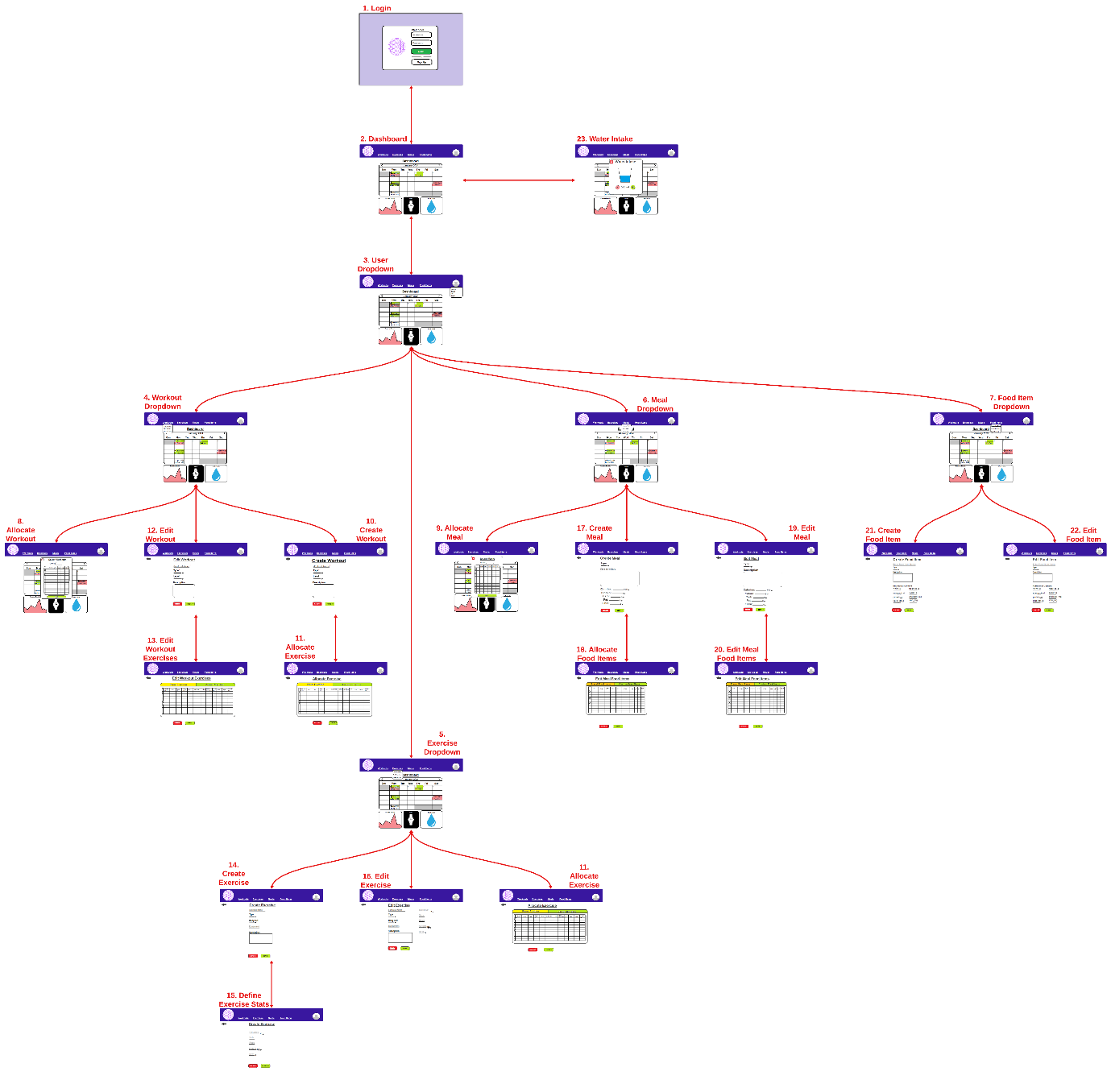

Table 27: [AFNT App Wireframes.](https://github.com/alisuhail-amanu2/AFNT/tree/main/Documents/Design/UI_Sketches/AFNT_Application)

Wireframes played a crucial role in the development of the AFNT application by providing a visual representation of its layout and structure. These skeletal outlines serve as blueprints for the app's user interface, making it easier to conceptualize and refine its functionality before proceeding with the actual development. By outlining the placement of various elements such as buttons, menus, and content sections, wireframes help ensure intuitive navigation and user-friendly interactions. Overall, wireframes are instrumental in streamlining the design process, reducing development time, and helps to ultimately enhance the user experience of the AFNT app.

### Kivy GUI Class Structure

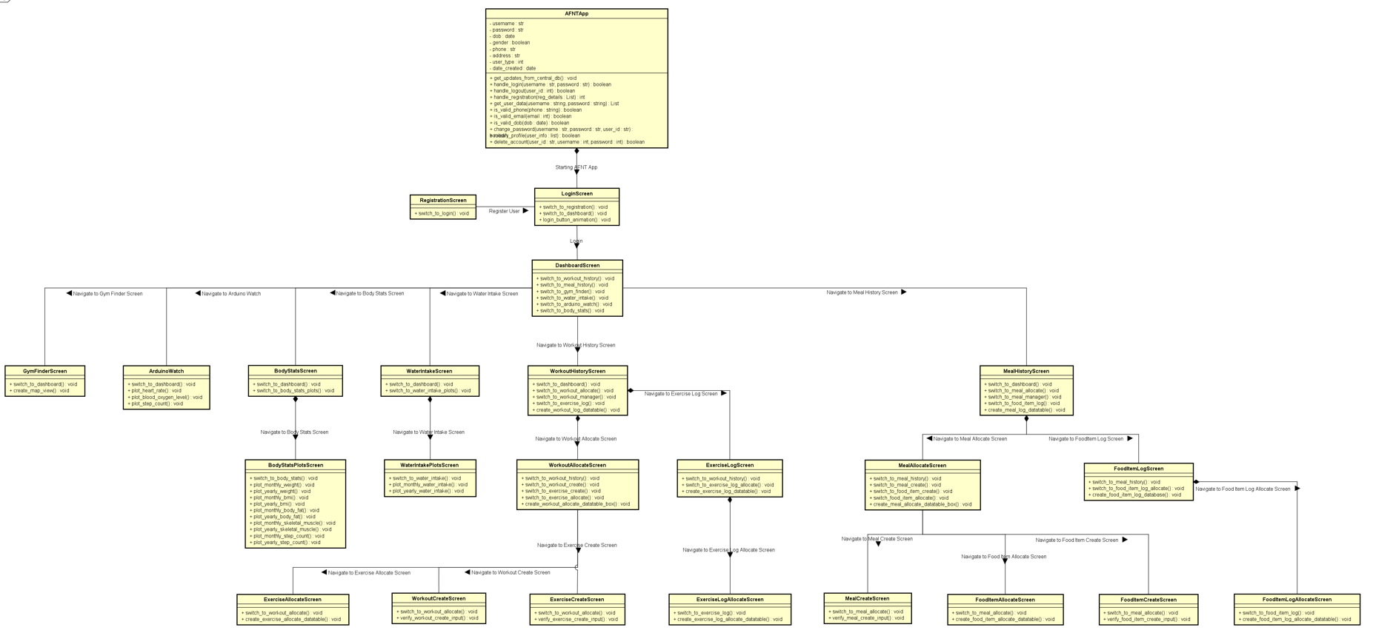

Figure 32: [AFNT GUI Class Diagrams.](https://github.com/alisuhail-amanu2/AFNT/blob/main/Documents/Design/AFNT%20Diagrams/Class-AFNT-Application.png)

Using the wireframes described in ‎5.3.1, a comprehensive class diagram was devised leveraging the Kivy ScreenManager module to craft an intuitive and user-friendly UI coupled with an efficient screen management system. The class diagram encompasses 25 distinct Screen classes, each meticulously designed to execute specific tasks and functionalities, as elucidated in the following tables.

**Note**: The acronym ARMV will signify the ability to Add, Remove, Modify, or View a specific class component within the AFNT framework.

Table 28: AFNT Main Kivy GUI Class Definitions.

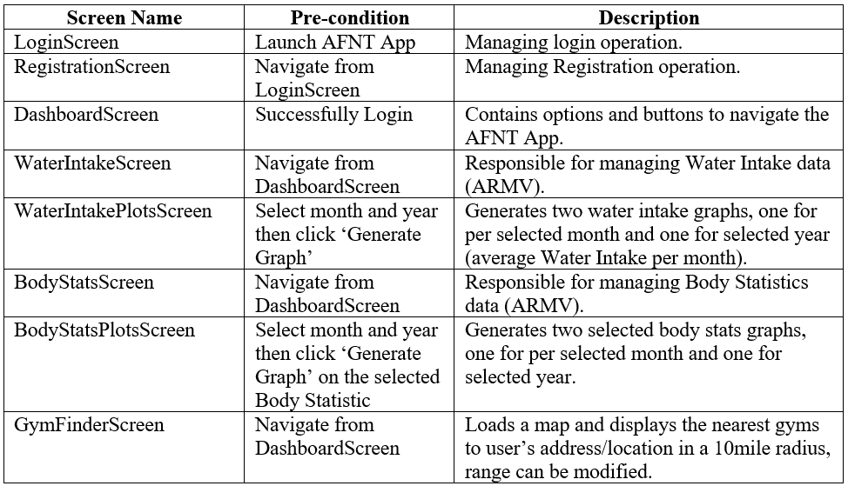

Table 29: AFNT Workouts and Exercises Kivy GUI class definitions.

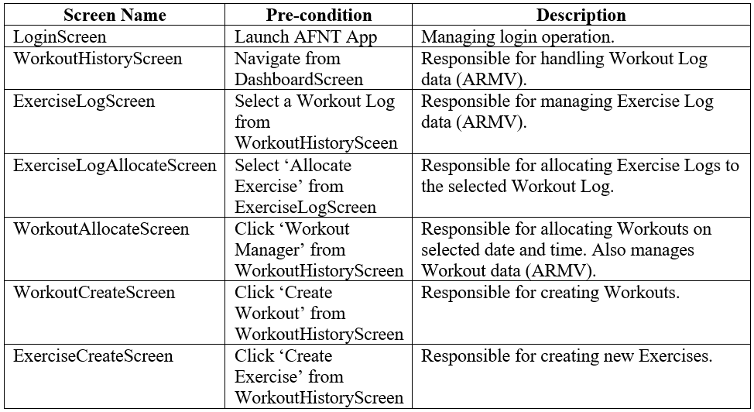

Table 30: AFNT Meals and Food Items Kivy GUI class definitions.

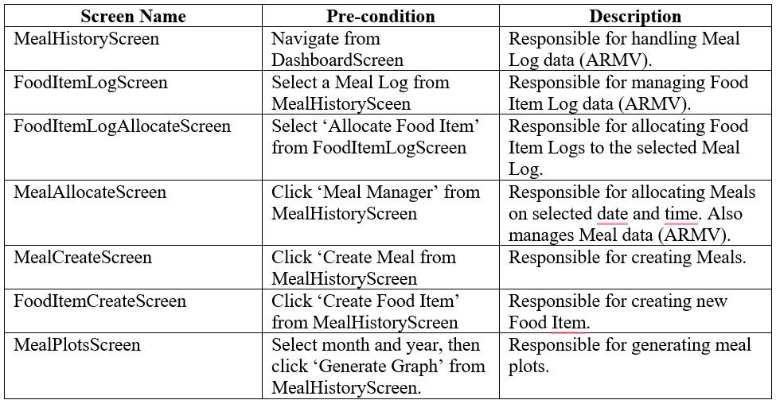

### Class Structure

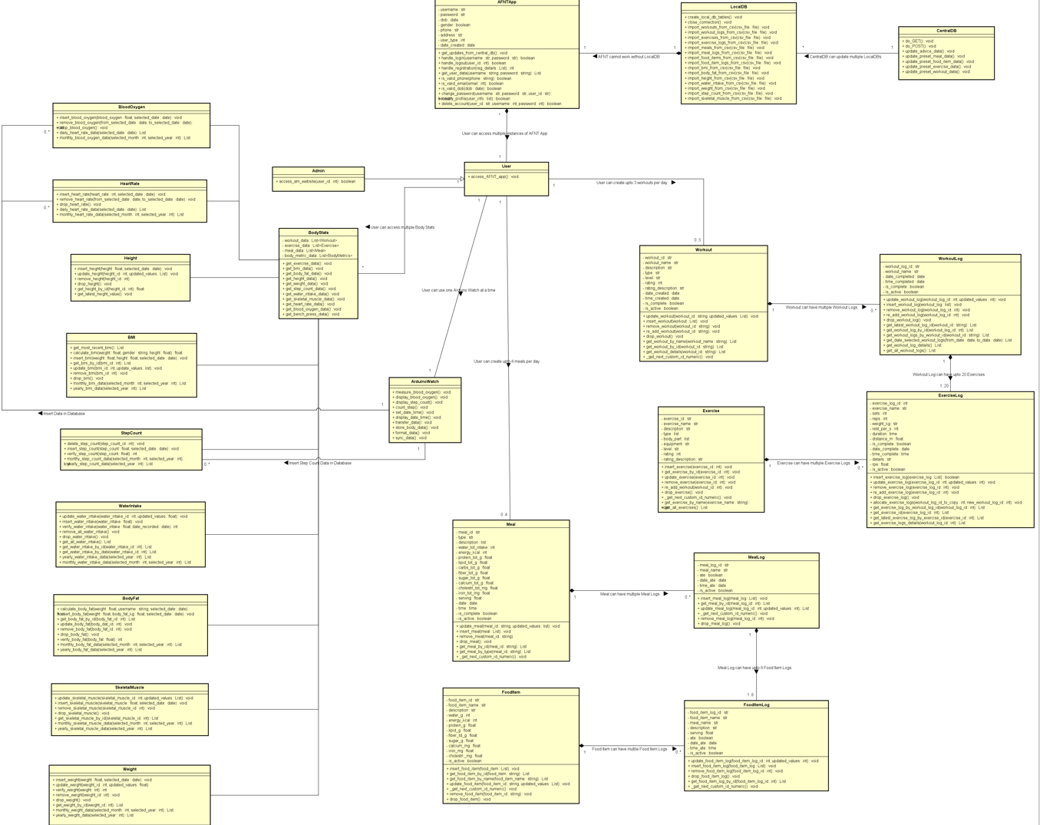

Figure 33: [AFNT Class Diagram.](https://github.com/alisuhail-amanu2/AFNT/blob/main/Documents/Design/AFNT%20Diagrams/Class-AFNT-Application.png)

There are 24 classes dedicated to managing each aspect of the AFNT project. Their descriptions are provided in the below table.

Table 31: AFNT Class descriptions.

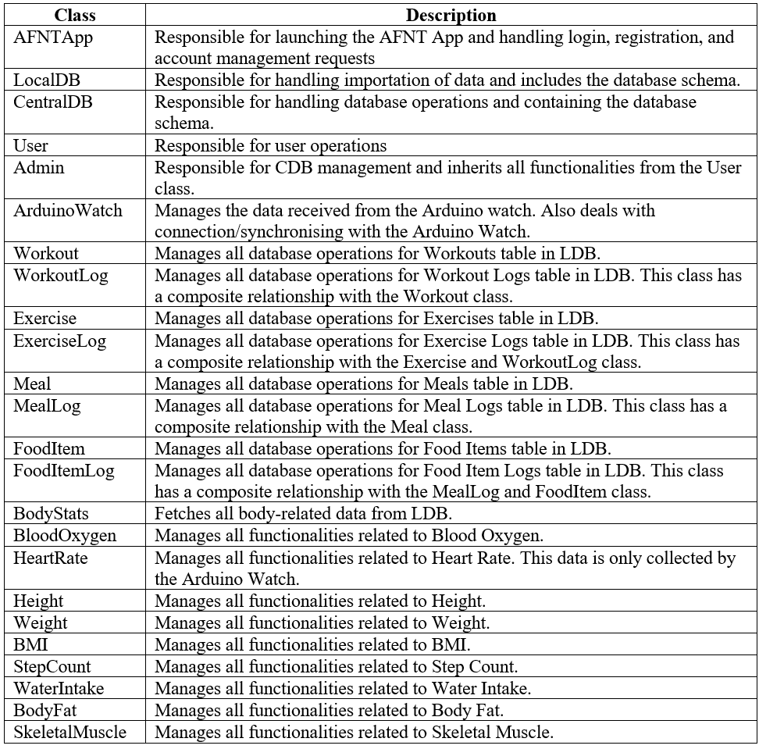

## Phase 4: Arduino Watch Design

Phase 4 expands on Phase 3 with the introduction of the Arduino Watch, capable of monitoring health metrics such as heart rate, blood oxygen level, and step count. The watch can transfer data to the AFNT application via Bluetooth or a wired connection. To understand the functionality of the Arduino Watch, it's important to understand the roles of the TinyDuino and TinyShield components.

### TinyDuino and TinyShield

The TinyDuino Platform is a compact open-source electronics platform based on Arduino technology. It consists of a TinyDuino processor board and TinyShields, which add functionalities like sensors, communications, and displays. These boards stack together using 32-pin connectors without soldering, creating a customizable stack for various projects. The TinyDuino Processor Board, similar to an Arduino Uno but much smaller, uses the Atmel Atmega328P microcontroller and supports 14 digital I/O pins (6 PWM) and 6 analogue inputs. The main difference is the TinyDuino's use of an 8MHz ceramic resonator instead of 16MHz, allowing operation down to 2.7 Volts, ideal for battery-powered applications (‘TinyDuino Overview’, 2024). Each TinyDuino module is designed to include essential circuitry for specific functions, optimizing size and cost.

The Arduino Watch is composed of 8 modular electronic components based on the TinyDuino platform, which can be connected together like LEGO bricks. These modular components were selected for their compact size and portability, unlike larger standard Arduino boards and components that require soldering. Although these smaller modular components are more expensive, they save significant assembly and configuration time. This section will provide detailed descriptions of each modular component used in the Arduino Watch, along with their technical capabilities and schematics

Table 32: Arduino Watch Modular Electronic Components.

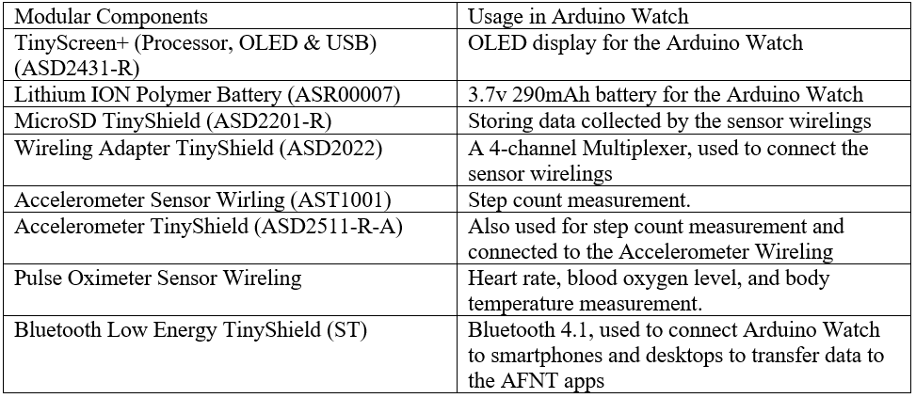

### TinyScreen+ OLED Screen

The OLED screen used for the Arduino Watch measures 0.96 inches diagonally and has a resolution of 96x64 RGB pixels, capable of displaying 16-bit colour with vivid brightness and excellent colour reproduction, thanks to its OLED technology which eliminates the need for a backlight. Alongside the screen, there are four buttons positioned on the side to facilitate user input. The OLED display is driven by an SSD1331 driver, ensuring efficient and effective rendering of graphics and text on the screen (‘TinyScreen | TinyScreen’, 2024).

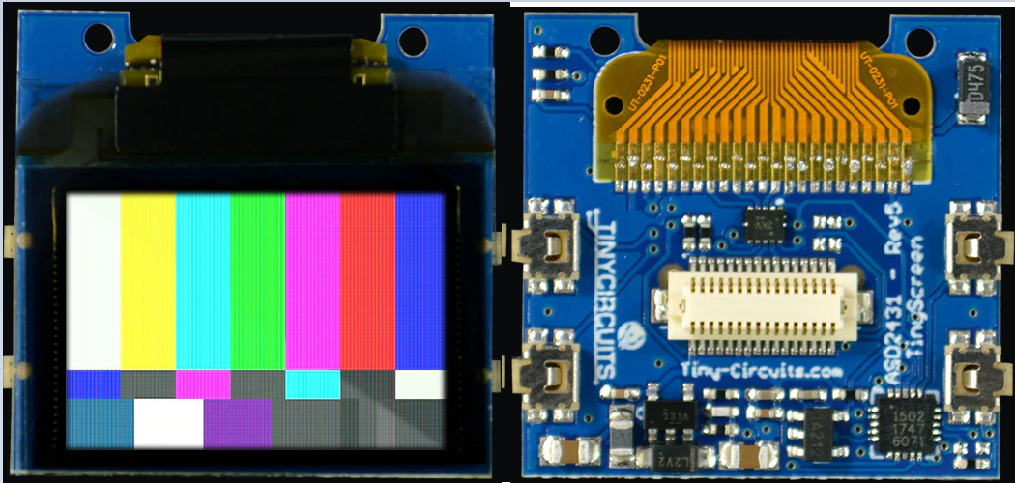

Figure 34: TinyScreen+ OLED (ASD2431-R).

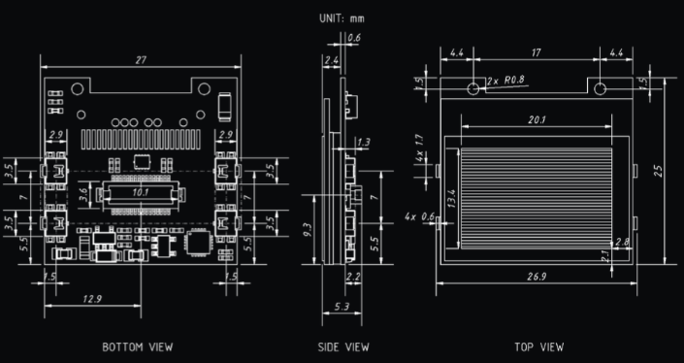

Figure 35: TinyScreen+ Dimensions.

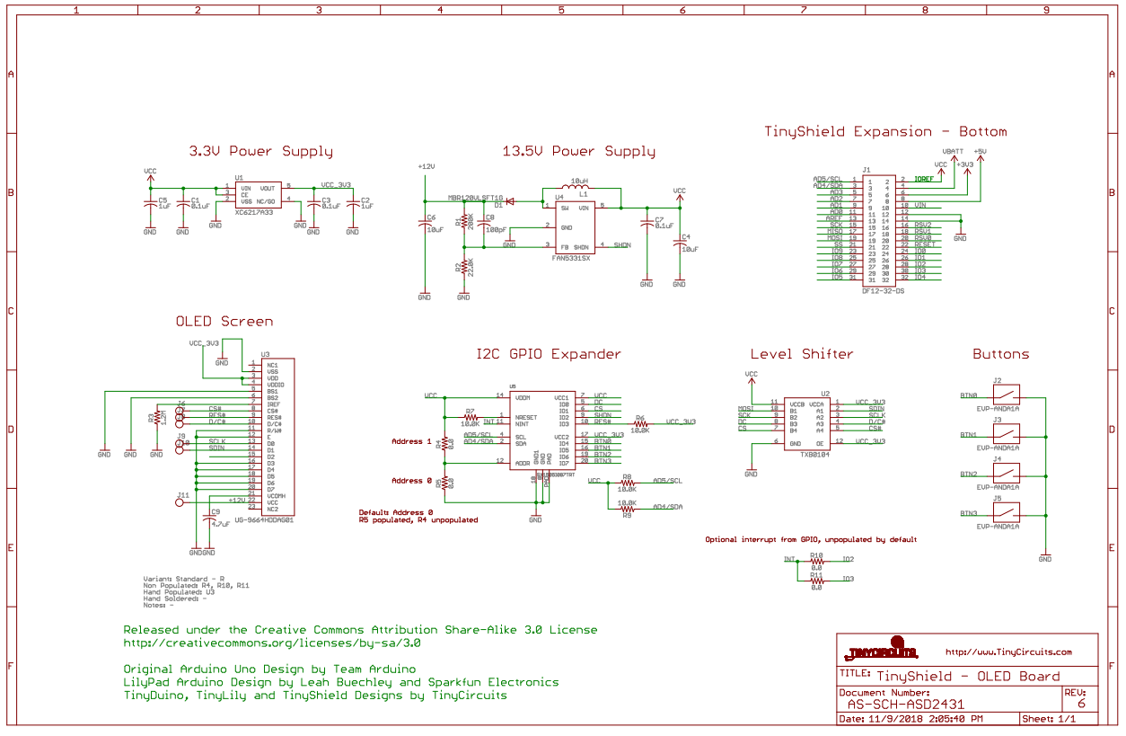

Figure 36: TinyScreen+ Schematic.

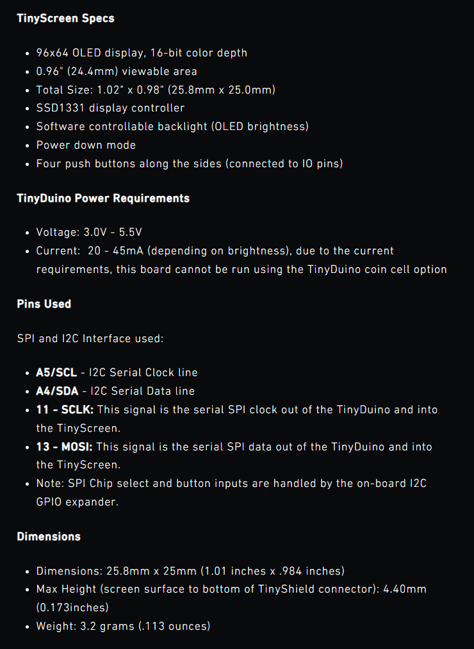

Figure 37: TinyScreen+ Specs.

### Lithium Ion Polymer Battery

This rechargeable lithium-ion polymer (LiPo) battery making it suitable for the Arduino Watch. It has a capacity of 290mAh at 3.7V, with a voltage range from 4.2V when fully charged to 3.0V when fully discharged. The battery is equipped with protection circuitry to prevent overcharging or deep discharge, enhancing safety and longevity (‘TinyCircuits | Lithium Ion Battery’, 2024).

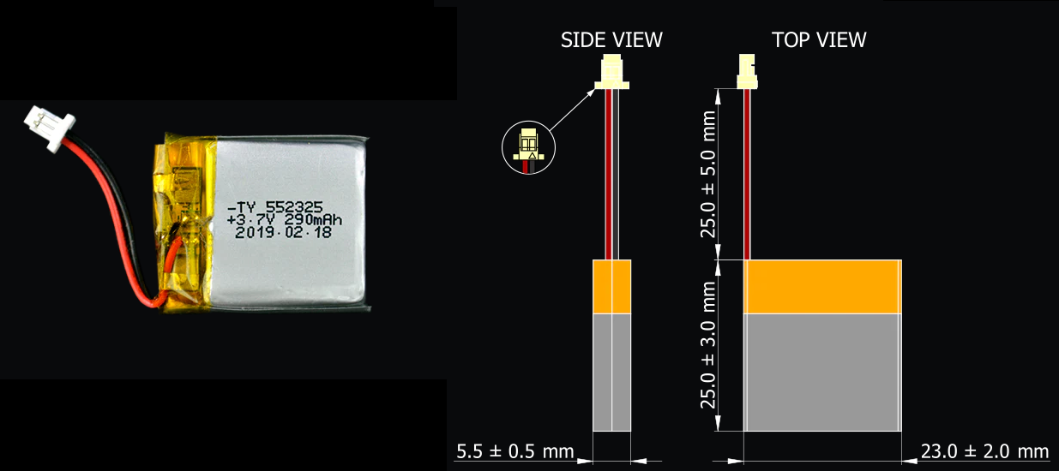

Figure 38: Lithium ION Battery (ASR00007) Dimensions.

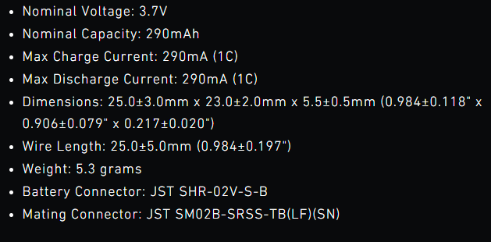

Figure 39: Lithium ION Battery Specs.

### MicroSD TinyShield

The TinyShield microSD Adapter enables the Arduino Watch to capture sensor data and save it onto a microSD card. Users can access this data by connecting the microSD card to the TinyDuino. The adapter is compatible with SD card support libraries available within the Arduino Software environment. The Arduino Watch will be using a 64GB microSD card.

This TinyShield includes level shifters and a local power supply, ensuring reliable and safe operation across the entire TinyDuino operating voltage range, up to 5V (‘TinyCircuits | MicroSD’, 2024).

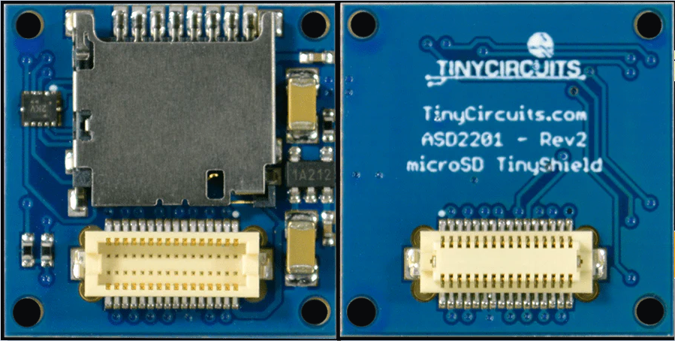

Figure 40: MicroSD TinyShield (ASD2201-R).

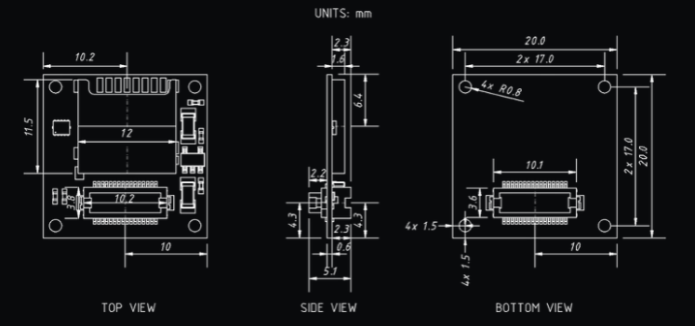

Figure 41: MicroSD TinyShield Dimensions.

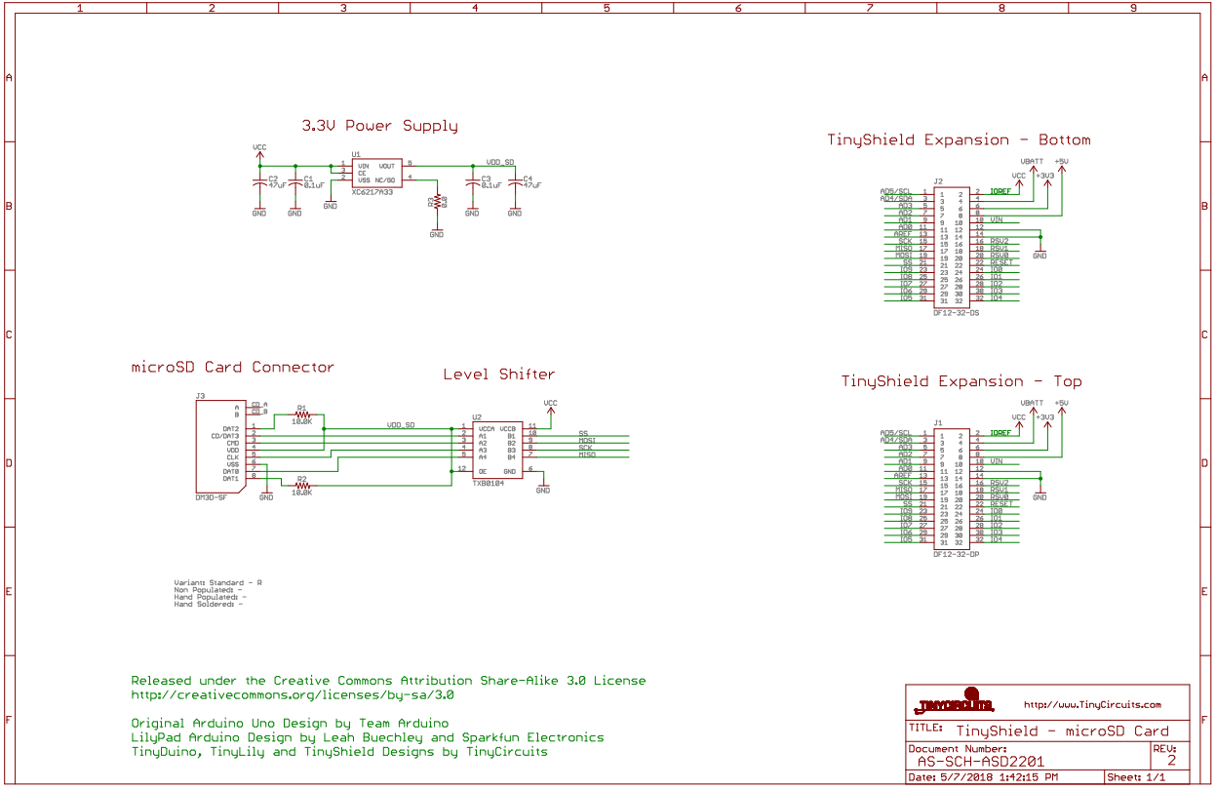

Figure 42: MicroSD TinyShield Schematic.

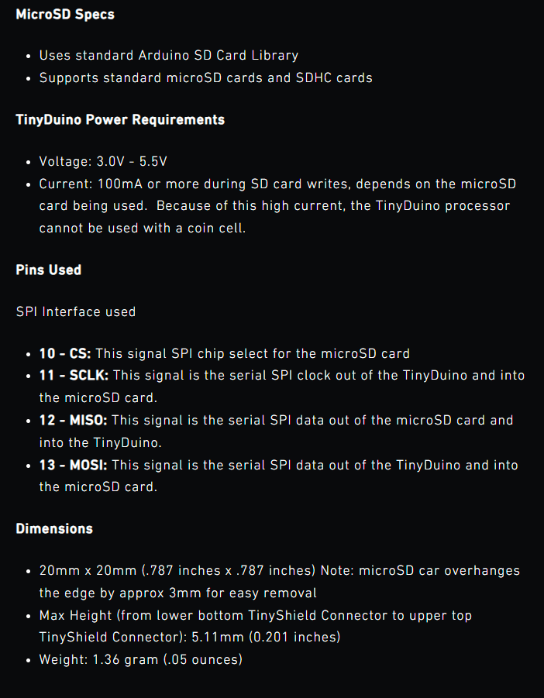

Figure 43: microSD TinyShield Specs.

### Wireling Adapter TinyShield

The Wireling Adapter TinyShield integrates a 4-channel multiplexer, along with onboard voltage regulation and level shifting capabilities, enabling connection of up to 4 Wirelings per Shield. The multiplexer feature helps to connect multiple I²C devices with the same address without encountering interference issues, which is essential for attaching wirelings such as the pulse oximeter and accelerometer to the TinyDuino (Arduino Watch).

Wireling Adapter TinyShields are designed to work seamlessly with TinyCircuits processors featuring a 32-pin connector (‘TinyCircuits | Wireling Adapter’, 2022).

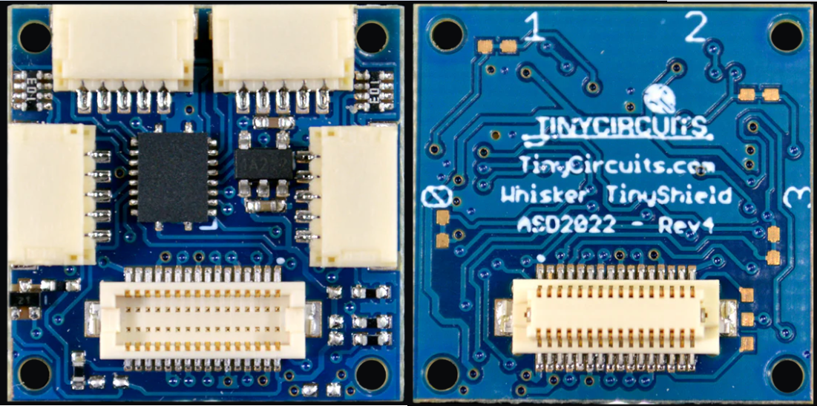

Figure 44: Wireling Adapter TinyShield (ASD2022).

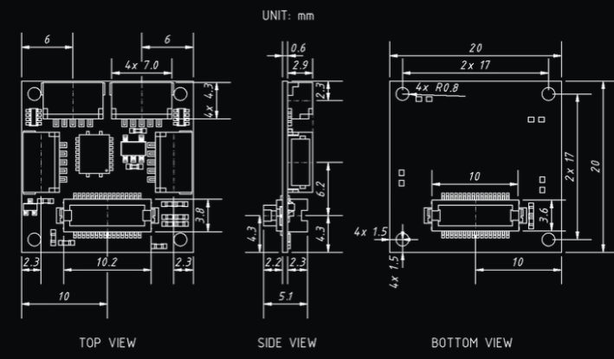

Figure 45: Wireling Adapter Dimensions.

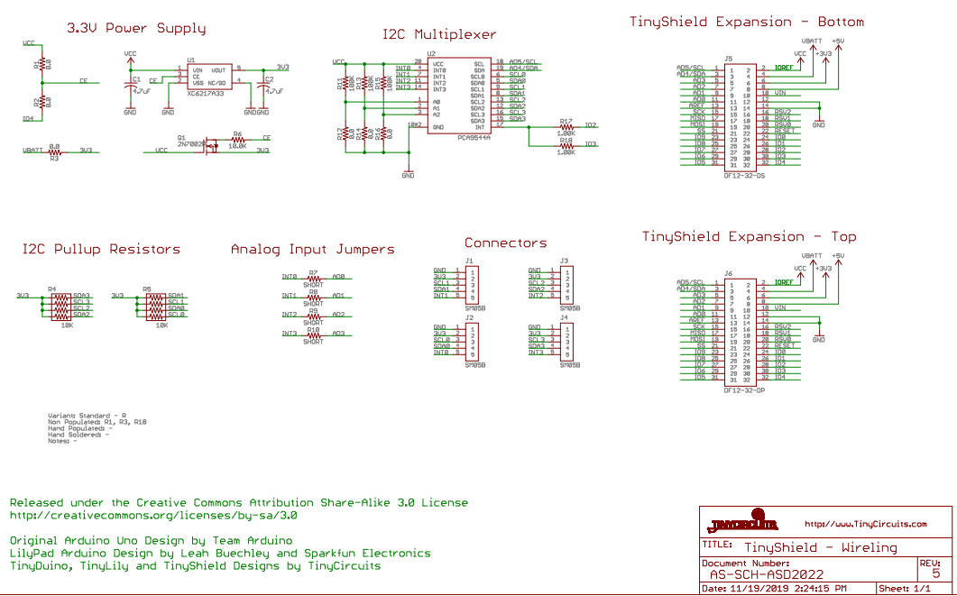

Figure 46: Wireling Adapter Schematic.

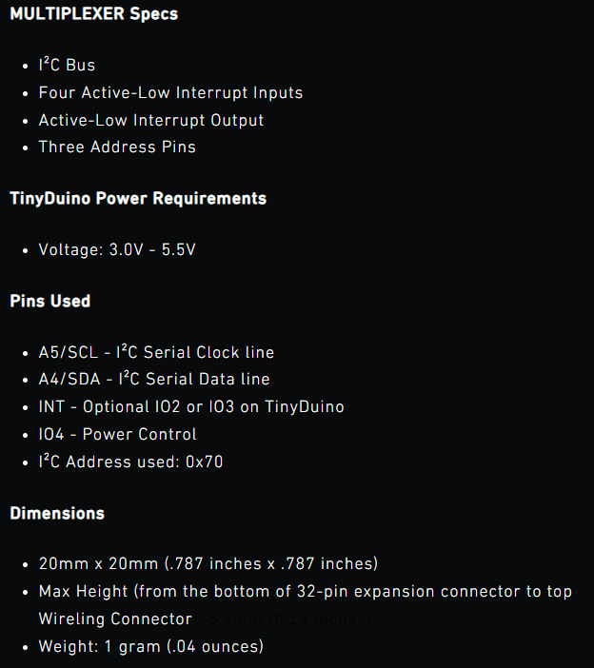

Figure 47: Wireling Adapter TinyShield Specs.

### Accelerometer TinyShield and Sensor Wireling

This TinyShield contains the Bosch BMA250 3-axis accelerometer, known for its high performance and low power consumption. The BMA250 measures accelerations along three perpendicular axes, enabling the detection of tilt, motion, shock, and vibration, which is ideal for step counting in the Arduino Watch. This will be connected to the Arduino Watch via the Wireling Adapter TinyShield, which will be connected to the Accelerometer Wireling.

While the BMA250 is typically designed to operate at 1.8V, the Accelerometer TinyShield includes level shifters and a local power supply to guarantee reliable and safe operation across the entire TinyDuino operating voltage range, up to 5V (‘TinyCircuits | Accelerometer Shield’, 2024).

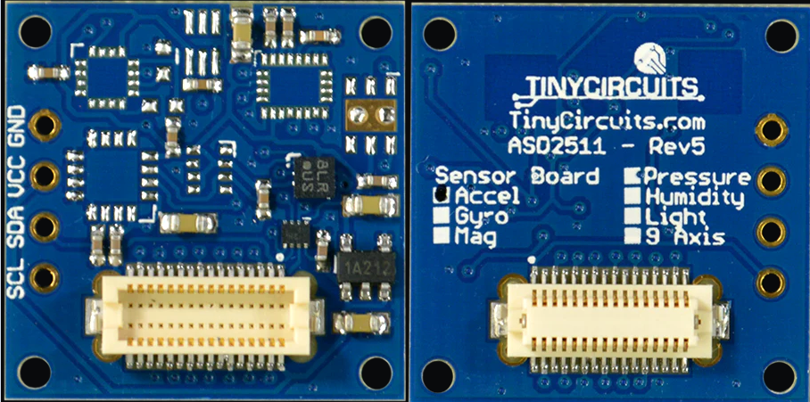

Figure 48: Accelerometer TinyShield (ASD2511-R-A).

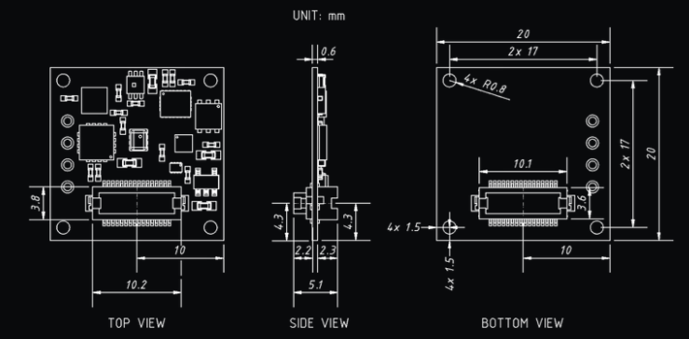

Figure 49: Accelerometer TinyShield Dimensions.

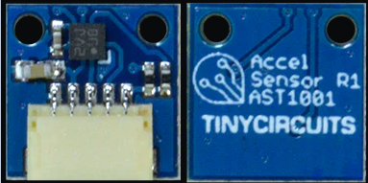

Figure 50: Accelerometer Wireling (AST1001).

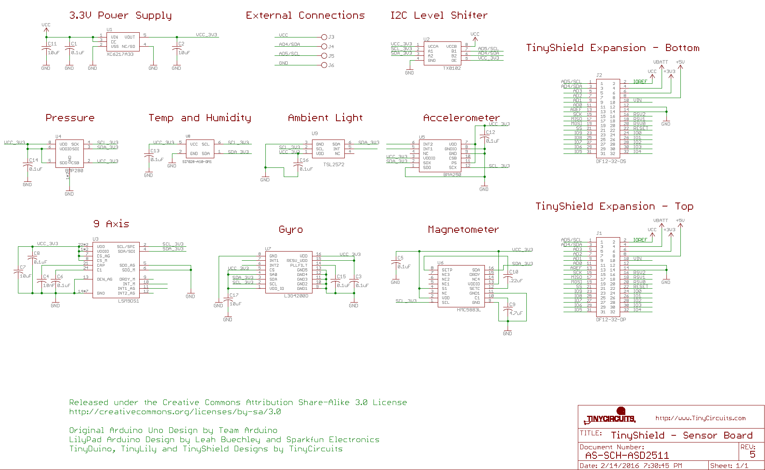

Figure 51: Accelerometer TinyShield Schematic.

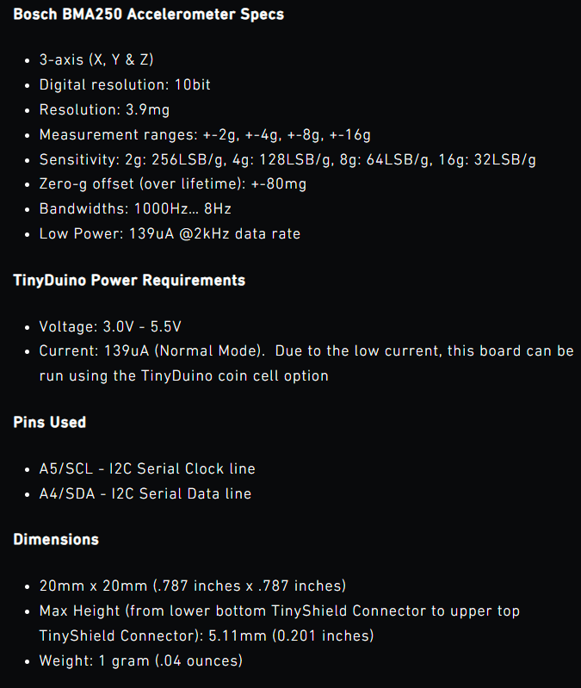

Figure 52: Accelerometer TinyShield Specs.

### Pulse Oximeter Sensor Wireling

This Wireling enables the measurement of heartbeat, blood oxygen saturation level, cardiogram data, and temperature using the MAX30101 pulse sensor. The sensor integrates internal LEDs, photodetectors, optical components, and low-noise electronics (‘TinyShield | Pulse Oximeter Sensor’, 2024). Making it suitable for the Arduino Watch to capture multiple types of physiological data with a single sensor.

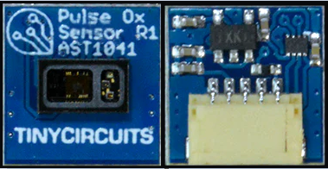

Figure 53: Pulse Oximeter Sensor Wireling (AST1041).

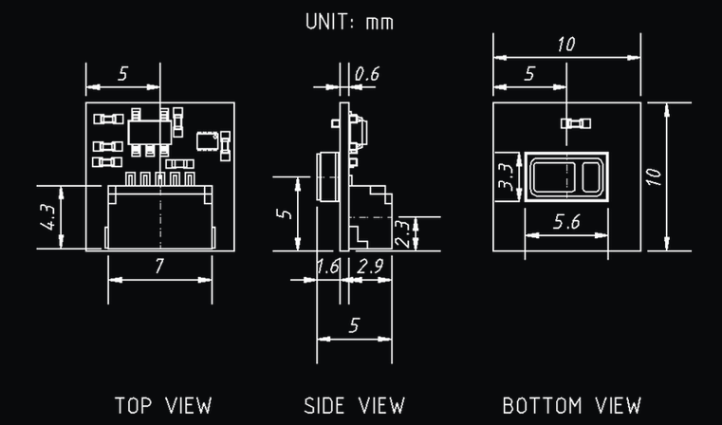

Figure 54: Pulse Oximeter Sensor Wireling Dimensions.

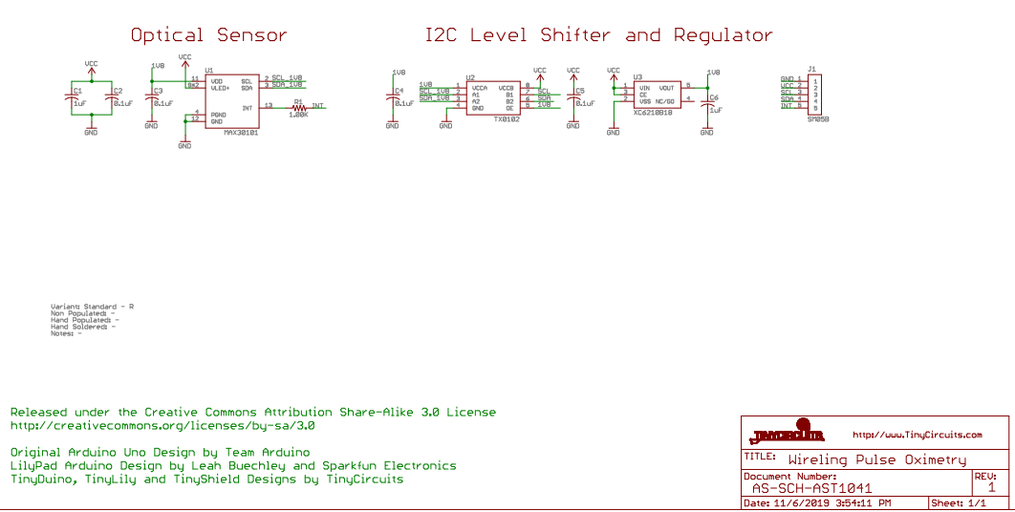

Figure 55: Pulse Oximeter Sensor Wireling Schematic.

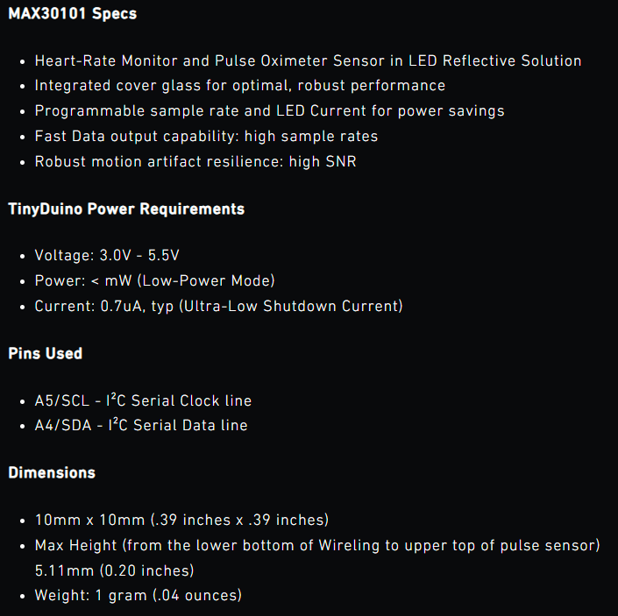

Figure 56: Pulse Oximeter Sensor Wireling Specs.

### Bluetooth Low Energy TinyShield (ST)

The Bluetooth Low Energy (BLE) TinyShield combines master and slave modes into a single module. It enables the TinyDuino (Arduino Watch) system to connect with compatible iOS or Android devices using BLE, also known as Bluetooth 4.1. This technology is particularly advantageous for the watch, facilitating connectivity with low-power sensors and accessories to most modern smartphones.

The SPBTLE-RF0 module within BLE supports both master and slave modes, allowing the Arduino Watch to communicate with both BLE devices (i.e. smartphones) and other BLE modules or TinyShields operating in slave mode (‘TinyCircuits | Bluetooth Low Energy Shield (ST)’, 2024).

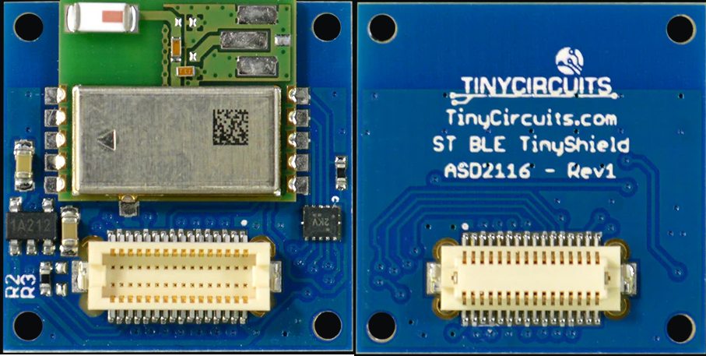

Figure 57: Bluetooth Low Energy TinyShield (ASD2116).

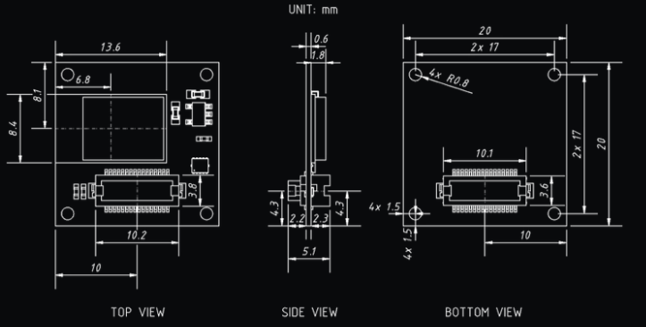

Figure 58: Bluetooth Low Energy TinyShield Dimensions.

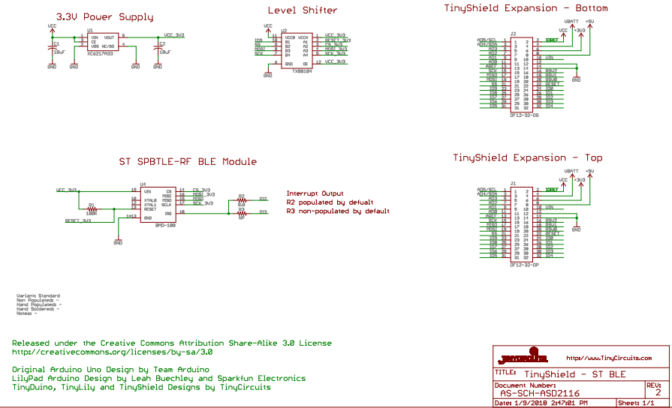

Figure 59: Bluetooth Low Energy TinyShield Schematic.

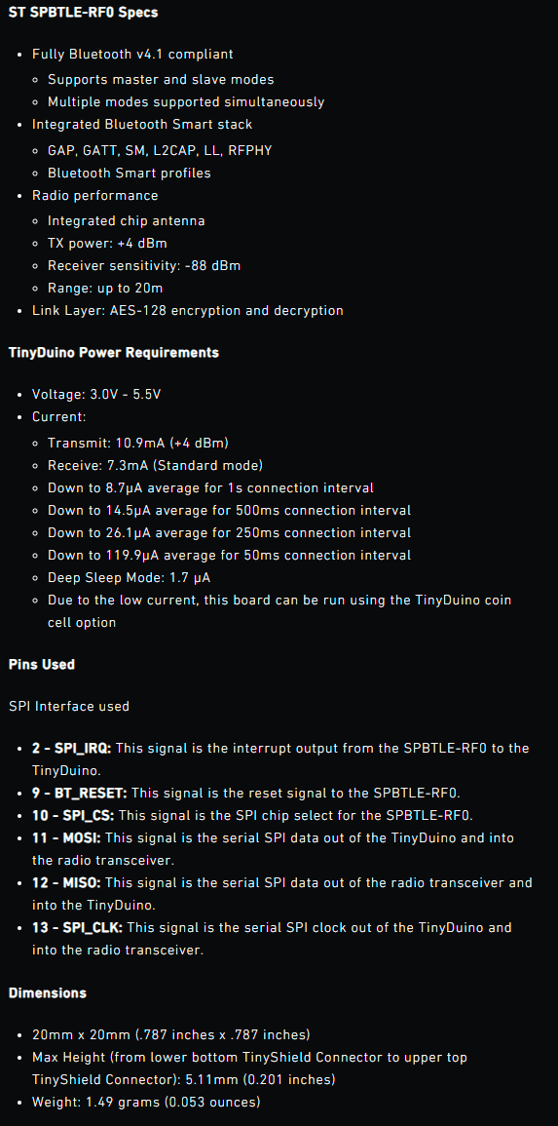

Figure 60: Bluetooth Low Energy TinyShield Specs.

### Arduino Watch Modular Component Stack

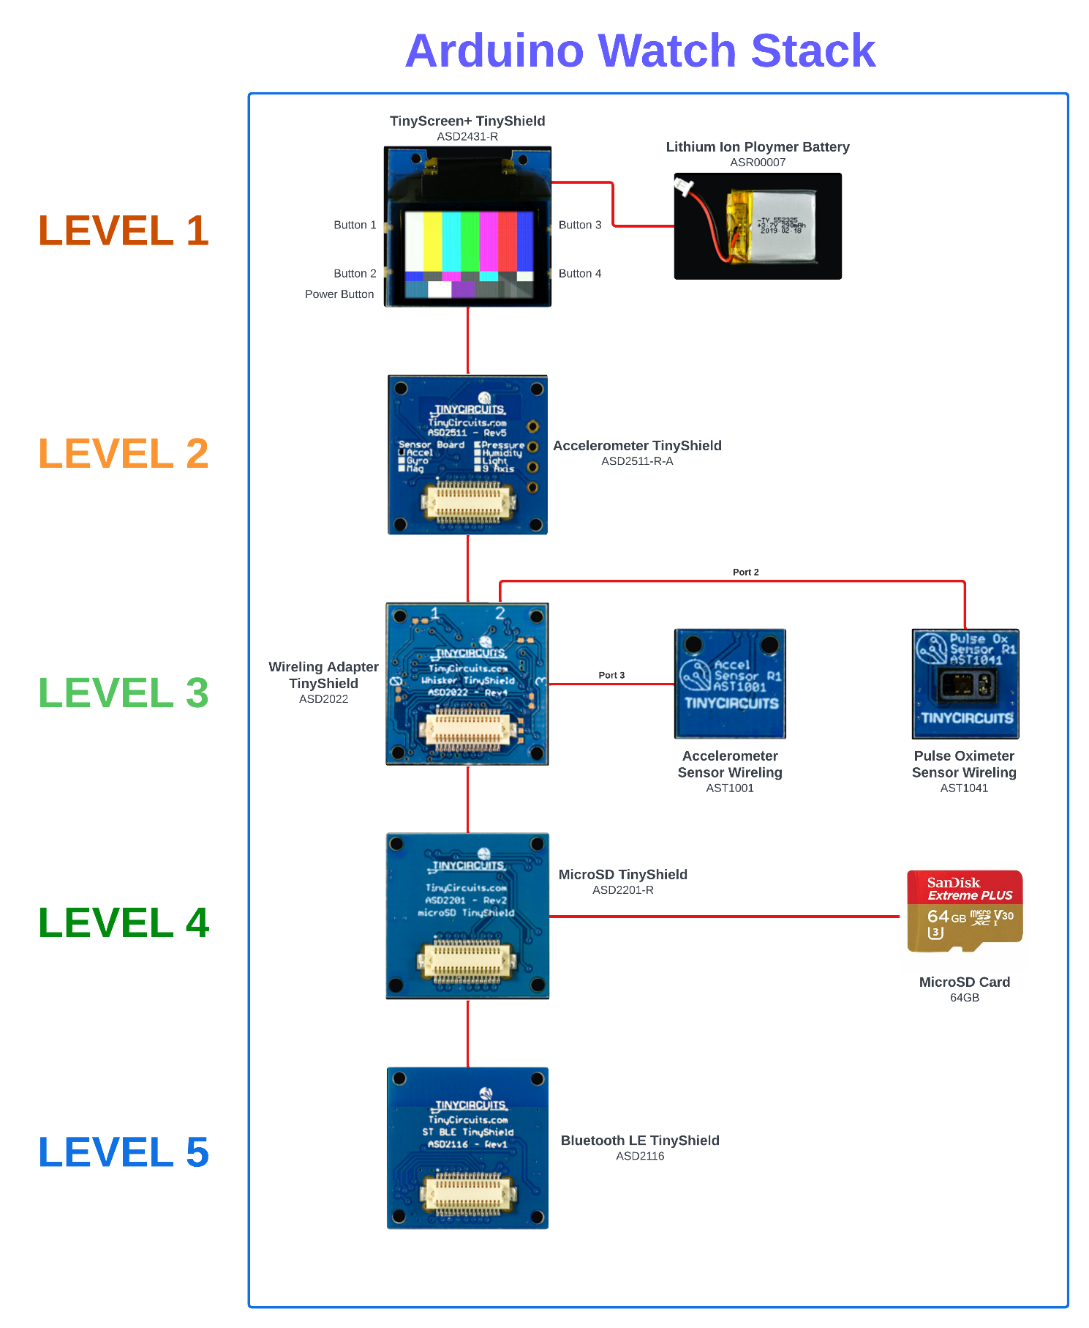

Figure 61: Arduino Watch Modular Component Stack diagram.

In this chapter, we have explored the comprehensive design process of the AFNT project, spanning from database design to hardware integration for the Arduino Watch. Each phase plays a crucial role in enhancing the functionality and user experience of the AFNT system. By analyzing the design details such as database schema, website wireframes, application structure, and selection of modular components, this chapter establishes a solid foundation for the upcoming development and implementation stages discussed further in Chapter ‎‎6. The detailed documentation and design files provided for each phase offer valuable insights and guidance for the project's implementation.

# Implementation

This chapter provides an overview of the implementation progress of the AFNT project across its four key phases. Each phase is discussed individually, detailing the technologies used and the extent of implementation achieved.

In terms of progress, Phase 1 has been predominantly implemented, with over 90% completion, focusing on database design and setup. Phase 3 and Phase 4 follow closely behind, with approximately 70% of their functionalities implemented, particularly in developing the AFNT application and integrating the Arduino Watch hardware. Phase 2, however, experienced minimal development due to time constraints and lower priority within the project's timeline. This chapter will delve into the specifics of each phase's implementation status and the technologies employed to complete AFNT project objectives and requirements.

## Phase 1: DBMS Implementation

### Central Database

The CDB serves as the repository for predefined workouts, meals, and user credentials, enabling secure login and access to AFNT user data. The CDB is implemented using MySQL Workbench due to its reliable performance, scalability, and robust data management capabilities, essential for handling critical user information securely. Its security features, including encryption options and user access controls, provide necessary protection for sensitive data stored in the database (‘SQL Server | Microsoft’, 2022).

Currently, only the `users` table is actively used in the CDB, with Phase 2 development remaining largely incomplete due to time constraints. Below are the examples of how the CDB tables were implemented.

Figure 120: Create exercises table (CDB).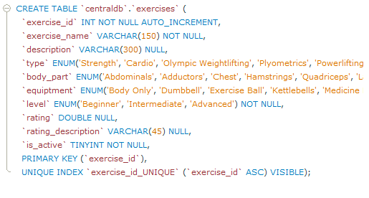

Figure 120: Create exercises table (CDB).

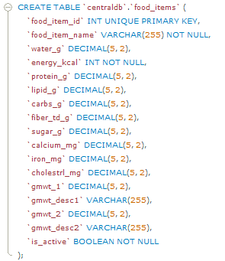

Figure 124: Create food items table (CDB).

To view how all CDB tables were created, navigate to Appendix B: Creating Central Database.

For data, the food items and exercises datasets sourced from Kaggle serve as test samples. The exercises dataset contains nearly 3000 records (Pandit, N. 2022), while the food items dataset comprises approximately 8800 records (Vinit S., 2022). This data can populate the meals table and support the creation of both custom and preset workouts, allowing users to personalize their workout and meal data alongside their user profile information.

### Local Database

SQLite was employed to implement the LDB in Phase 1.5 of the project. This choice was made to ensure data privacy, as SQLite stores data locally on the device rather than on a server, enhancing security.

The localDB schema includes tables for exercises, workouts, food items, meals, and body statistics, enabling comprehensive data management for user-specific information. Despite its advantages, SQLite has limitations, particularly in its lack of support for certain data types compared to more robust database systems. However, for the scope of this project, SQLite serves as an effective and efficient solution for managing local data storage and retrieval. The creation of specific tables within the localDB demonstrates the structured approach to organizing fitness and nutrition-related data for the AFNT application.

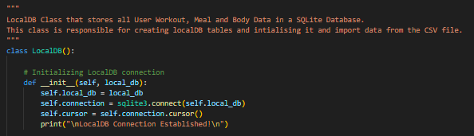

Figure 62: Initialization and connection to the LDB.

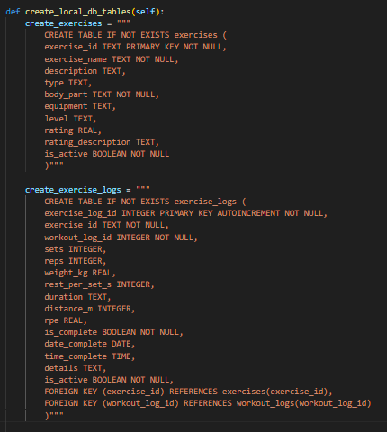

Figure 63: Create exercise tables (LDB).

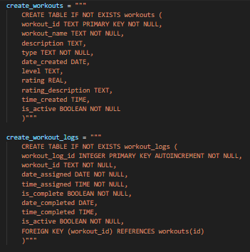

Figure 64: Create workout tables (LDB).

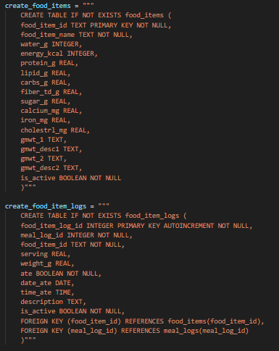

Figure 65: Create food item tables (LDB).

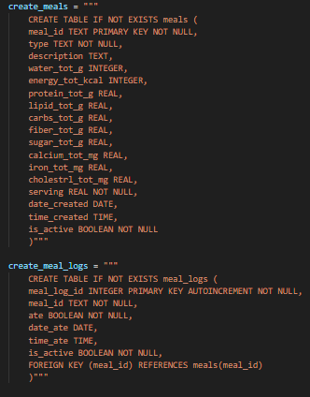

Figure 66: Create meal tables (LDB).

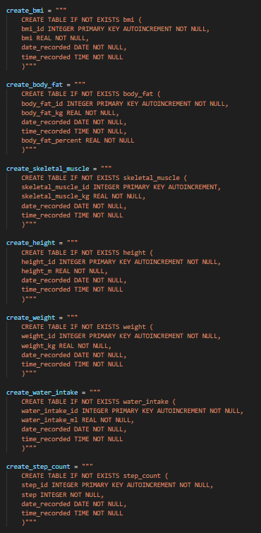

Figure 67: Create body statistic tables (LDB).

The LDB similarly utilizes the exercises and food items datasets sourced from Kaggle, enabling administrators and users to generate and adjust preset workouts and meals as needed.

## Phase 2: Admin Management Website Implementation

Phase 2 entails building the AMWebsite, a crucial component for database administration in the AFNT project. This phase centres on creating a secure and user-friendly interface to manage user credentials, workouts, meals, and other data stored in the CDB server.

Due to time constraints and delays associated with other university projects, along with its lower priority, phase 2 of the project was postponed to prioritize critical aspects. As of now, only the website login screen and authentication via a login server have been completed. Phase 2 employs Python Flask for both backend and frontend development, chosen for its simplicity and widespread adoption in the industry (‘Flask Documentation’, 2024). Abundant online resources are available to facilitate its effective implementation.

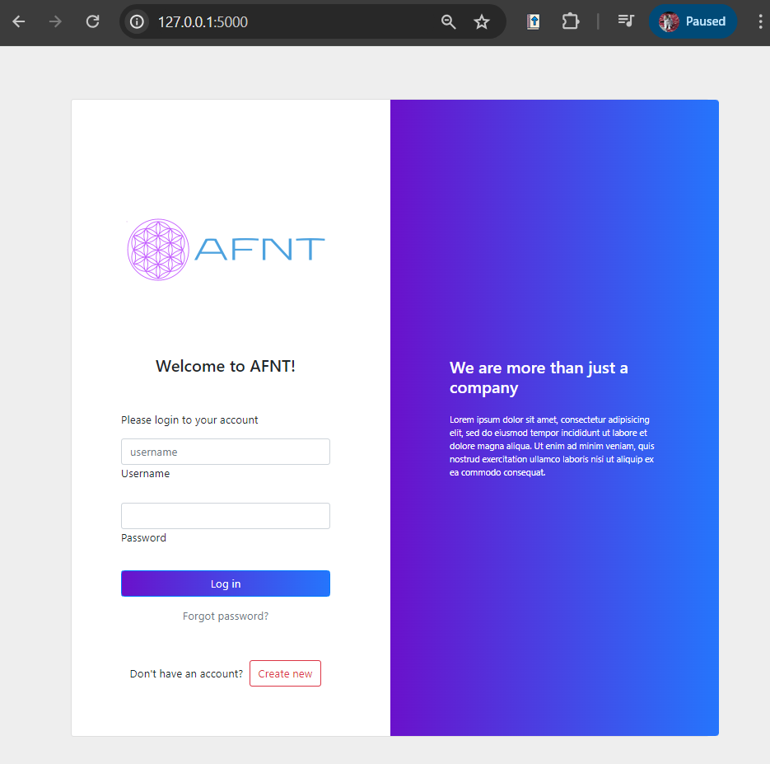

Figure 68: AM Website Login Screen.

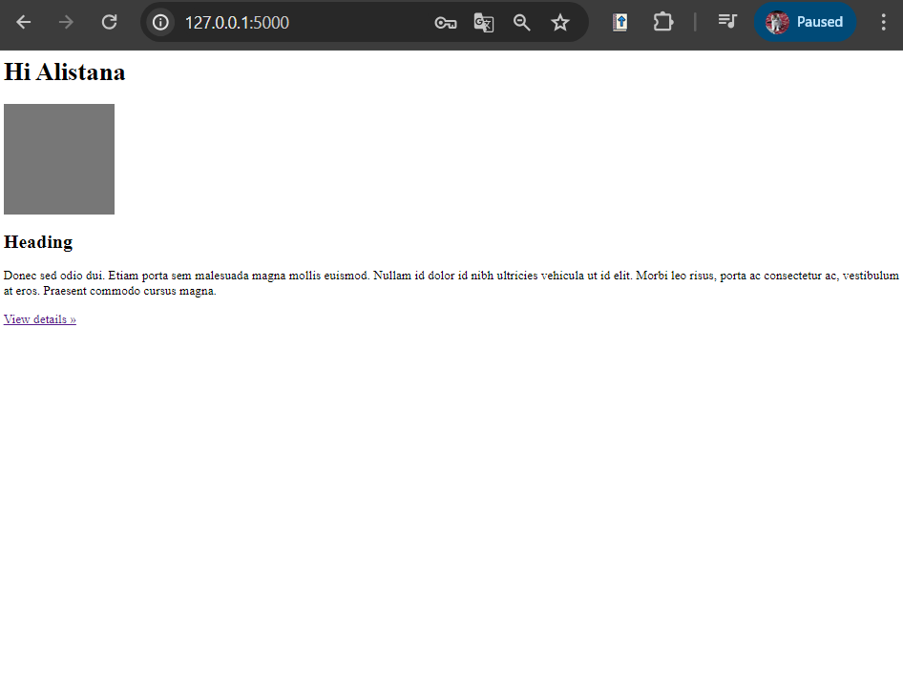

Figure 69: AM Website Login Success Screen (Dashboard).

## Phase 3: AFNT Application Implementation

In developing the AFNT application and Graphical User Interface (GUI), Python programming language and the Kivy GUI Framework were used as it offers flexibility and cross-platform support, making it an ideal choice. It's open-source and user-friendly (‘Kivy: Cross-platform Python Framework’, 2024). Please note that the AFNT App was implemented for the desktop version. Due to time constraints and the need to prioritize critical functionalities and requirements for the AFNT project, implementation and testing on smartphones was not conducted.

### Kvlang Language

Kvlang is a declarative language used in Kivy for designing user interfaces (UIs) with a clear separation of logic and presentation. It allows developers to define the structure, appearance, and behaviour of UI components in a concise and readable format (Douglas, 2023). Kvlang simplifies the process of UI development by enabling rapid prototyping and easy customization of UI elements. By defining UI layouts and properties directly in Kvlang files, developers can create dynamic and interactive applications efficiently. This declarative approach enhances code readability and maintainability, making Kvlang a powerful tool for building cross-platform applications with Kivy.

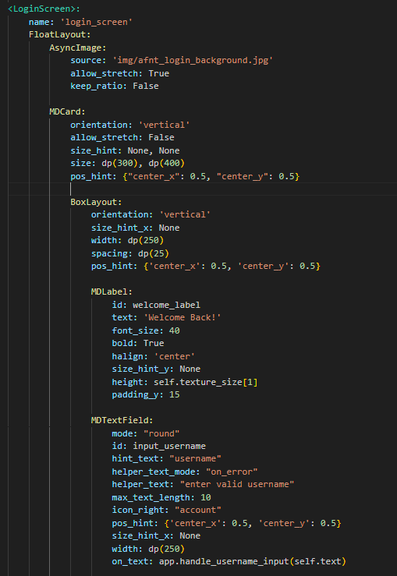

Figure 70: Kvlang example.

### Kivy Material Design

In addition to leveraging Python and the Kivy GUI Framework, the project also incorporates KivyMD for its Material Design User Interface (MUI) components. KivyMD extends the capabilities of Kivy by providing a range of ready-to-use UI elements that align with Material Design guidelines, enhancing the visual appeal and usability of the AFNT application (‘KivyMD’, 2022). The utilization of MUI components not only streamlines the development process but also ensures consistency and modern aesthetics across different platforms. Moreover, the cross-platform nature of the AFNT app, facilitated by Kivy and KivyMD, enables seamless usage on various devices, including mobile platforms, thereby enhancing accessibility and user experience. This approach underscores the importance of leveraging frameworks that prioritize user interface design and cross-device compatibility in modern software development.

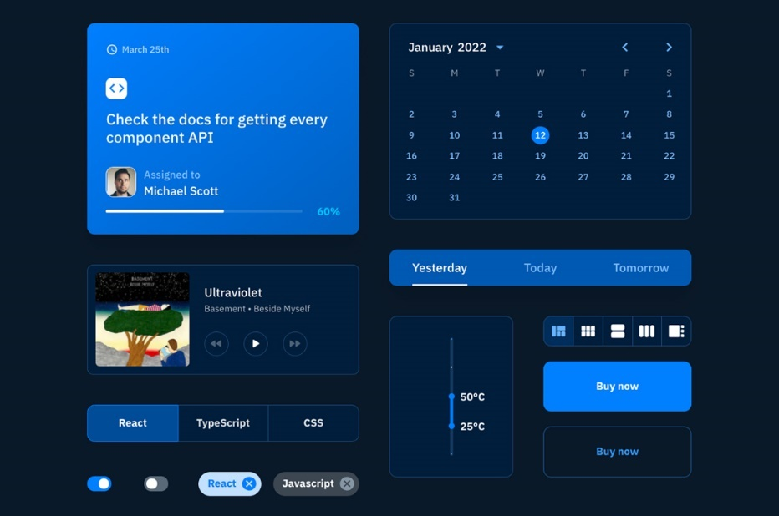

Figure 71: Example of MUI components.

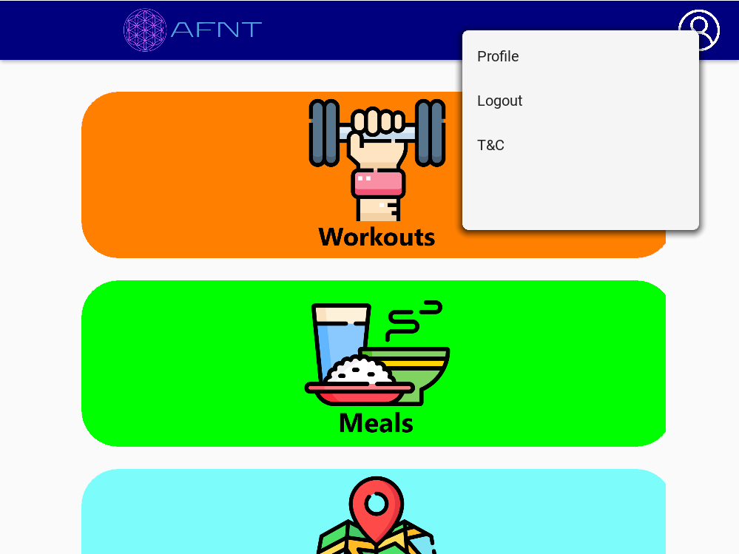

Figure 72: Utilizing MUI components in AFNT.

### Kiny Screen Manager

In Kivy, the ScreenManager is essential for managing multiple screens within applications, allowing seamless transitions between different user interfaces. Each defined screen corresponds to specific functionality like login, registration, dashboard, workout history, and more. Developers utilize ScreenManager to dynamically switch between these screens based on user interactions or application logic, ensuring an intuitive user experience. By creating separate screen classes inheriting from Kivy's Screen class, developers encapsulate layout and behaviour for each screen and manage transitions effectively. ScreenManager also supports various transition effects, enhancing the visual appeal and usability of multi-screen applications.

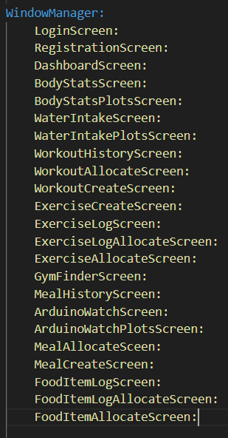

Figure 73: AFNT Screen classes.

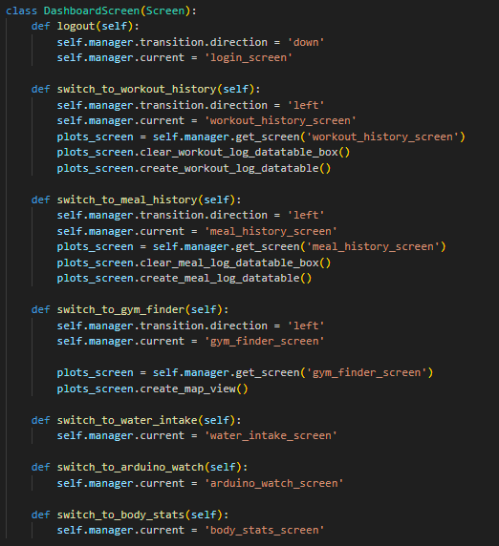

Figure 74: Dashboard Screen class.

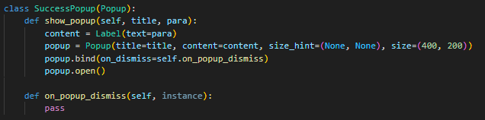

Figure 75: Basic Popup class example.

### Major Components

To make it easier to cover each objective and requirement for Phase 3. This subchapter will categorize every requirement into 7 components (screens) as shown below:

Table 33: Phase 3 components.

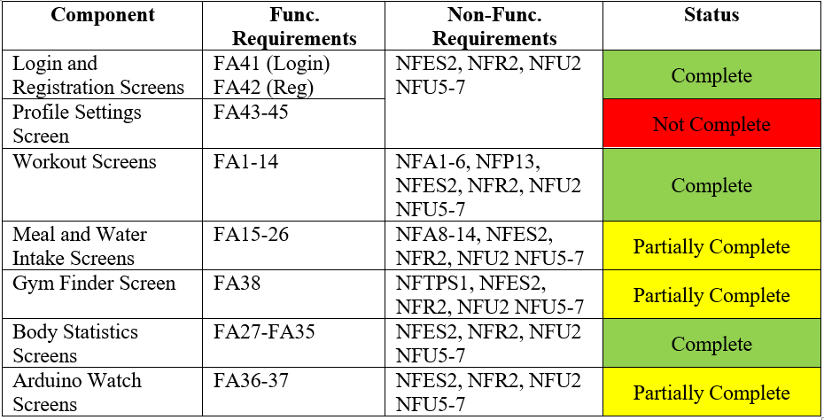

### Login and Registration Screens

The login and registration screens utilize CDB for accessing and storing user login credentials.

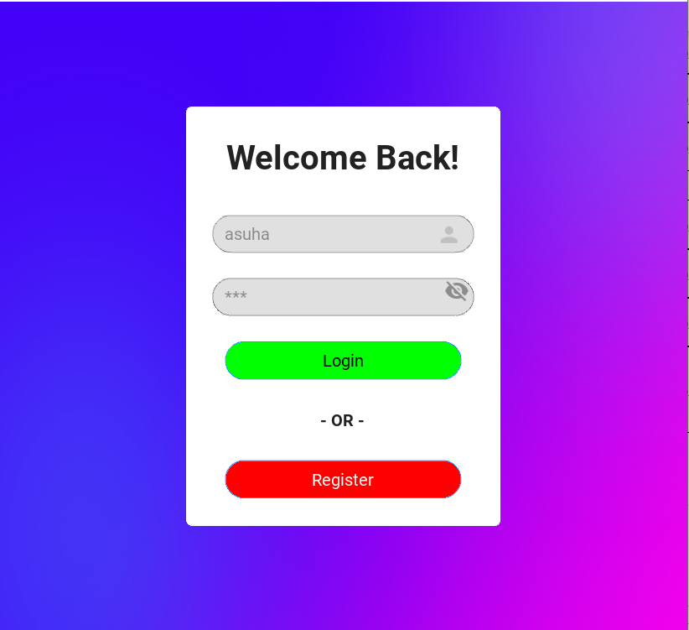

Figure 76: AFNT Login Screen.

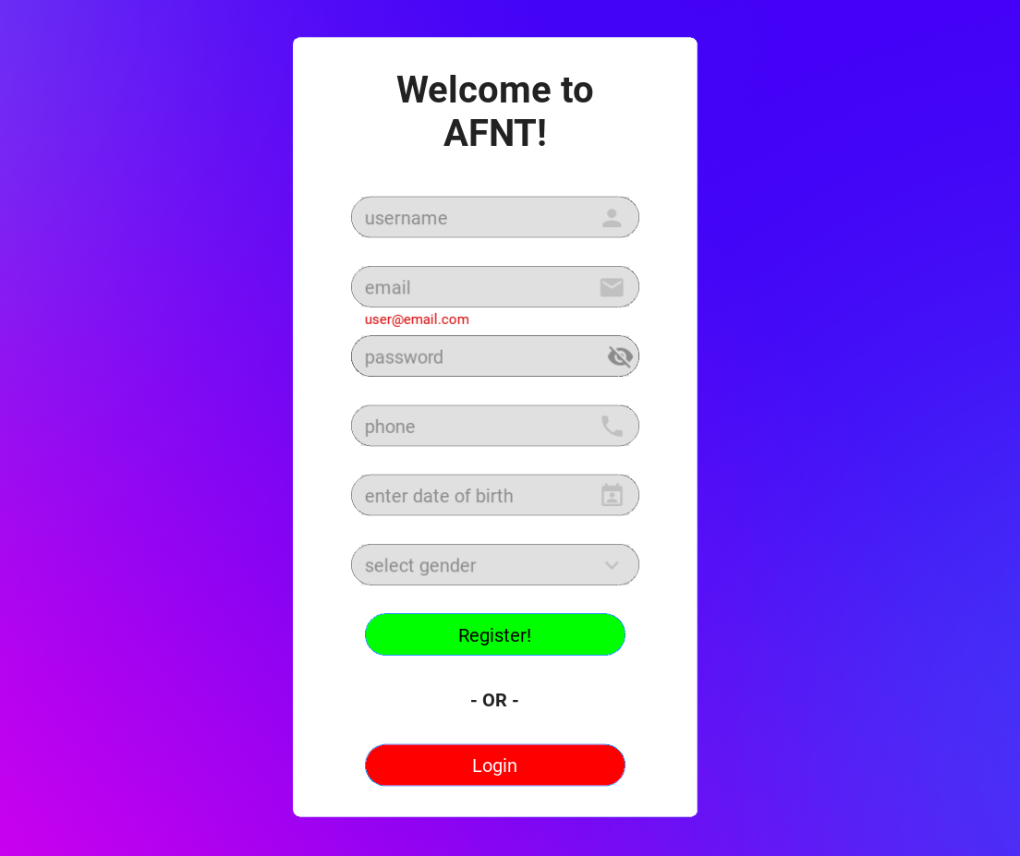

Figure 77: AFNT Registration Screen.

### Workout Screens

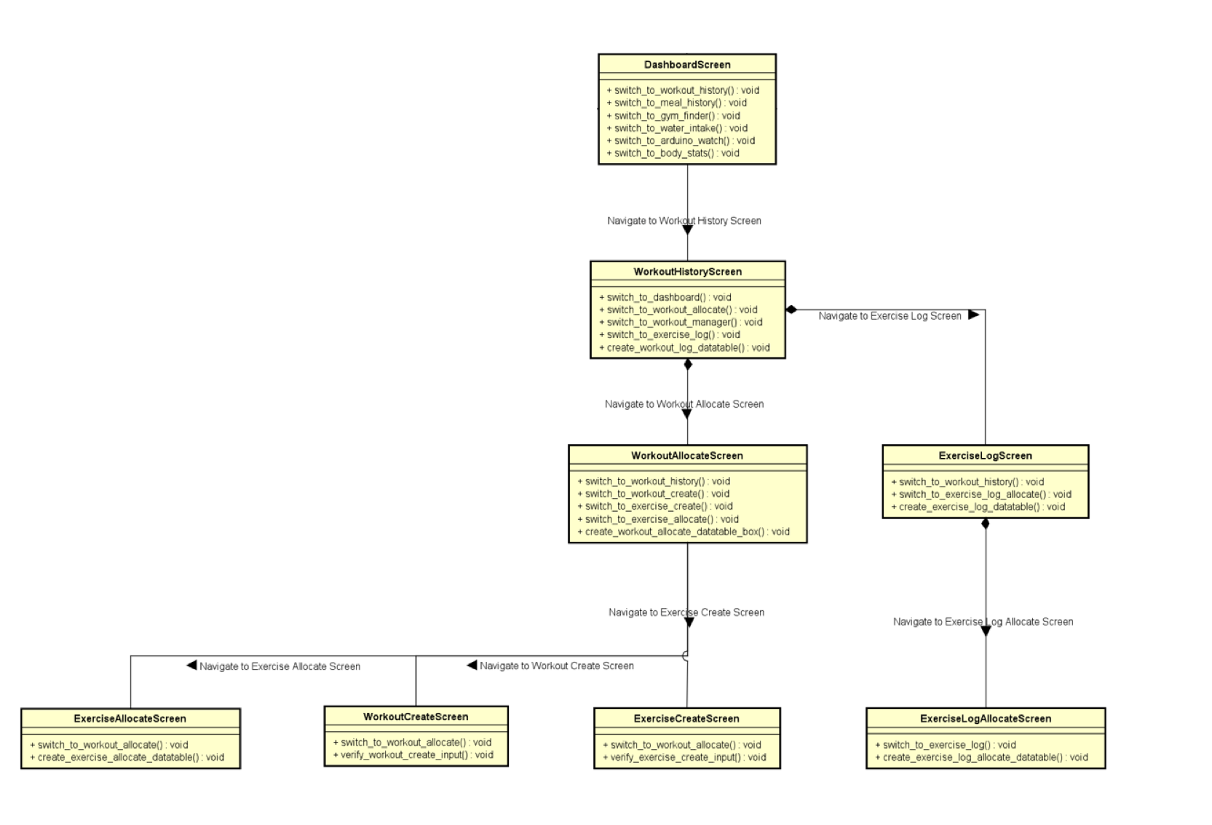

Figure 78: Workout Screens class diagram.

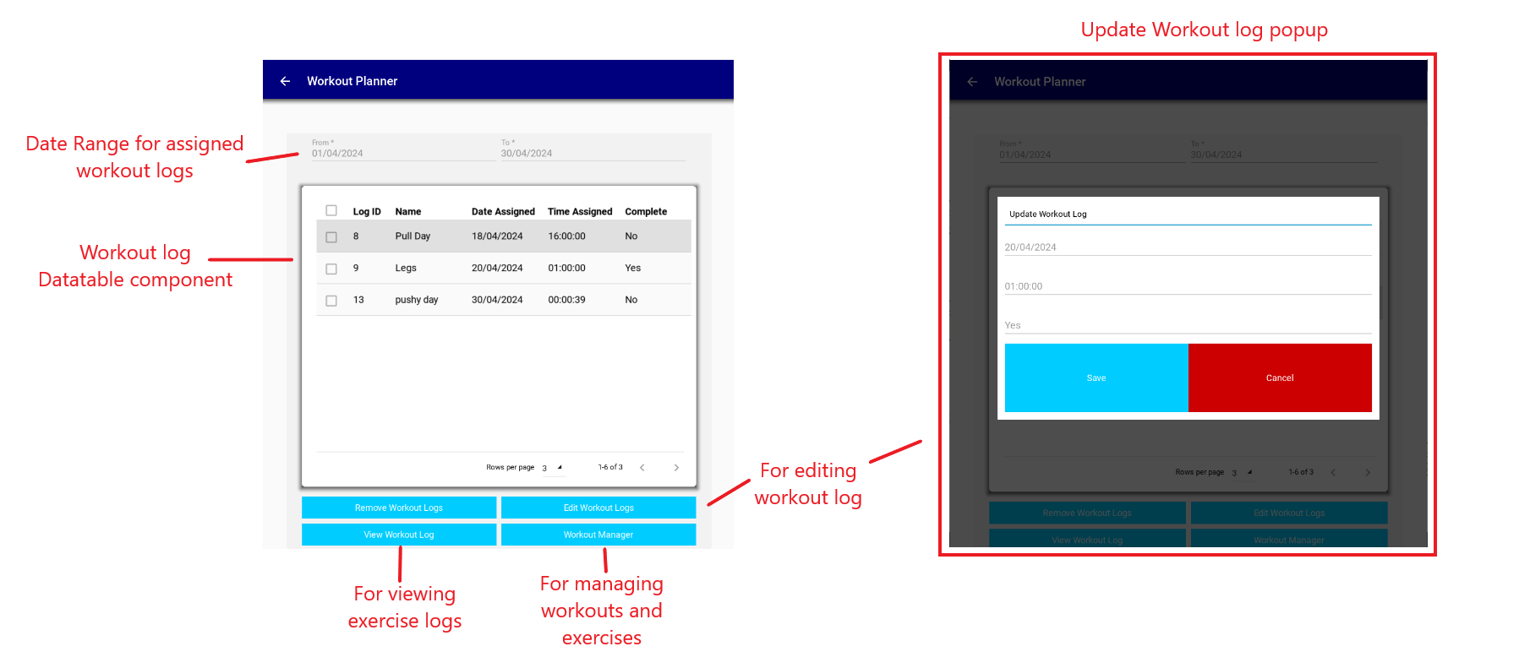

Figure 79: Workout History Screen.

Each of these screens covers specific requirements for workouts and exercises. For instance, the workout history screen class is responsible for managing the WorkoutLog class.

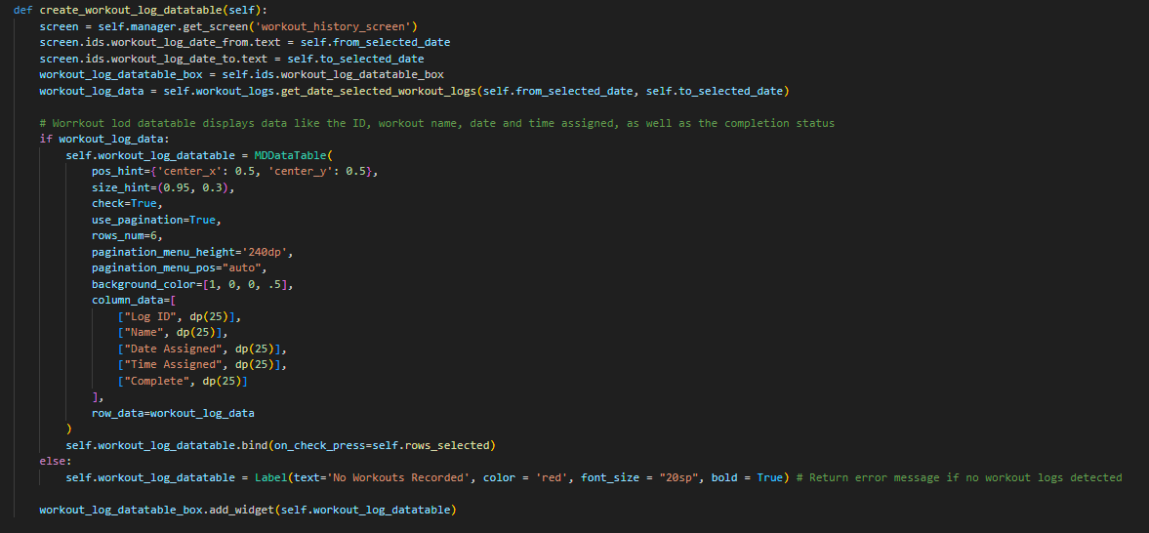

Figure 80: Creating a Datatable using KivyMD.

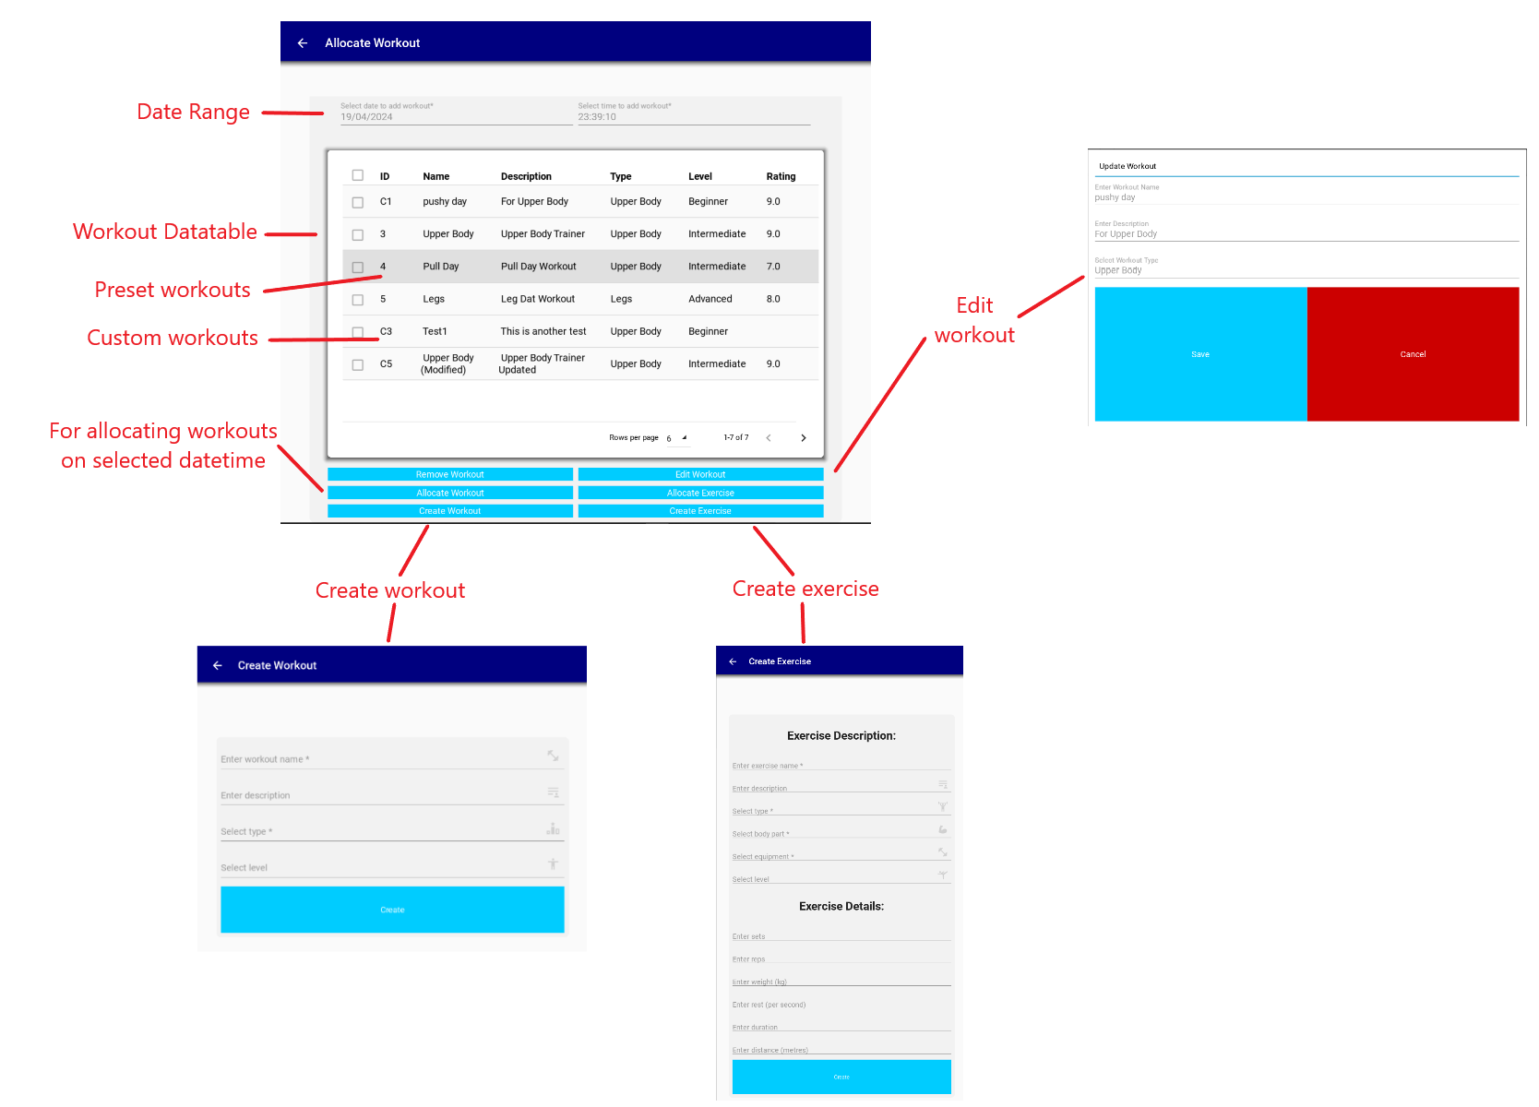

Figure 81: Allocate Workout and Create Exercise and Workout Screens.

Selecting `Workout Manager` in the Workout History Screen will direct user to the Allocate Workout screen, where the user can manage the Workout and Exercise classes.

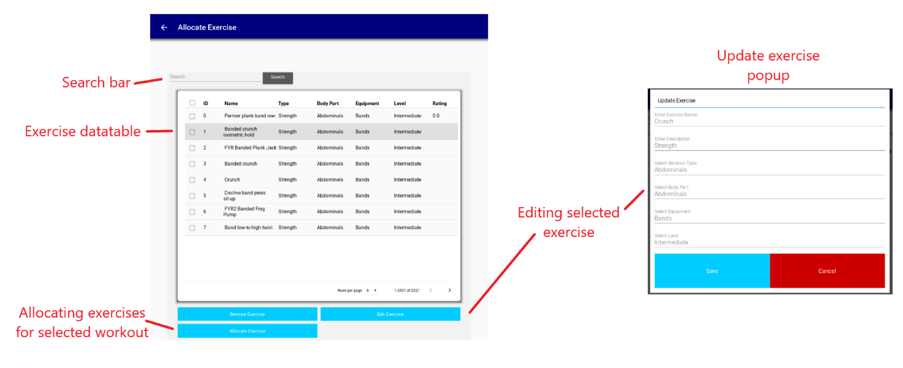

Figure 82: Allocate Exercise Screen.

To access this page a workout has to be selected in the Workout Allocate Screen, then select `Allocate Exercise`.

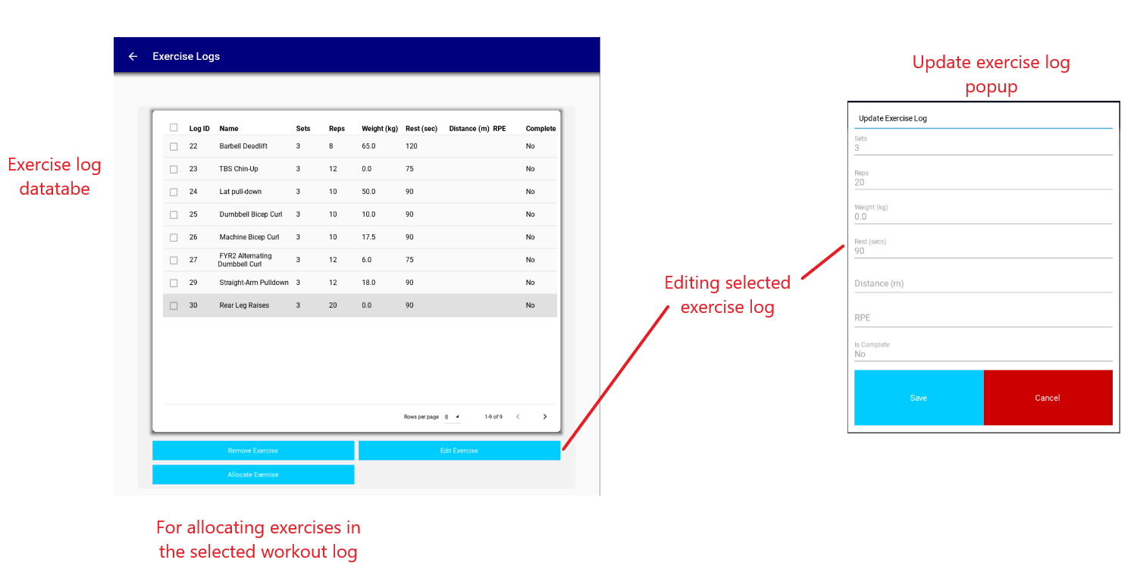

Figure 83: Exercise Logs Screen.

To access this screen, select a workout log in the Workout History Screen, then select `View Workout Log`.

### Meal and Water Intake Screens

The meal screens remain incomplete due to time constraints and other project deadlines. Presently, the only partially finished meal screen is the Meal History Screen, responsible for displaying meal logs and supporting only the delete functionality.

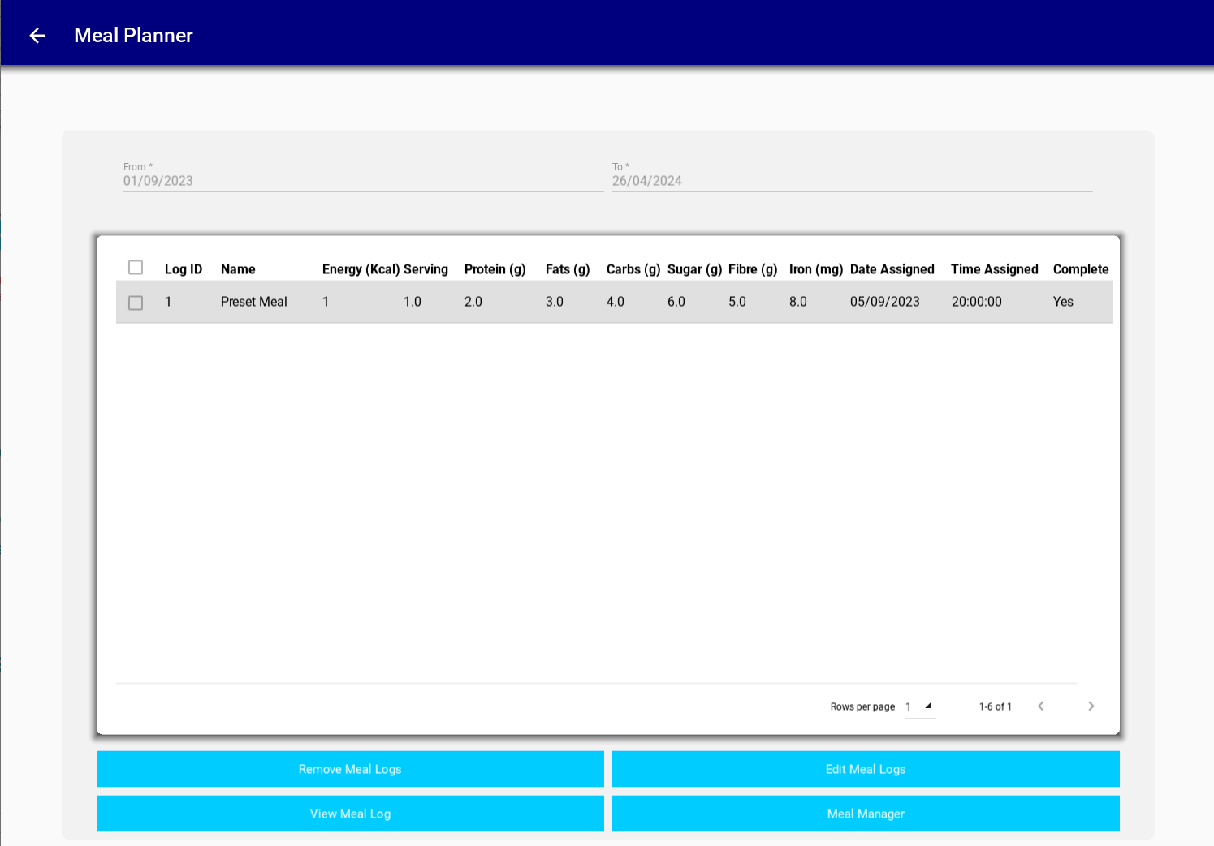

Figure 84: Meal History Screen.

Regarding water intake, the Water Intake Screen has been developed to monitor and track water intake. Additionally, this screen generates water intake plots for users using the matplotlib library within the Kivy framework.

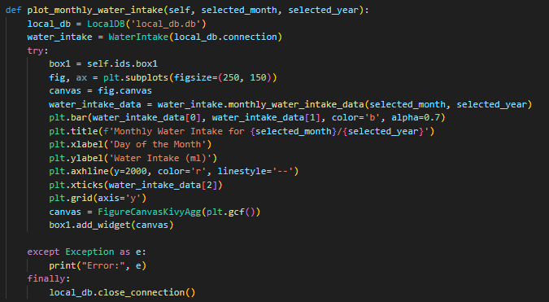

Figure 85: Plotting Water Intake Monthly Graph.

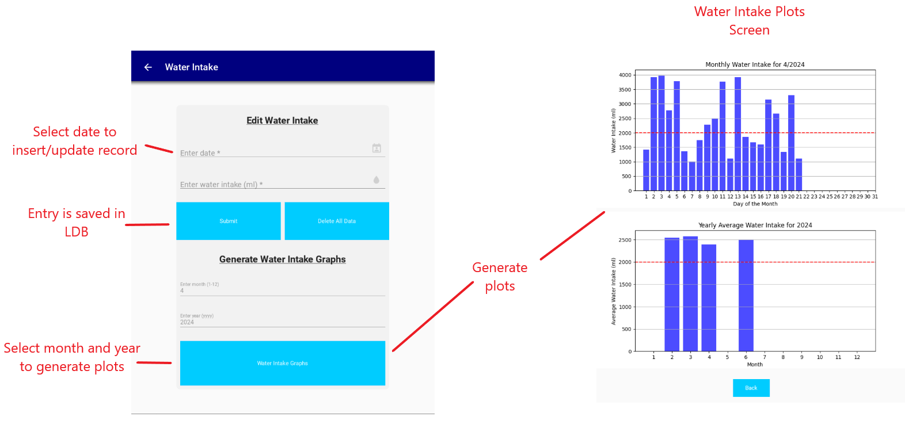

Figure 86: Water Intake & Plots Screens.

### Gym Finder Screen

In the GymFinderScreen class, a map API is integrated to display a map view for locating nearby gyms. The map view utilizes the MapView widget within Kivy, with a default location set to Bristol, England. However, the functionality for searching for the nearest gym is not fully implemented due to time constraints.

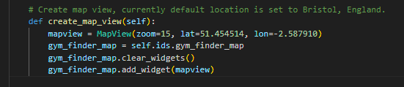

Figure 87: Implementing MapAPI for Gym Finder Screen.

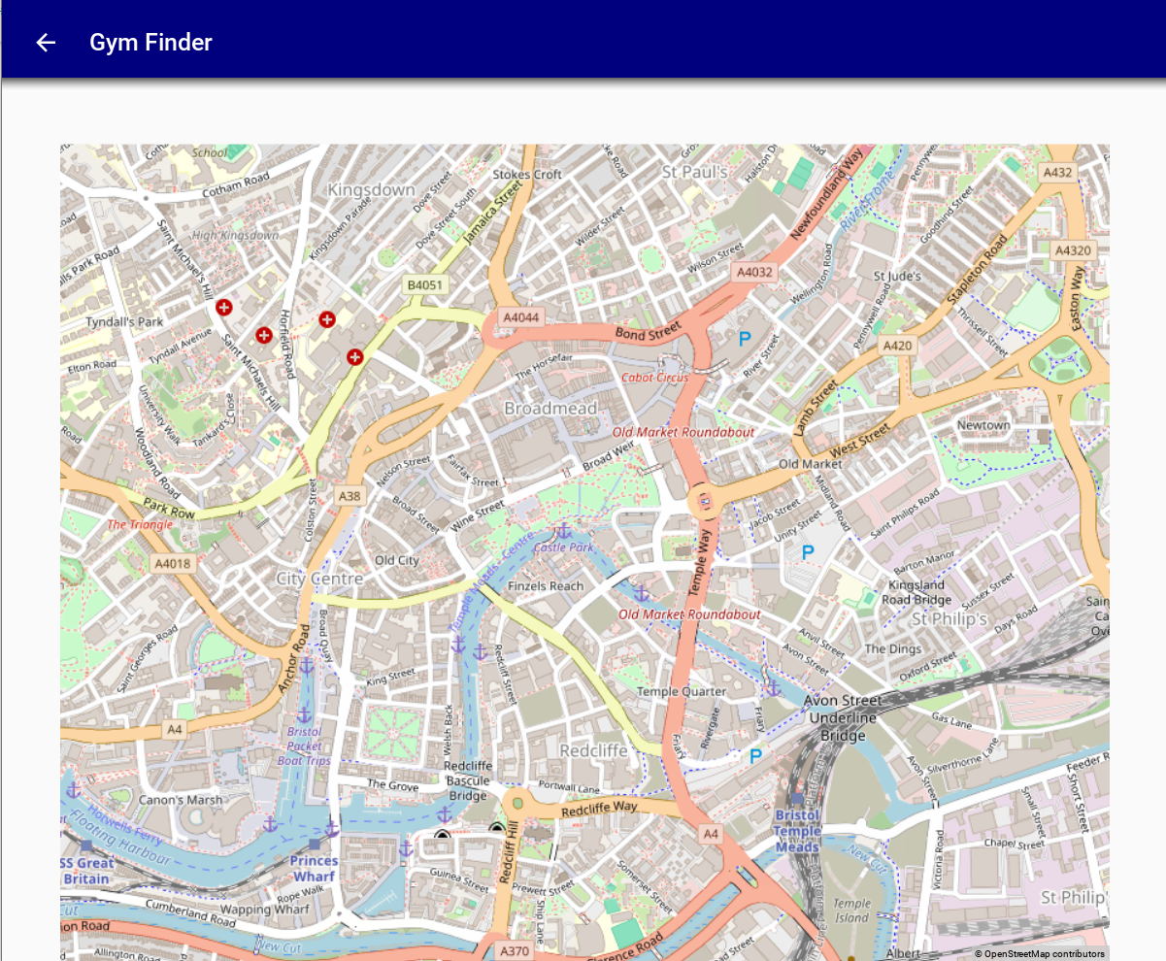

Figure 88: Gym Finder Screen.

### Body Statistics Screens

Similar to the Water Intake Screen, the Body Statistics Screen enables users to input and monitor various body-related metrics such as weight, height, body fat, BMI, skeletal muscle, and steps taken. Users can view this data through plots generated using the matplotlib library on the Body Statistics Plots Screen.

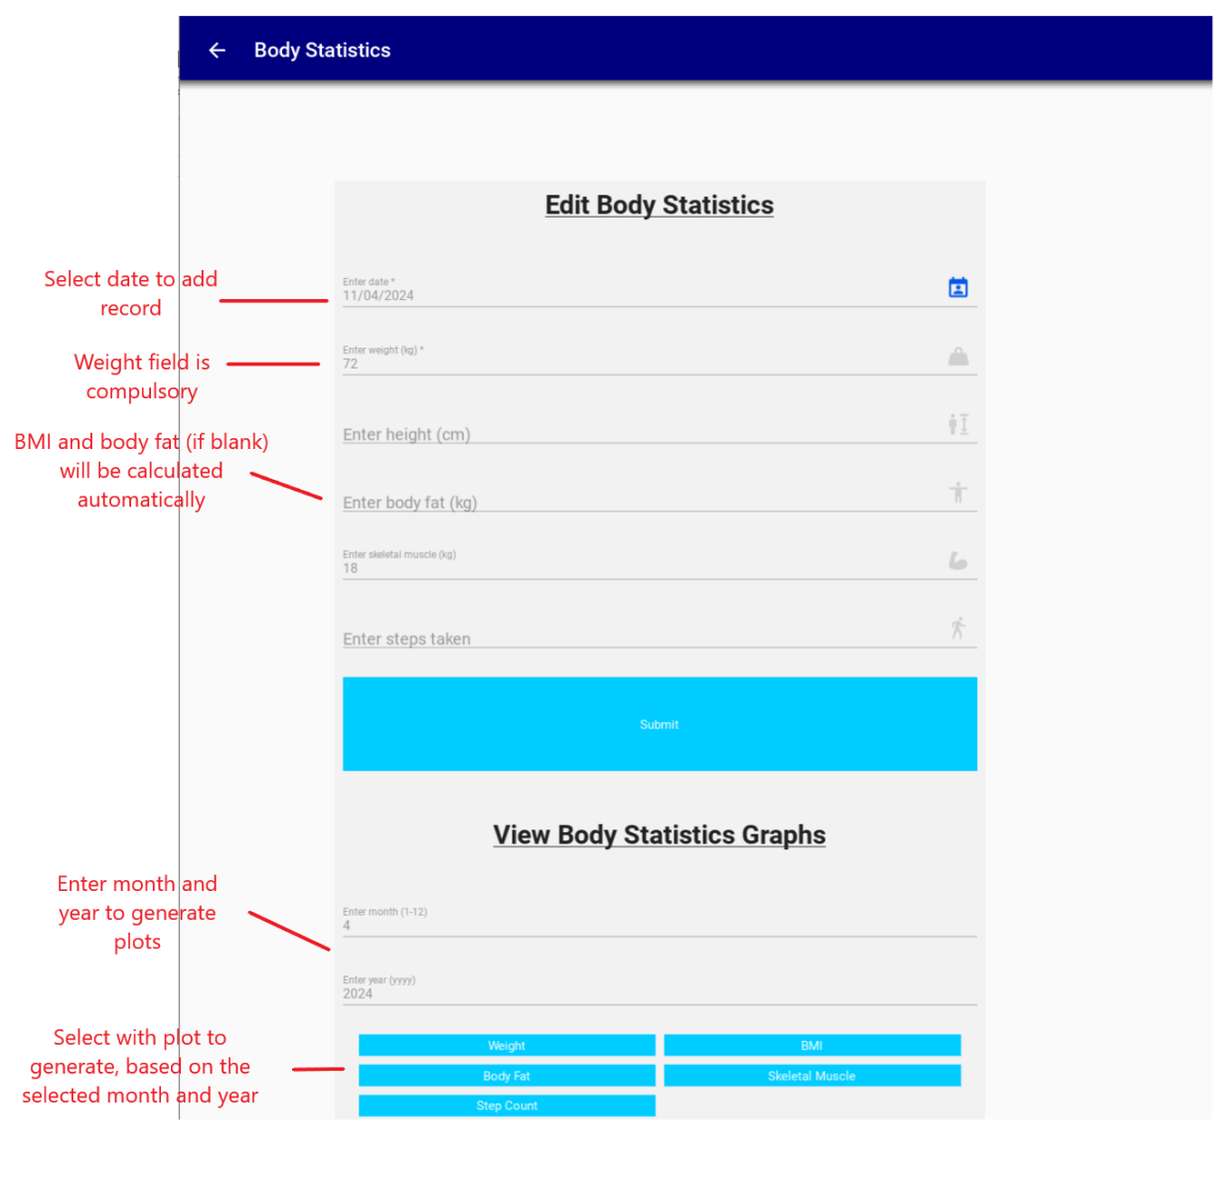

Figure 89: Body Statistics Screen.

The graphs displayed show monthly body statistics, followed by a yearly average graph at the bottom, providing comprehensive insights into the user's body metrics over time. It's important to note that the data displayed on the graph covers the period from February 1st to April 20th.

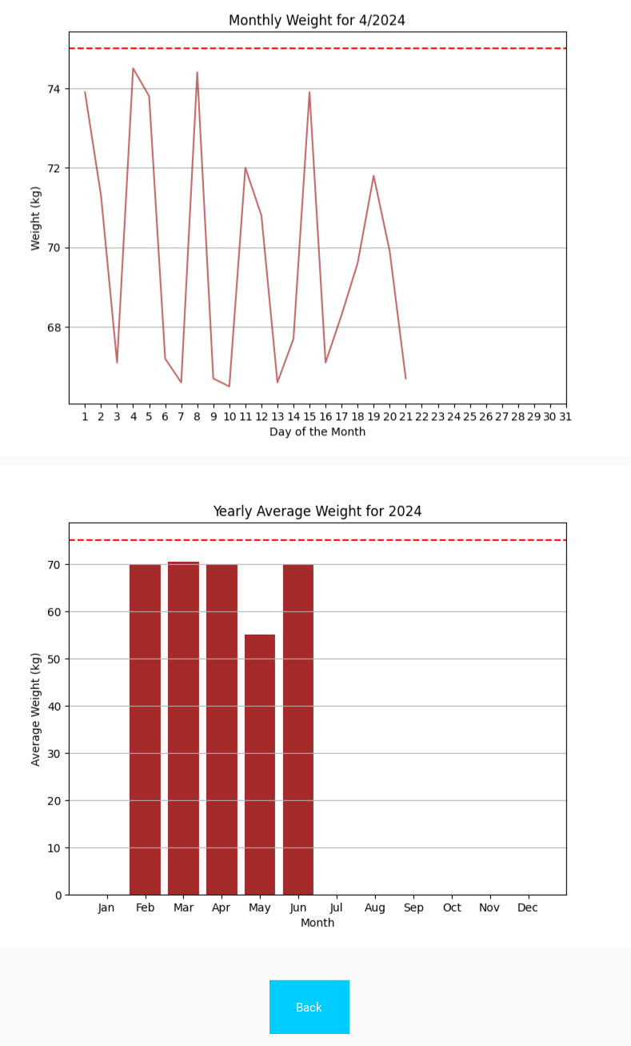

Figure 90: Monthly and Yearly Average Weight Graphs.

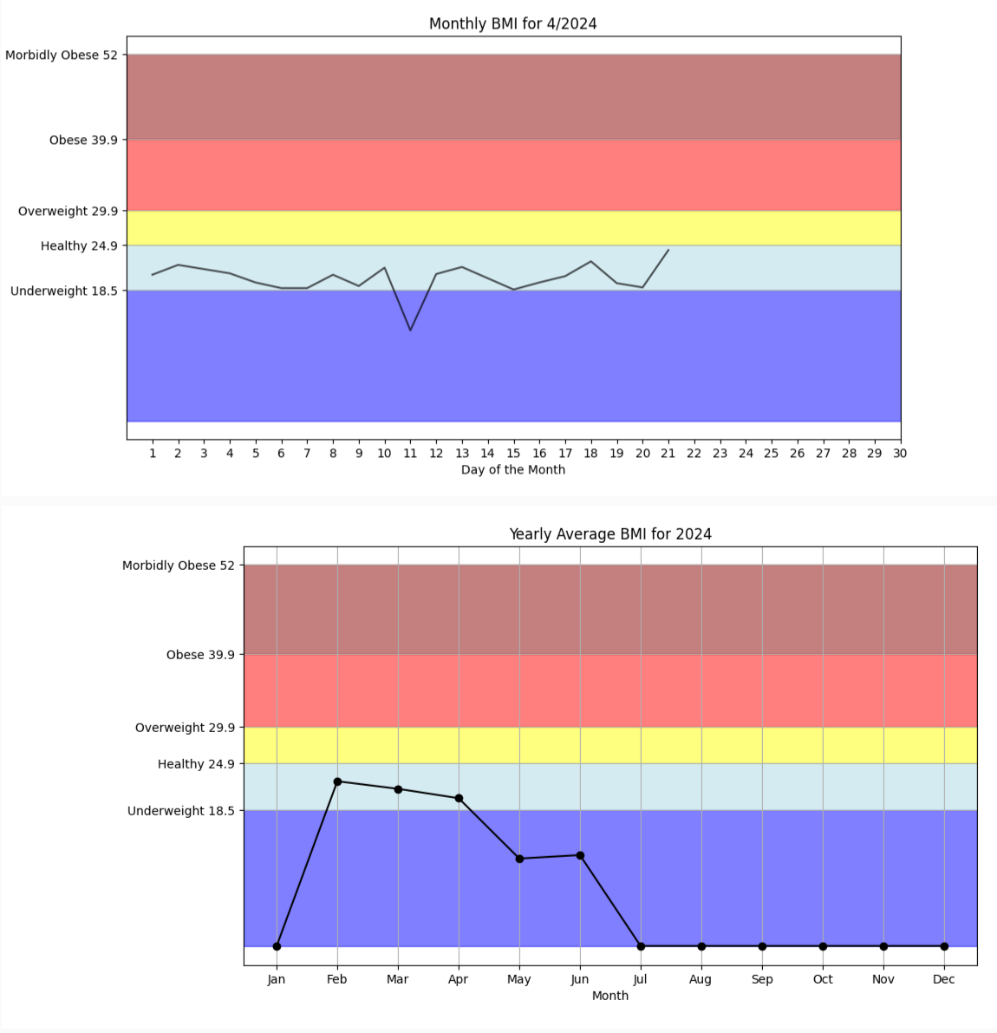

Figure 91: Monthly and Yearly Average BMI Graphs.

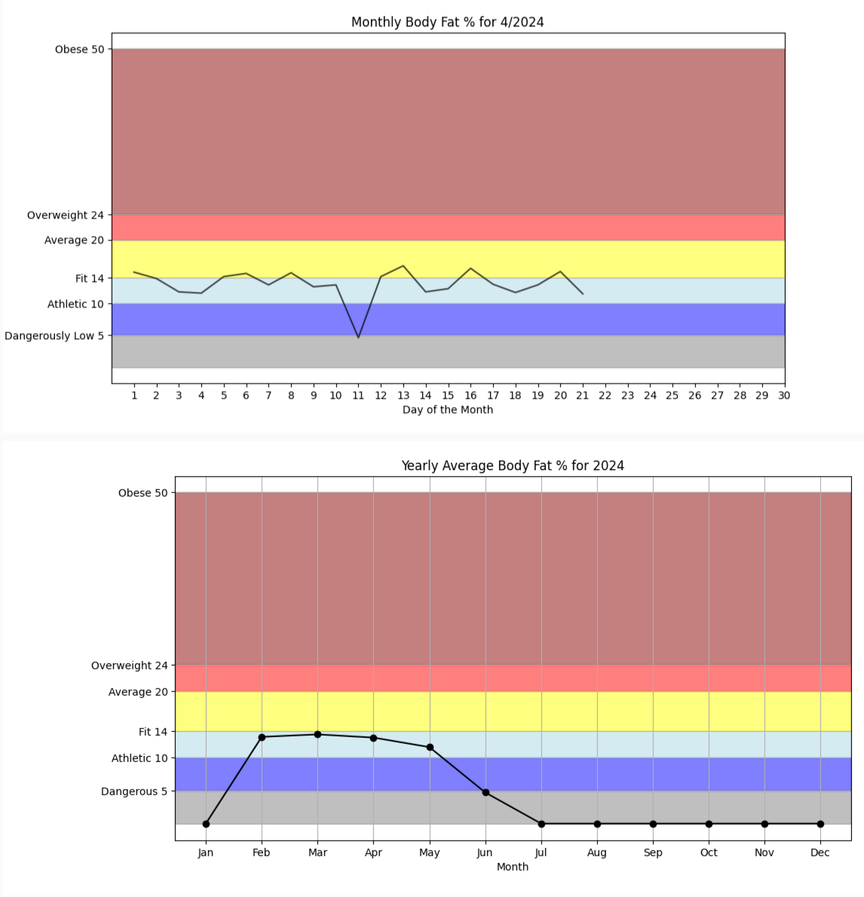

Figure 92: Monthly and Yearly Average Body Fat Graphs.

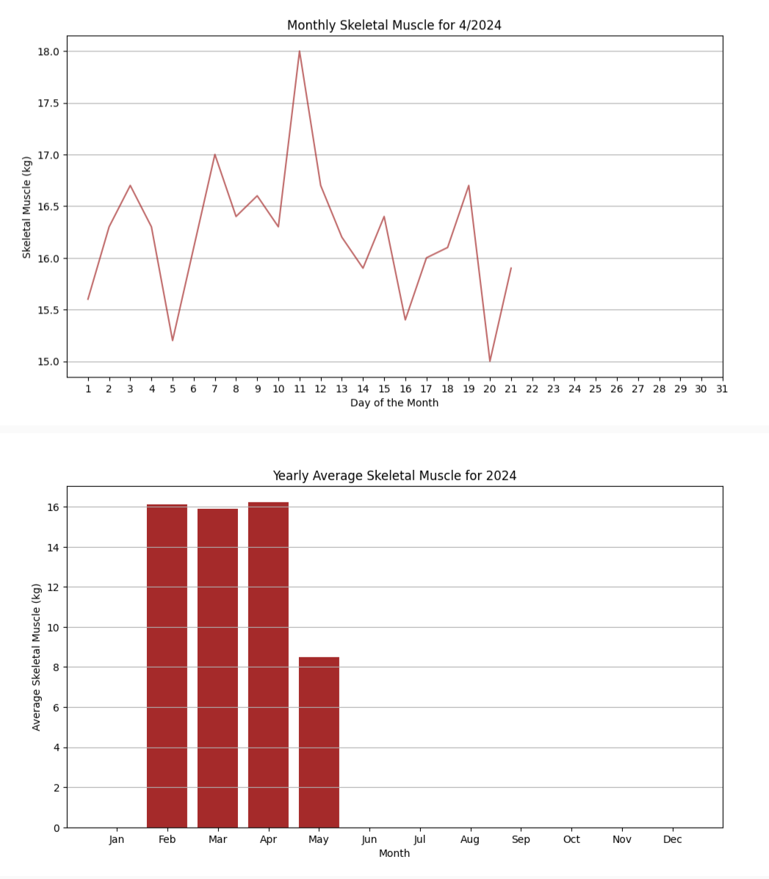

Figure 93: Monthly and Yearly Average Skeletal Muscle Graphs.

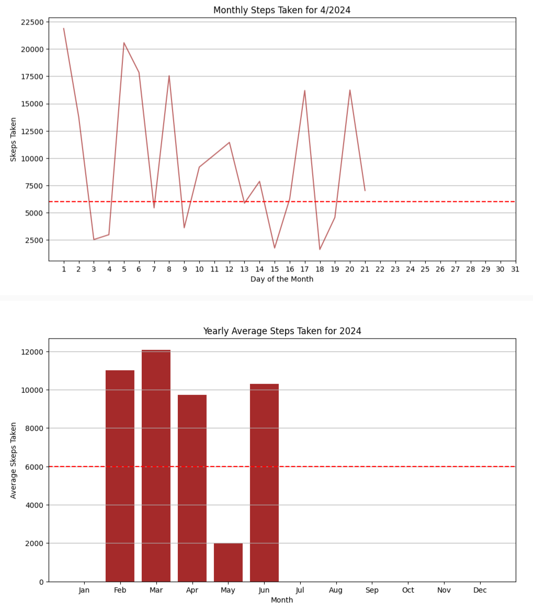

Figure 94: Monthly and Yearly Steps Graphs.

### Arduino Watch Screens

The Arduino Watch Screens manages synchronization and communication with the Arduino Watch, facilitating the transfer of watch data into the app for users to view body data. Currently, the app can only access this data via a wired connection to the microSD card, where the data is read and displayed as plots in the AFNT app. Bluetooth functionality was not fully implemented due to time constraints and delays in receiving Arduino Watch parts like the Bluetooth LE TinyShield modular component.

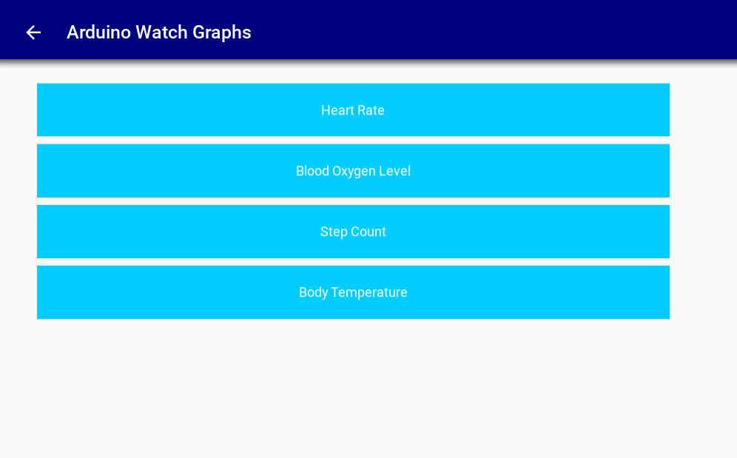

Figure 95: Arduino Watch Screen.

After successfully connecting the microSD card data to the computer, users can view the data in the form of mathplotlib graphs in the Arduino Watch Plots Screen as shown in the following plots:

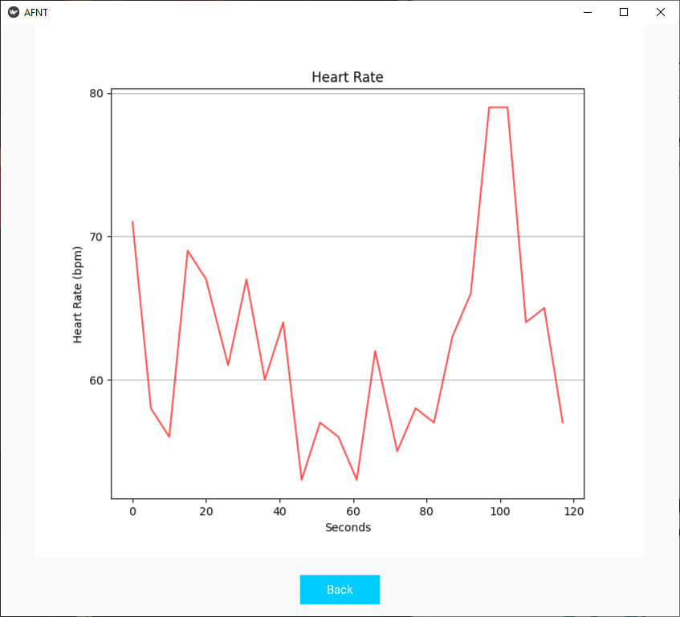

Figure 96: Heart Rate Plot.

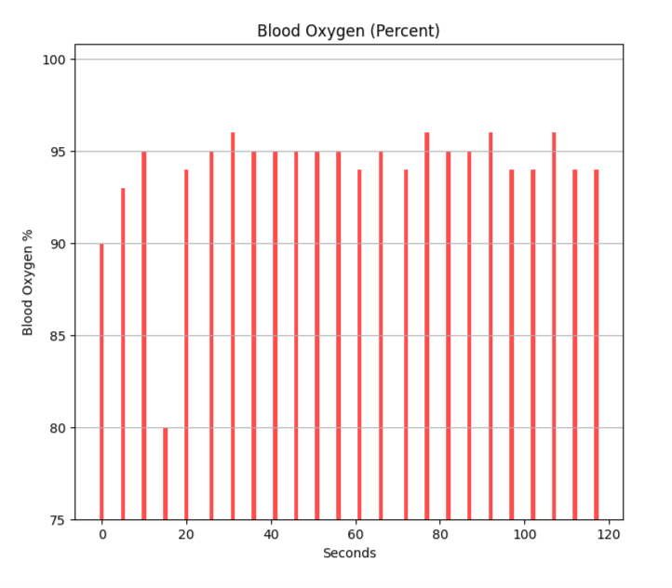

Figure 97: Blood Oxygen Level Plot.

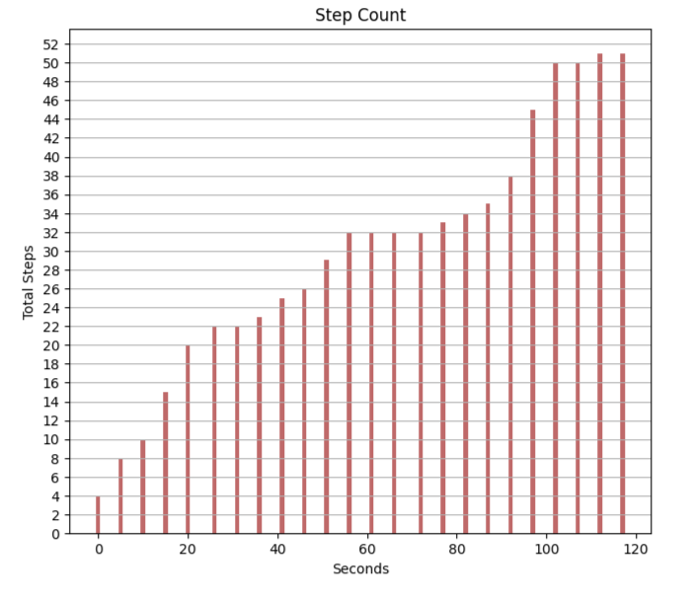

Figure 98: Step Count Plot.

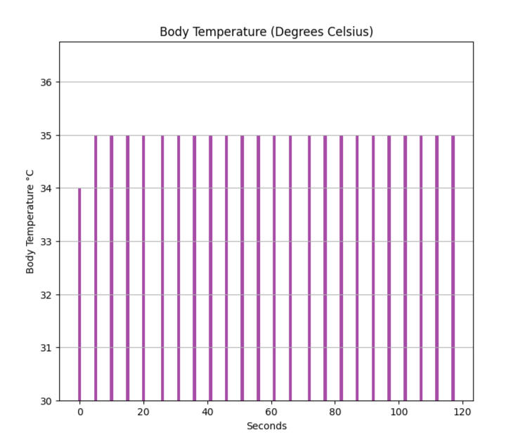

Figure 99: Body Temperature Plot.

To explore further details on how the Arduino Watch collects and stores this data, refer to section ‎6.4.

## Phase 4: Arduino Watch Implementation

As previously discussed, the Arduino Watch comprises 8 modular electronic components interconnected like Lego blocks, as depicted in the diagram below. We will delve into how this stack was assembled and explore how the Arduino Watch captures, records, and presents physiological data collected through its sensors. Additionally, we will examine how the accelerometer detects and measures steps.

### Stack Implementation and TinyShield Compatibility

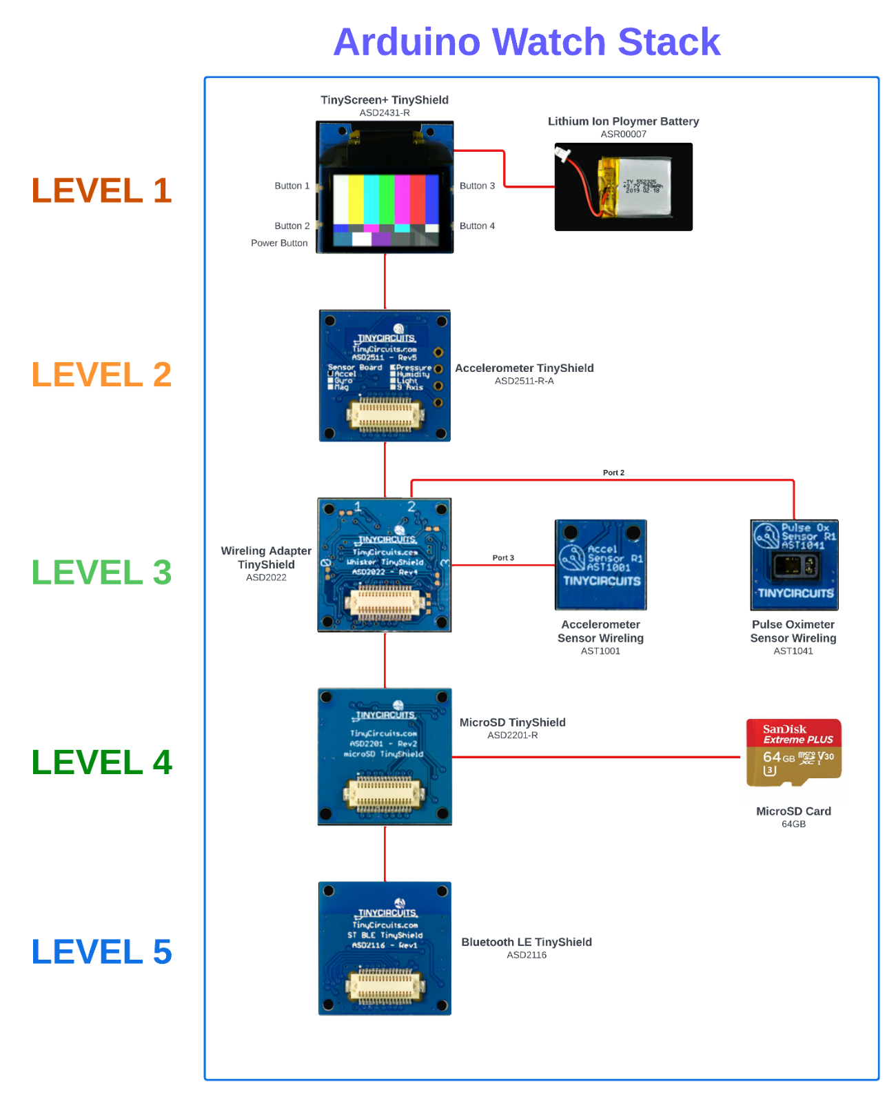

Figure 61: Arduino Watch Modular Component Stack diagram.

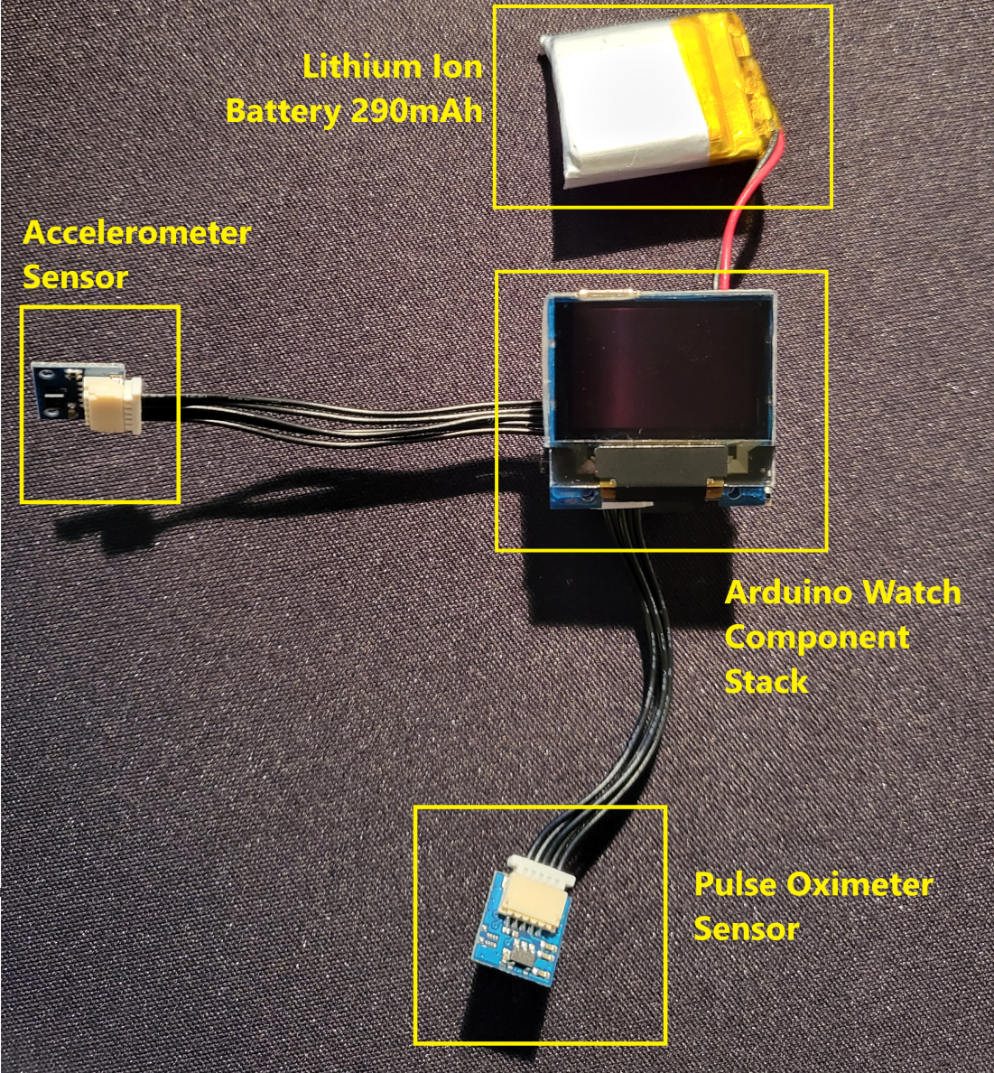

Figure 100: Arduino Watch component implementation.

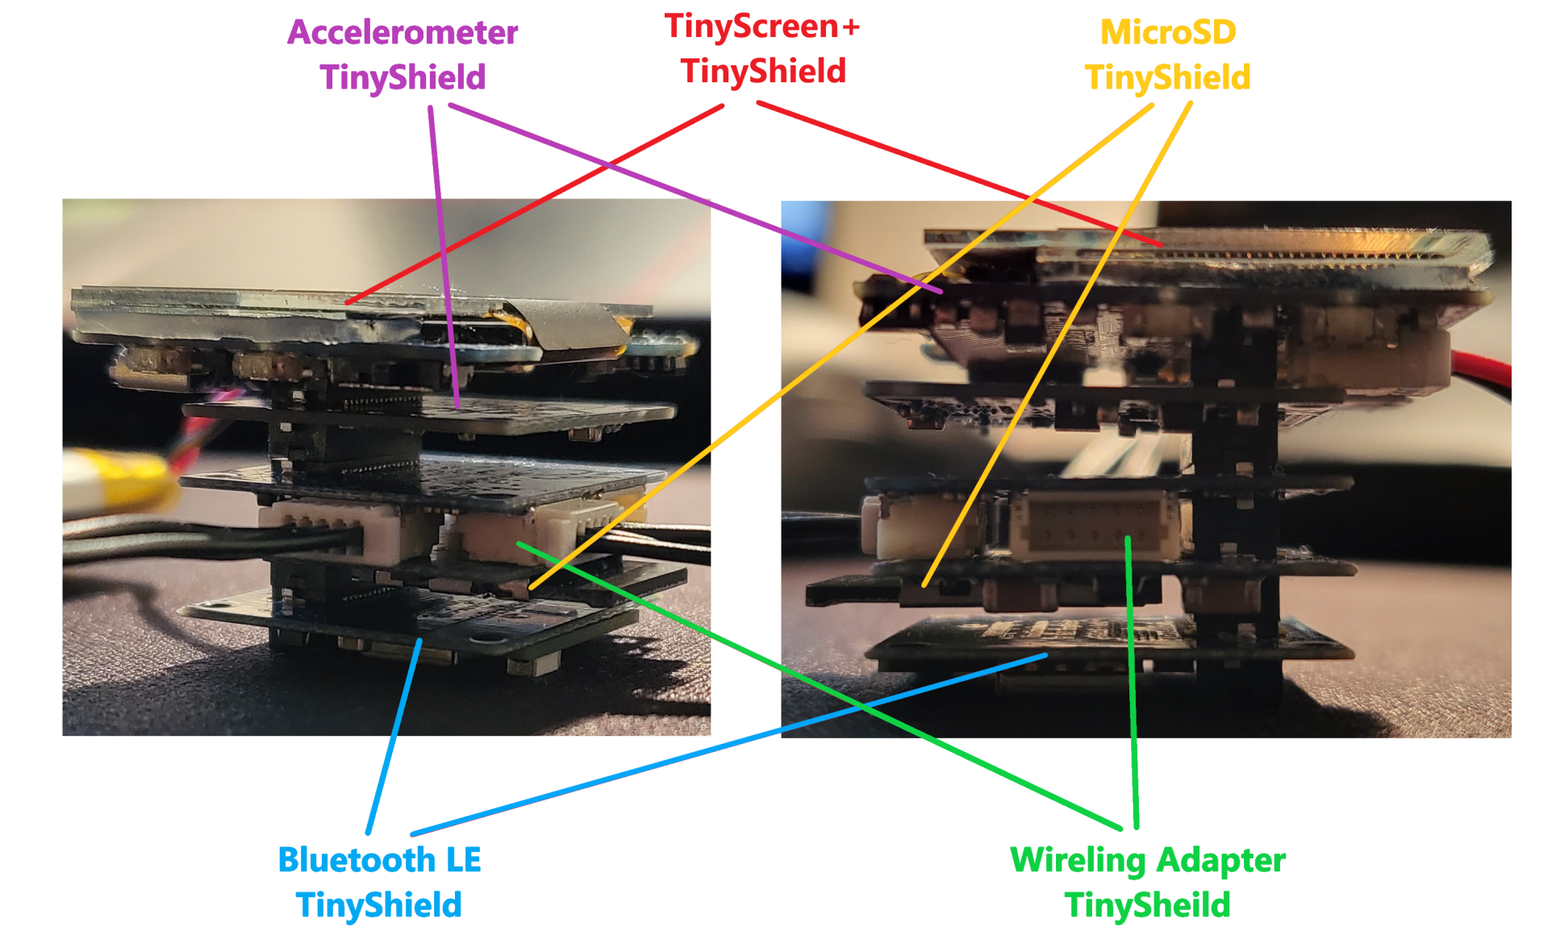

Figure 101: Implementing Arduino Watch stack.

The Arduino Watch stack can be assembled and rearranged by attaching the components together, and the order of the stack can be adjusted easily. This rearrangement does not impact the watch's behaviour or necessitate any modifications to the code, as the TinyDuino and TinyShields automatically adapt to the changes. However, if you change the sensor ports in the Wireling Adapter TinyShield, you may need to make minor code modifications to ensure that the sensor is assigned to the correct port and initialized properly for accurate data collection.

Table 34: [TinyShield Compatibility. (‘TinyDuino Overview’, 2024)](https://learn.tinycircuits.com/TinyDuino_Overview/)

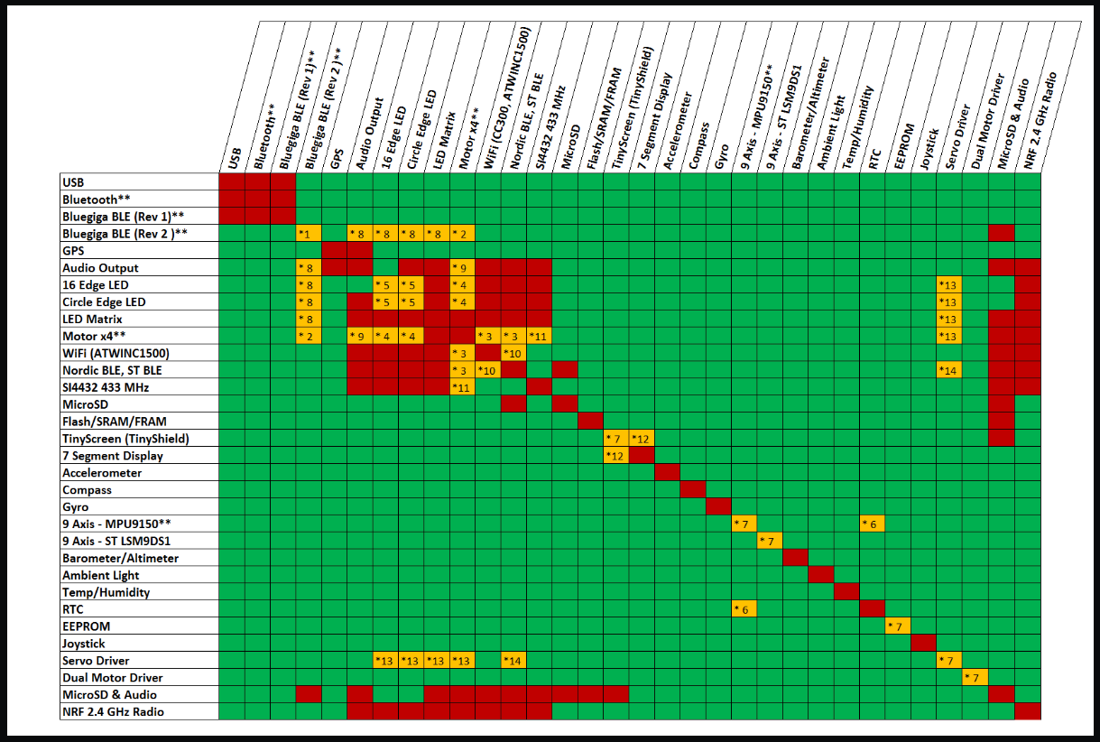

**Green:** The two TinyShields can be used together on the same stack without issue.

**Yellow:** Special conditions.

**Red:** The two boards cannot be used together.

### Pulse Oximeter Sensor Configuration

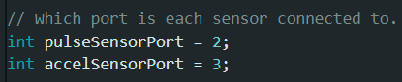

Figure 102: Senor port allocations in the Wireling Adapter TinyShield.

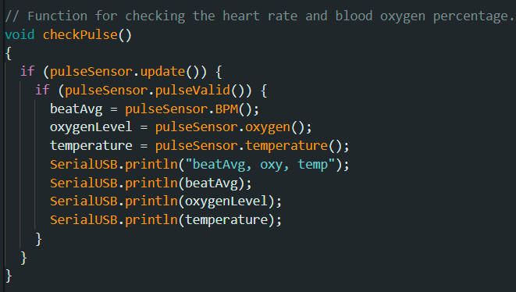

Figure 103: checkPulse function.

The function checkPulse is used to retrieve data recorded by the pulse oximeter, providing information on the person's heart rate (BPM), oxygen level (%), and body temperature (°C). The sensor can also capture cardiogram data, although this functionality is currently not within the scope of the project.

### Accelerometer Sensor Configuration and Step Calculation

For step data, the step calculation involves utilizing data from an accelerometer sensor, which measures acceleration along three axes: X, Y, and Z. These axes represent different spatial directions:

**Axes**: The X, Y, and Z axes correspond to different spatial directions relative to the orientation of the sensor. The X-axis typically represents horizontal movement from side to side, the Y-axis represents horizontal movement forward and backward, and the Z-axis represents vertical movement up and down (Volkwyn *et al.*, 2020).

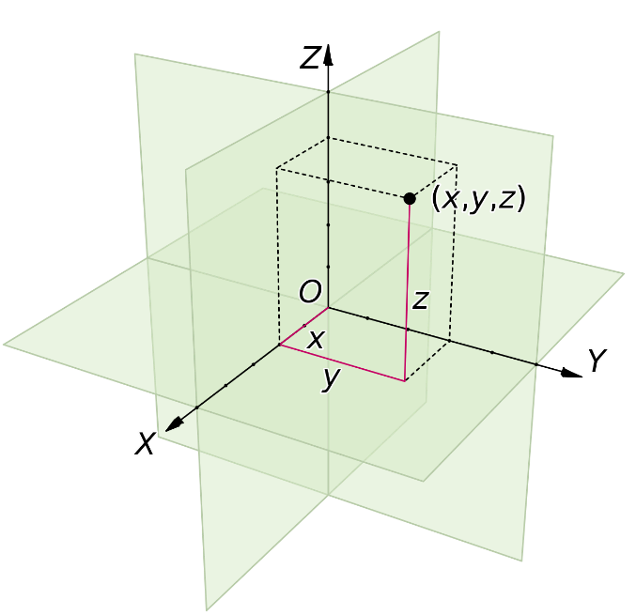

Figure 104: 3D Cartesian Coordinate System (Jorge S., 2018).

There is an origin labelled as O, along with axis lines X, Y, and Z as indicated by arrows. The tick marks on these axes are spaced one unit apart. A black dot represents a point located at coordinates x = 2, y = 3, and z = 4, denoted as (2, 3, 4).

**Magnitude (of a Vector)**: In this context, magnitude refers to the overall acceleration experienced by the device. It is calculated using the accelerometer readings along the X, Y, and Z axes. The magnitude (`A`) is computed as the square root of the sum of the squares of the individual axis values (`X`, `Y`, `Z`), mathematically represented as:

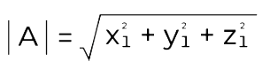

Figure 105: Magnitude of a Vector formula (GeeksforGeeks, 2022).

Here, `X`, `Y`, and `Z` are the acceleration values along the respective axes.

The step detection algorithm uses changes in this acceleration magnitude (`A`) to detect when a step occurs. By analyzing the difference between the current magnitude value (`A`) and a previously recorded value (`B`), the algorithm can infer changes in movement indicative of steps. Thresholds and peak-to-peak ranges are used to distinguish meaningful step-like motions from other movements. When a significant change in acceleration aligns with predefined criteria for a step, such as specific ranges or patterns, the step count is updated to reflect the occurrence of a step. This approach translates physical movements, detected through acceleration data along multiple axes, into digital step counts within the program logic.

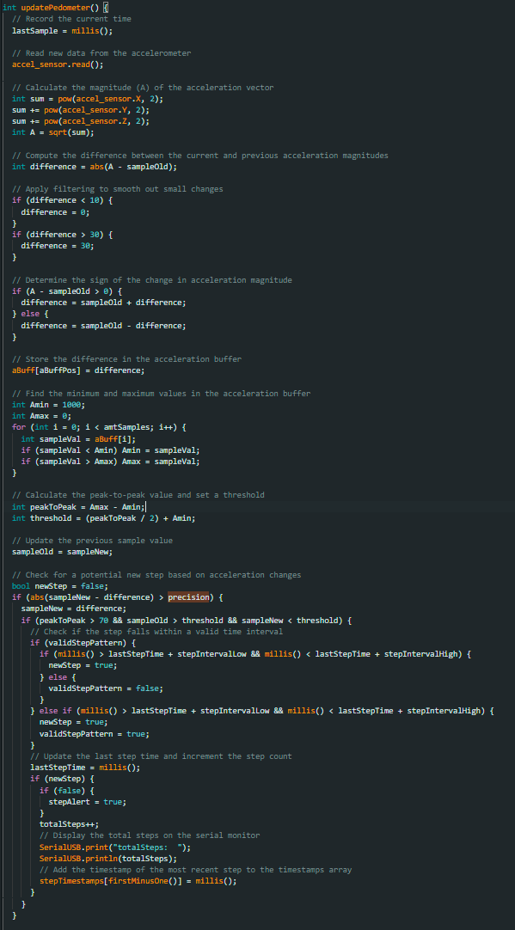

Figure 106: Step calculation.

### Logging Data to microSD Card

The Arduino Watch records all collected data, including the date and time, into a CSV file named `arduino.csv` at 5-second intervals.

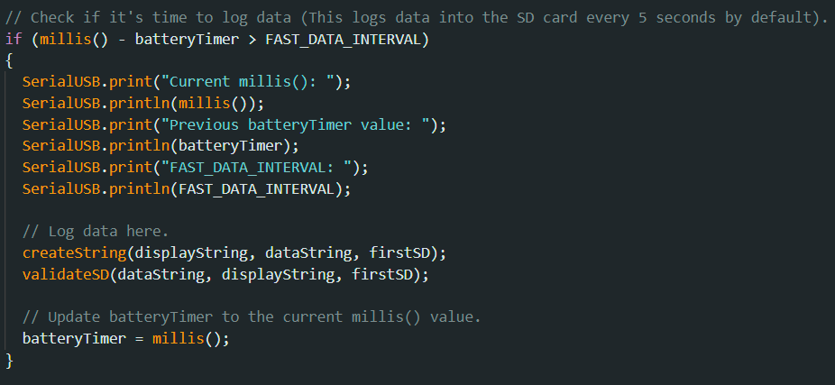

Figure 107: Log data every 5 seconds in the Arduino Watch.

The `createString` function collects physiological data, formats it as a CSV string, and returns it. The `validateSD` function verifies that the watch is equipped with a microSD card containing the required CSV file.

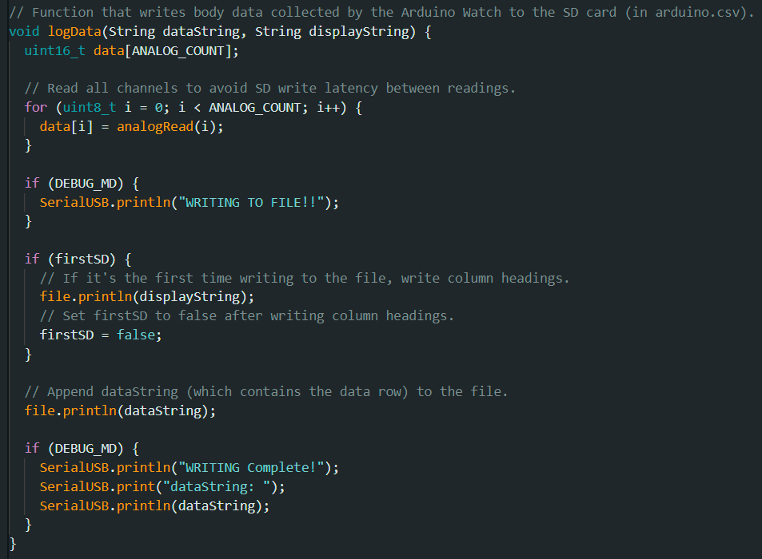

Figure 108: logData function.

The `logData` function is responsible for writing the collected data into the `arduino.csv` file located on the microSD card.

Table 35: Logging watch data in `arduino.csv`.

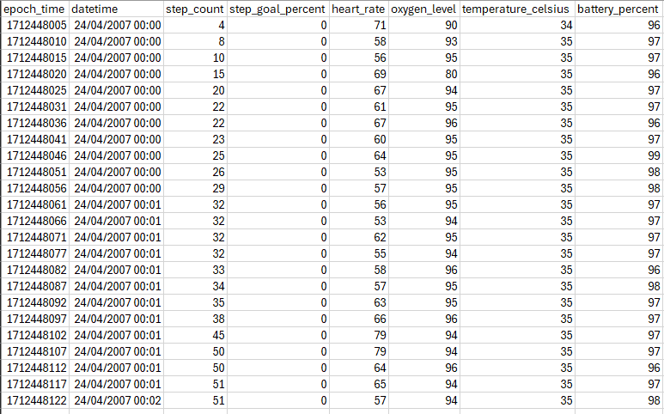

### Watch Main Display

The watch display presents the current date and time along with information on steps, step goal percentage, blood oxygen level, heart rate, and battery level.

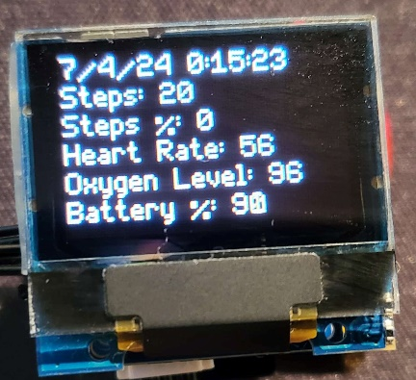

Figure 109: Arduino Watch display.

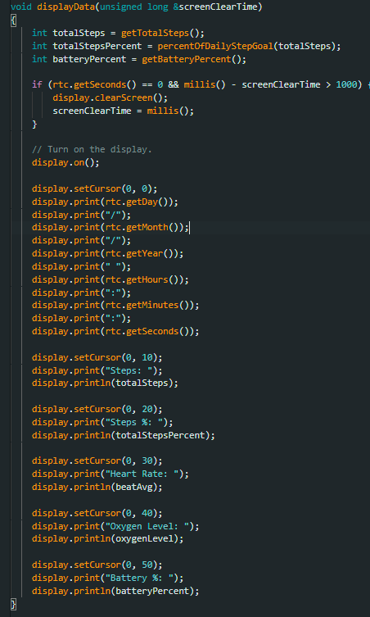

Figure 110: Arduino Watch display data code.

### Bluetooth Low Energy Functionality

The Bluetooth Low Energy (BLE) communication between the Arduino Watch and a smartphone has been tested and implemented. However, at this moment, the synchronization and transmission of body data from the Arduino Watch via BLE have not been implemented due to time constraints. The STBLE library is essential for enabling BLE functionality and can be customized to adjust BLE behaviour as needed.

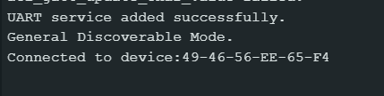

Figure 111: Arduino Watch connecting to a smartphone.

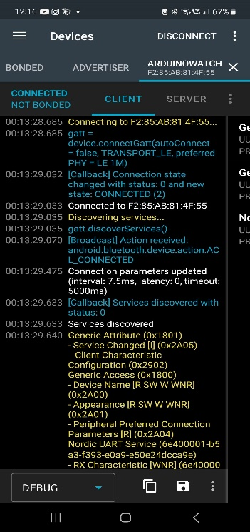

Figure 112: Andriod smartphone connecting to the Arduino Watch.

Once the connection between the Android smartphone and the Arduino Watch is established, data can be exchanged bidirectionally between the devices. The BLE functionality was verified using the 'nRF Connect' app, available for both iOS and Android platforms, which supports BLE communication and facilitates sending and receiving instructions to and from the Arduino Watch.



Figure 113: nRF Connect application.

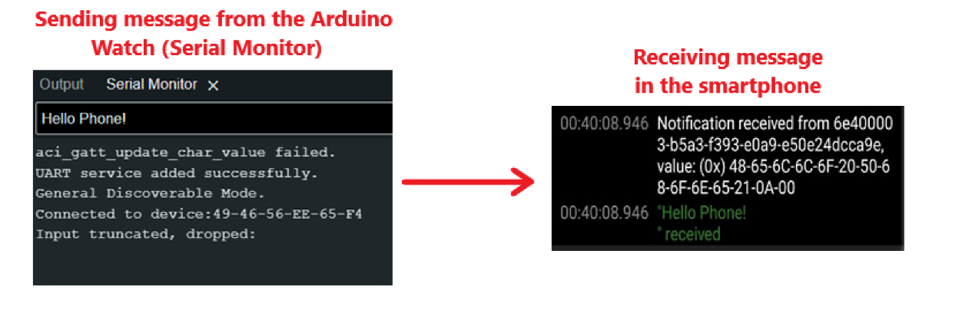

Figure 114: Sending a message from the Arduino Watch to the smartphone.

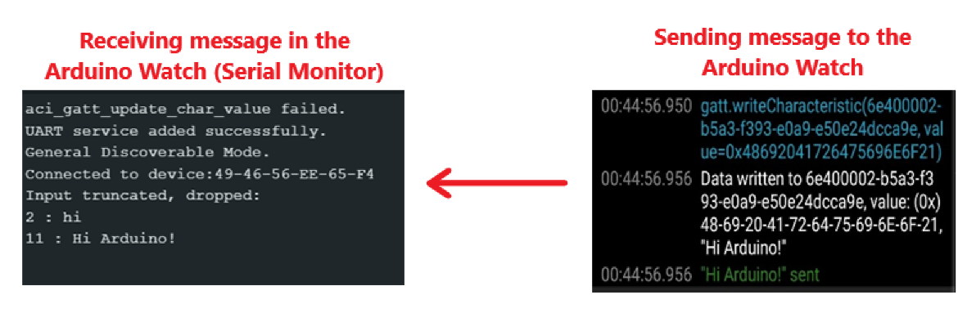

Figure 115: Receiving a message from the smartphone to the Arduino Watch.

This code has certain limitations; currently, only 20 characters of data can be sent at a time.

In summary, the AFNT project has made significant strides in implementing its core functionalities across multiple phases. Notably, Phase 1 has achieved over 90% completion, focusing on database design and setup, while Phase 3 and Phase 4 are approximately 70% implemented, emphasizing the development of the AFNT application and integration with the Arduino Watch. Despite challenges and constraints, such as time limitations and project priorities, the project has leveraged a range of technologies and frameworks to realize its objectives effectively. Moreover, this chapter underscores the importance of each phase's contributions to the overall success of the AFNT project and highlights areas for further exploration and refinement in subsequent project stages.

# Project Evaluation

This chapter aims to evaluate the AFNT project by assesses the progress and achievements across its key phases. This evaluation encompasses a review of project objectives, agile development practices, successes, challenges encountered in each phase, and comprehensive testing strategies.

## Requirements and Objectives

In summary, the AFNT project is driven by five main objectives. Objective 1 is nearly complete but requires additional data and testing for the CDB, while the LDB has been fully implemented. Objective 2 has achieved significant progress but lacks meal tracking, gym locater, cross-platform and administrative management features, leading to Phase 2 (O3) development, which was limited due to time constraints. Objective 4 has fulfilled most of its requirements, including connection with the AFNT app, but lacks BLE communication and robust synchronization techniques with the application, primarily due to time limitations. Finally, Objective 5 focuses on ensuring clean and manageable program code, a goal that has been achieved, although further optimization remains possible.



Figure 116: AFNT Objectives.

As for project requirements, the project currently encompasses a total of 117 requirements, which have undergone several reviews and revisions throughout the project's timeline. Among these requirements, 10 of these are categorized as "W" (won't have). Each requirement's completion contributes to the project's progress and goal achievement. A scoring system is employed where completed requirements score a full point, while those in progress or partially complete score 0.5, and requirements not yet implemented score 0. Using this scoring method, the overall progress of the AFNT project is estimated at around 74%. This calculation reflects the advancement of the project in meeting its objectives, though it does not consider the priority levels assigned to requirements based on the MoSCoW framework. Below is a table illustrating the current progress status of the requirements.

Table 36: Functional Requirement Progress.

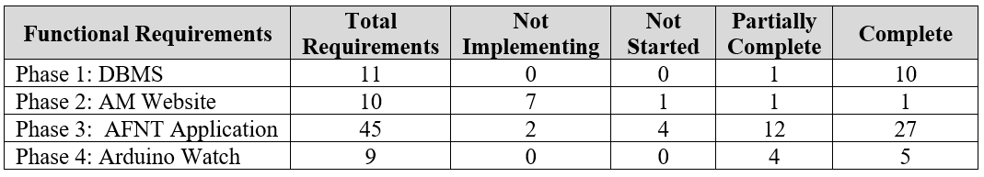

Table 37: Non-Functional Requirement Progress.

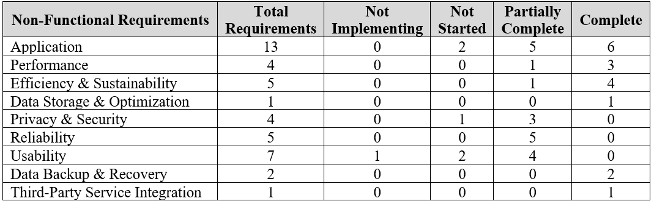

## Agile and Kanban

Utilizing Trello for agile development greatly facilitated the identification, division, and implementation of tasks based on project requirements and phases, which were derived from UML diagrams and user stories. This approach enabled efficient tracking and management of tasks and requirements. The use of a Gantt chart and sprint planner further improved project management, allowing for iterative feedback and continuous enhancement. Overall, this experience has been invaluable, providing essential skills in managing large, long-term projects and enabling comfortable adaptation to industry-standard Kanban boards and agile methodologies.

## Successes and Challenges in Each Phase

### Phase 1

Phase 1 and 1.5 progressed smoothly in terms of development and meeting deadlines (Sprint 1), leveraging my extensive experience in database design and development gained throughout the course. The implementation of the LDB and CDB proceeded seamlessly. However, I encountered challenges with testing and acquiring data to populate the database. To address this, I sourced data samples from online platforms like Kaggle, which required adjustments to align with database requirements and ensure data security.

### Phase 2

Following the completion of Phase 1, I transitioned into Phase 2 of the project, delving into server technologies and Python Flask. Despite facing time constraints and lower project priority, I initiated research and groundwork on server setups and Flask implementation. While unable to fully complete this phase, I successfully created wireframes for the website and made significant progress in website development, particularly by implementing the login functionality. However, delays in the design and planning phases of subsequent project stages, namely Phase 3 and the newly introduced Phase 4, posed challenges in sustaining momentum for Phase 2 development. Nevertheless, this experience provided valuable insights into server technologies and Python Flask, enriching my understanding of these domains.

### Phase 3

Phase 3 encountered persistent delays attributed to iterative design changes and evolving requirements for the AFNT App. After finalizing the design, planning, and research on Kivy GUI, Phase 3 development commenced shortly before the Project in Progress week (Sprint 2), resulting in a significant three-week delay. Despite these setbacks, substantial progress was made between February and March (Sprint 3), with the completion of most Phase 3 requirements, including workout management, body data tracking, and water intake monitoring features. However, critical tasks such as nutrition tracking were left unfinished, and the gym tracking feature, though partially implemented with the integration of MapAPI, remained incomplete due to time constraints and the impending need to shift focus to Phase 4, which presented greater challenges as the project deadline drew near.

### Phase 4

Phase 4 started positively with thorough research to acquire the necessary components for the Arduino Watch, tailored to meet project specifications. I opted for TinyCircuits and purchased their modular components due to their compact size and ease of assembly without soldering, despite the higher cost. This investment proved valuable as it provided me with substantial knowledge in Arduino development, an area I had not explored previously. The bulk of Arduino Watch implementation occurred from late March to mid-April (Sprint 4), which was challenging given the project deadline at the end of April and associated shipping delays. Despite these constraints, I rapidly quickly learned and implemented foundational body data tracking and recording functionalities outlined in Phase 4. However, due to limited familiarity with Bluetooth Low Energy (BLE) technology, I could not fully complete the BLE implementation or synchronization with the AFNT app. Nonetheless, I successfully established a basic connection between the Arduino Watch and my smartphone, enabling limited message exchange within the project scope.

## Testing

[**Click Here**](https://github.com/alisuhail-amanu2/AFNT/blob/main/Documents/Test%20Sheet.xlsx)to access the test sheets.

Phases 1, 3, and 4 were thoroughly tested using an open-source agile testing template ('Test Case Template', 2023). Each test case is uniquely identified by an ID that specifies the project phase, test scenario, pre and post-conditions, steps to replicate the test, and expected versus actual results. Additionally, evidence in the form of before and after screenshots accompanies each test case to provide comprehensive validation. Moreover, the test case ID format includes an abbreviation representing the type of test case and the specific project phase being tested, followed by a unique indexing number.

To identify tests for Phases 1 and 3 related to the DBMS and application: The test case ID format includes 'A' to denote Application, followed by a screen name abbreviation and a corresponding number. For instance, 'AWIPS1' represents <*Application*><*Water Intake Plots Screen*><*ID 1*>.

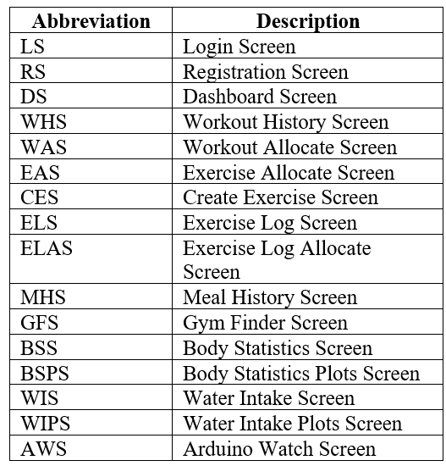

Figure 117: Test Case ID Abbreviations (Application).

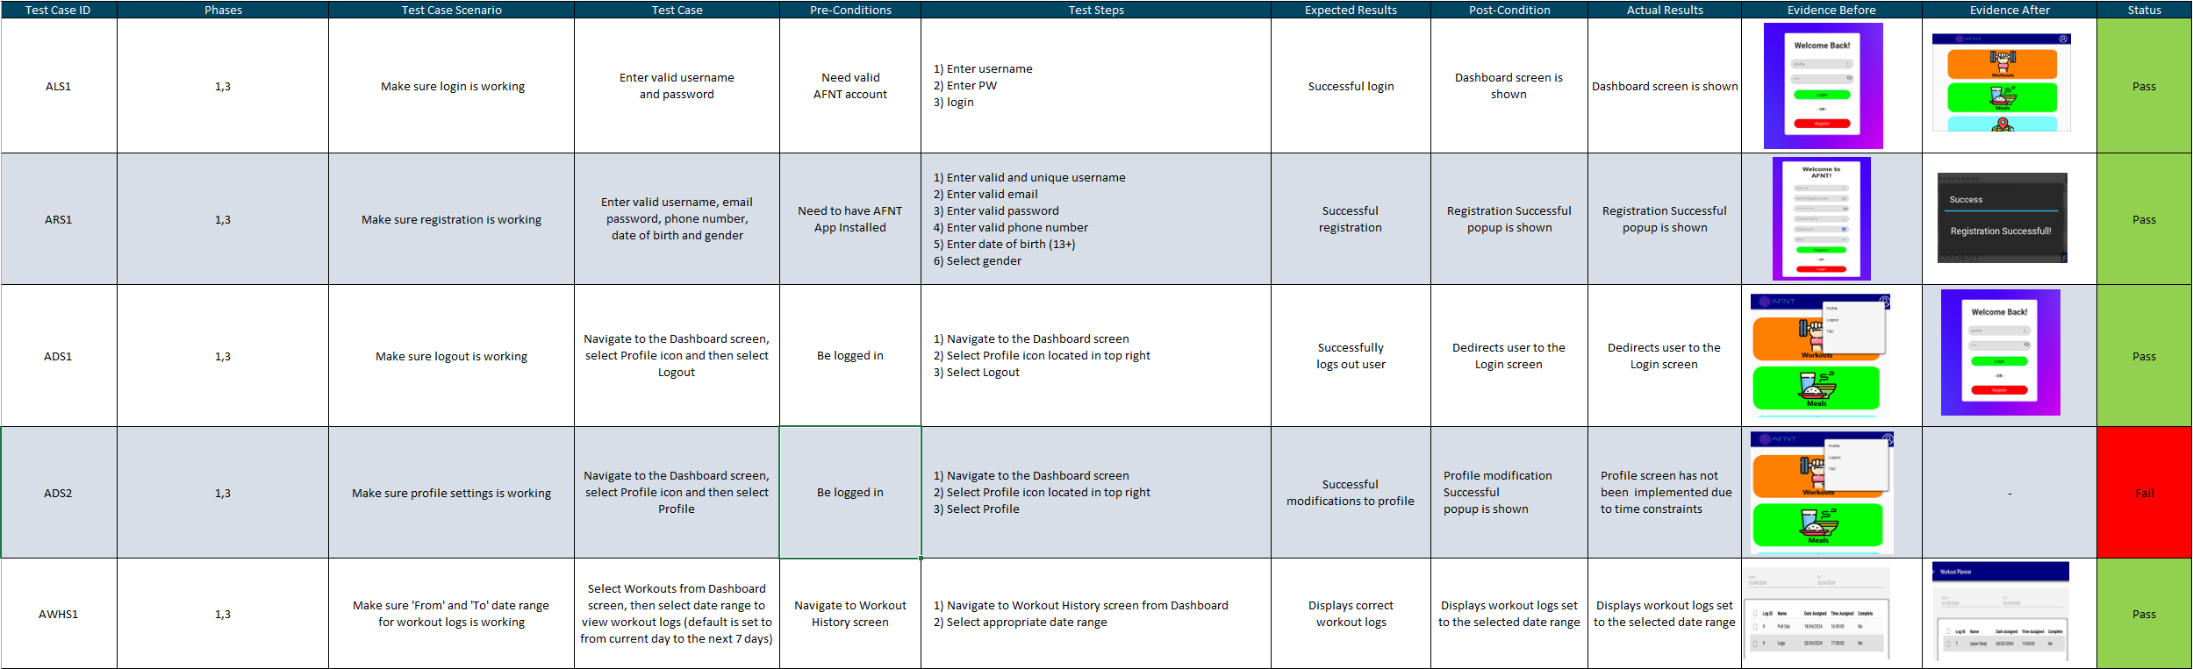

Figure 118: [Screenshot of Application Test Cases.](https://github.com/alisuhail-amanu2/AFNT/blob/main/Documents/Test%20Sheet.xlsx)

For identifying Arduino Watch tests: The test case ID format begins with 'AW' followed by a number. For example, 'AW5' denotes <*Arduino Watch*><*ID 5*>.

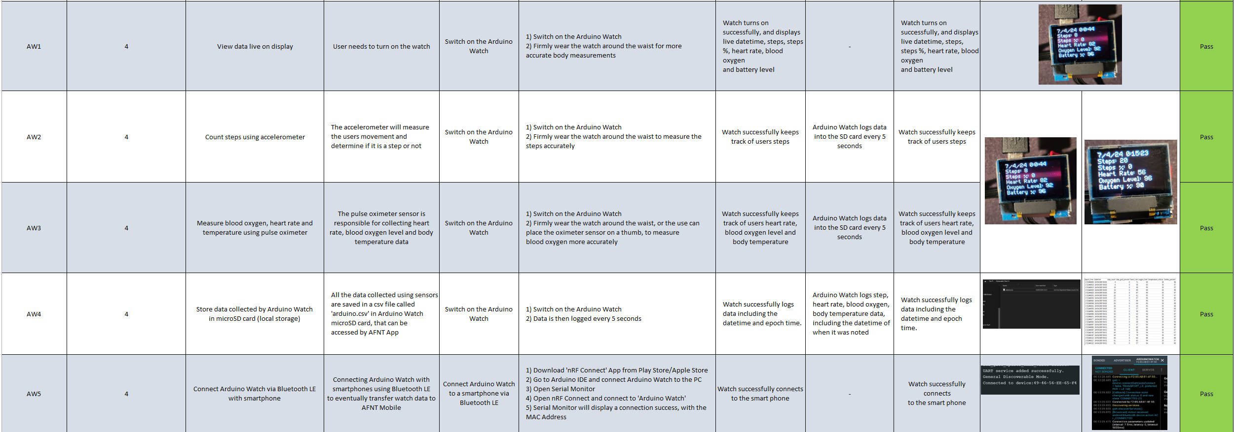

Figure 119: [Screenshot of Arduino Watch Test Cases.](https://github.com/alisuhail-amanu2/AFNT/blob/main/Documents/Test%20Sheet.xlsx)

There are a total of 51 tests, with 43 dedicated to Phases 1 and 3, and the remaining 8 specific to the Arduino Watch. Out of these tests, 5 have failed primarily due to incomplete implementation of related requirements or functionalities. Since tests are designed based on implemented requirements, there are no tests for unimplemented functionalities. Despite the failures, the overall test results are promising, showcasing the project's progress in terms of functionality. The failed tests are attributed to incomplete features such as nutrition tracking, gym tracking, and the Arduino Watch's BLE functionality, which were constrained by time limitations.

Agile testing strategies, like the one used here, played a crucial role in the iterative development of the AFNT project by continuously assessing project functionalities against defined criteria. These tests help identify issues early, allowing for prompt resolution and ensuring that subsequent iterations incorporate necessary improvements. By integrating testing into each phase, agile methodologies promote flexibility and responsiveness to changing project requirements, ultimately enhancing the overall quality and functionality of the deliverables.

The evaluation of the AFNT project highlights significant progress and challenges across its phases. Agile methodologies, including Trello for task management and agile testing templates, have facilitated structured project execution. Objectives 1, 2, 4, and 5 have achieved substantial progress, with certain features requiring further development. Each project phase encountered unique challenges, such as data acquisition in Phase 1 and design delays in Phase 3. Testing has been integral, identifying areas for improvement, particularly in incomplete functionalities. Moving forward, the project aims to address outstanding requirements and optimize functionalities while leveraging agile methodologies to refine the AFNT project.

# Further Work and Conclusions

# References / Bibliography

1. Campbell, D. (2023) *More than half of humans on track to be overweight or obese by 2035 – report* *the Guardian*. 2 March 2023 [online]. Available from: https://www.theguardian.com/society/2023/mar/02/more-than-half-of-humans-on-track-to-be-overweight-or-obese-by-2035-report [Accessed 22 January 2024].
2. ‘Obesity Consequences’ (2012) *Obesity Prevention Source*. 21 October 2012 [online]. Available from: https://www.hsph.harvard.edu/obesity-prevention-source/obesity-consequences/#:~:text=The%20High%20Cost%20of%20Excess%20Weight&text=No%20less%20real%20are%20the,overweight%20does%20not%20decrease%20mortality. [Accessed 22 January 2024].
3. ‌Wright, S. and Aronne, L.J. (2012) Causes of obesity. *PubMed* [online]. 37 (5), pp. 730–732. Available from: https://link.springer.com/article/10.1007/s00261-012-9862-x [Accessed 22 January 2024].
4. Desjardins, J. (2020) *Animation: The World’s Rapid Rise in Life Expectancy, in Just 13 Seconds* *Visual Capitalist*. 11 May 2020 [online]. Available from: https://www.visualcapitalist.com/rapid-rise-in-life-expectancy/ [Accessed 23 January 2024].
5. ‌ Woessner, M.N., Tacey, A., Ariella Levinger-Limor, Parker, A., Levinger, P. and Levinger, I. (2021) The Evolution of Technology and Physical Inactivity: The Good, the Bad, and the Way Forward. *Frontiers in Public Health* [online]. 9. Available from: https://www.frontiersin.org/articles/10.3389/fpubh.2021.655491/full?&utm_source=Email_to_authors_&utm_medium=Email&utm_content=T1_11.5e1_author&utm_campaign=Email_publication&field=&journalName=Frontiers_in_Public_Health&id=655491#F1 [Accessed 23 January 2024].
6. ‌Caballero B. (2007) The Global Epidemic of Obesity: An Overview. *Epidemiologic Reviews* [online]. 29 (1), pp. 1–5. Available from: https://academic.oup.com/epirev/article/29/1/1/444345?login=false [Accessed 23 January 2024].
7. Moscaritolo, A. (2024) *The Ultimate Guide to Health and Fitness Tech for 2024* *PCMag UK*. 5 January 2024 [online]. Available from: https://uk.pcmag.com/gallery/130809/the-ultimate-guide-to-health-and-fitness-tech [Accessed 23 January 2024].
8. ‌ Pankush Kalgotra, Raja, U. and Sharda, R. (2022) Growth in the development of health and fitness mobile apps amid COVID-19 pandemic. *DOAJ (DOAJ: Directory of Open Access Journals)* [online]. 8, p. 205520762211290-205520762211290. Available from: https://www.ncbi.nlm.nih.gov/pmc/articles/PMC9536106/ [Accessed 23 January 2024].
9. ‘Fitness App Revenue and Usage Statistics (2024)’ (2024) *Business of Apps*. 8 January 2024 [online]. Available from: https://www.businessofapps.com/data/fitness-app-market/ [Accessed 23 January 2024].
10. ‌‘How to look after your mental health using exercise’ (2015) *Mental Health Foundation*. 2015 [online]. Available from: https://www.mentalhealth.org.uk/explore-mental-health/publications/how-look-after-your-mental-health-using-exercise [Accessed 17 October 2023].
11. ‌ ‘7 great reasons why exercise matters’ (2023) *Mayo Clinic*. 2023 [online]. Available from: https://www.mayoclinic.org/healthy-lifestyle/fitness/in-depth/exercise/art-20048389 [Accessed 17 October 2023].
12. ‌ Godman, H. (2014) *Regular exercise changes the brain to improve memory, thinking skills - Harvard Health* *Harvard Health*. 9 April 2014 [online]. Available from: https://www.health.harvard.edu/blog/regular-exercise-changes-brain-improve-memory-thinking-skills-201404097110 [Accessed 17 October 2023].
13. ‌ ‘How Can Exercise Affect Sleep? | Sleep Foundation’ (2013) *Sleep Foundation*. 25 February 2013 [online]. Available from: https://www.sleepfoundation.org/physical-activity/exercise-and-sleep [Accessed 17 October 2023].
14. ‌ ‘How to boost your immune system - Harvard Health’ (2014) *Harvard Health*. 22 September 2014 [online]. Available from: https://www.health.harvard.edu/staying-healthy/how-to-boost-your-immune-system [Accessed 17 October 2023].
15. www.facebook.com/thefitnessgrp (2023) *How Much Does a Gym Membership Cost in the UK (2023)* *Thefitnessgrp.co.uk*. 19 July 2023 [online]. Available from: https://www.thefitnessgrp.co.uk/how-much-does-a-gym-membership-cost/ [Accessed 25 January 2024].
16. ‘Top excuses people use for not going to the gym | Better’ (2023) *Better.org.uk*. 2023 [online]. Available from: https://www.better.org.uk/content_pages/top-gym-excuses [Accessed 25 January 2024].
17. Millington, B. (2018) *A brief history (and a look into the future) of fitness technology* *The Conversation*. 11 January 2018 [online]. Available from: https://theconversation.com/a-brief-history-and-a-look-into-the-future-of-fitness-technology-89884 [Accessed 23 January 2024].
18. ‘Healthcare - Apple Watch’ (2017) *Apple (United Kingdom)*. 2017 [online]. Available from: https://www.apple.com/uk/healthcare/apple-watch/ [Accessed 23 January 2024].
19. ‌ Waghchoure, E. (2023) *The Evolution of Fitness Trackers: Your Personal Health Companion* *Medium*. 16 September 2023 [online]. Available from: https://medium.com/@elijah.ndspl/the-evolution-of-fitness-trackers-your-personal-health-companion-5745e41ee9e2 [Accessed 23 January 2024].
20. ‘Samsung Health | Apps & Services | Samsung UK’ (2023) *Samsung uk*. 21 November 2023 [online]. Available from: https://www.samsung.com/uk/apps/samsung-health/ [Accessed 26 January 2024].
21. ‘Calorie Tracker & BMR Calculator to Reach Your Goals | MyFitnessPal’ (2024) *Myfitnesspal.com*. 2024 [online]. Available from: https://www.myfitnesspal.com/ [Accessed 26 January 2024].
22. ‘Lose It! - Calorie counting made easy’ (2022) *Loseit.com*. 2022 [online]. Available from: https://www.loseit.com/ [Accessed 26 January 2024].
23. ‘Strava | Running, Cycling & Hiking App - Train, Track & Share’ (2024) *Strava.com*. 2024 [online]. Available from: https://www.strava.com/features [Accessed 26 January 2024].
24. ‘The Fitbit App’ (2024) *Fitbit.com*. 2024 [online]. Available from: https://www.fitbit.com/global/uk/technology/fitbit-app [Accessed 26 January 2024].
25. Garmin International (2024) *Garmin Connect | Free Online Fitness Community* *Garmin Connect*. 2024 [online]. Available from: https://connect.garmin.com/ [Accessed 26 January 2024].
26. ‘Nike Training Club App. Home Workouts & More.’ (2023) *Nike.com*. 2023 [online]. Available from: https://www.nike.com/ntc-app [Accessed 24 January 2024].
27. (Beachbodyondemand, 2023) *Beachbodyondemand.com*. 2023 [online]. Available from: https://www.beachbodyondemand.com/?locale=en_US [Accessed 24 January 2024].
28. ‌‘Permissions on Android’ (2024) *Android Developers*. 2024 [online]. Available from: https://developer.android.com/guide/topics/permissions/overview#normal-dangerous [Accessed 24 January 2024].
29. ‌Olmstead, K. (2015) *Apps Permissions in the Google Play Store* *Pew Research Center: Internet, Science & Tech*. 10 November 2015 [online]. Available from: https://www.pewresearch.org/internet/2015/11/10/apps-permissions-in-the-google-play-store/ [Accessed 24 January 2024].
30. Grundy, Q., Held, F. and Bero, L. (2017) Tracing the Potential Flow of Consumer Data: A Network Analysis of Prominent Health and Fitness Apps. *Journal of Medical Internet Research* [online]. 19 (6), pp. e233–e233. Available from: https://www.jmir.org/2017/6/e233/#ref7 [Accessed 24 January 2024].
31. Li, J. (2015) A Privacy Preservation Model for Health-Related Social Networking Sites. *Journal of Medical Internet Research* [online]. 17 (7), pp. e168–e168. Available from: https://www.jmir.org/2015/7/e168/ [Accessed 24 January 2024].
32. ‘Appconner - Best Apps & Stories’ (2021) *Appconner*. 2021 [online]. Available from: https://www.appconner.com/app-samsung-health?utm_source=bing&utm_medium=cpc&utm_campaign=%e6%96%b0213b_afcapp_uk_jay%209.30%200.1*&utm_term=samsung%20health&utm_content=1830_samsung%20health* [Accessed 26 January 2024].
33. ‘Overview of UK GDPR’ (2016) *Practical Law*. 2016 [online]. Available from: https://uk.practicallaw.thomsonreuters.com/Document/I968a9c521afe11e89bf099c0ee06c731/View/FullText.html?navigationPath=Search%2Fv1%2Fresults%2Fnavigation%2Fi0ad740160000018d3e479a10da2c4879%3Fppcid%3Dc2504c02e0aa4c198285633427e0550a%26Nav%3DKNOWHOW_UK%26fragmentIdentifier%3DI968a9c521afe11e89bf099c0ee06c731%26parentRank%3D0%26startIndex%3D1%26contextData%3D%2528sc.Search%2529%26transitionType%3DSearchItem&listSource=Search&listPageSource=4be1b00a2501e5d28b058acb57e263c2&list=KNOWHOW_UK&rank=2&sessionScopeId=09fc82fad034c2252f14fe02939c428e76892af50a3a0a55be4a0ac57ed2c67c&ppcid=c2504c02e0aa4c198285633427e0550a&originationContext=Search%20Result&transitionType=SearchItem&contextData=(sc.Search)&comp=pluk [Accessed 25 January 2024].
34. WCAG 2 (2018) *WCAG 2 Overview* *Web Accessibility Initiative (WAI)*. 2018 [online]. Available from: https://www.w3.org/WAI/standards-guidelines/wcag/ [Accessed 25 January 2024].
35. ‘Powerful and Fast UML Diagramming Software - Astah’ (2023) *Astah*. September 2023 [online]. Available from: https://astah.net/products/astah-uml/ [Accessed 25 January 2024].
36. ‘Free Online Spreadsheet Software: Excel | Microsoft 365’ (2016) *Microsoft.com*. 2016 [online]. Available from: https://www.microsoft.com/en-us/microsoft-365/excel?ocid=ORSEARCH_Bing [Accessed 25 January 2024].
37. ‘SQLite Home Page’ (2024) *Sqlite.org*. 2024 [online]. Available from: https://www.sqlite.org/index.html [Accessed 25 January 2024].
38. ‘SQL Server Downloads | Microsoft’ (2022) *Microsoft.com*. 2022 [online]. Available from: https://www.microsoft.com/en-GB/sql-server/sql-server-downloads [Accessed 25 January 2024].
39. ‘Welcome to Flask — Flask Documentation (3.0.x)’ (2024) *Palletsprojects.com*. 2024 [online]. Available from: https://flask.palletsprojects.com/en/3.0.x/ [Accessed 25 January 2024].
40. ‘Kivy: Cross-platform Python Framework for NUI’ (2024) *Kivy.org*. 2024 [online]. Available from: https://kivy.org/ [Accessed 25 January 2024].
41. ‘TinyCircuits - Maker of Tiny, Open Source Electronics’ (2024) *TinyCircuits*. 2024 [online]. Available from: https://tinycircuits.com/ [Accessed 25 January 2024].
42. ‘TinyCircuits Projects’ (2022) *TinyCircuits*. 24 January 2022 [online]. Available from: https://tinycircuits.com/blogs/learn [Accessed 25 January 2024].
43. Business, A. (2022) *Chapter 10: MoSCoW Prioritisation* *Agilebusiness.org*. 2022 [online]. Available from: https://www.agilebusiness.org/dsdm-project-framework/moscow-prioririsation.html [Accessed 22 March 2024].
44. Alam, M. (2022) *7 Crucial UML Diagram Advantages* *IdeaScale*. 16 March 2022 [online]. Available from: https://ideascale.com/blog/uml-diagram-advantages/ [Accessed 22 March 2024].
45. Atlassian (2019) *What is kanban?* *Atlassian*. 2019 [online]. Available from: https://www.atlassian.com/agile/kanban#:~:text=Kanban%20is%20one%20of%20the,for%20teams%20of%20all%20sizes. [Accessed 22 March 2024].
46. Pandit, N. (2022) *Gym Exercise Dataset* *Kaggle.com*. 2022 [online]. Available from: https://www.kaggle.com/datasets/niharika41298/gym-exercise-data/data [Accessed 23 March 2024].
47. vinitshah0110 (2022) *Food Composition* *Kaggle.com*. 2022 [online]. Available from: https://www.kaggle.com/datasets/vinitshah0110/food-composition [Accessed 23 March 2024].
48. ‘Body Fat Calculator’ (2017) *Calculator.net*. 2017 [online]. Available from: https://www.calculator.net/body-fat-calculator.html [Accessed 23 March 2024].
49. ‘BMI Calculator’ (2024) *Calculator.net*. 2024 [online]. Available from: https://www.calculator.net/bmi-calculator.html [Accessed 23 March 2024].
50. ‘TinyDuino Overview - TinyCircuits Docs’ (2024) *Tinycircuits.com*. 2024 [online]. Available from: https://learn.tinycircuits.com/TinyDuino_Overview/ [Accessed 20 April 2024].
51. ‘OLED Shield | TinyScreen | TinyCircuits.com’ (2024) *TinyCircuits*. 2024 [online]. Available from: https://tinycircuits.com/products/tinyscreen?variant=13748964423 [Accessed 18 April 2024].
52. ‘Lithium Ion Polymer Battery - 3.7V 290mAh | TinyCircuits.com’ (2024) *TinyCircuits*. 2024 [online]. Available from: https://tinycircuits.com/products/lithium-ion-polymer-battery-3-7v-290mah?_pos=4&_sid=64d75c1d1&_ss=r [Accessed 18 April 2024].
53. ‘MicroSD Shield | TinyShield | TinyCircuits.com’ (2024) *TinyCircuits*. 2024 [online]. Available from: https://tinycircuits.com/products/microsd-tinyshield?_pos=3&_sid=33c073989&_ss=r [Accessed 18 April 2024].
54. ‘TinyCircuits | Wireling Adapter’ (2022) *TinyCircuits*. 2022 [online]. Available from: https://tinycircuits.com/products/wireling-adapter-tinyshield?_pos=14&_sid=924b00554&_ss=r [Accessed 18 April 2024].
55. ‘TinyCircuits | Accelerometer Shield’ (2024) *TinyCircuits*. 2024 [online]. Available from: https://tinycircuits.com/products/accelerometer-tinyshield?_pos=3&_sid=5fb80dca9&_ss=r [Accessed 18 April 2024].
56. ‘TinyCircuits | Accelerometer Sensor’ (2024) *TinyCircuits*. 2024 [online]. Available from: https://tinycircuits.com/products/accelerometer-wireling-bma250?_pos=2&_sid=97eec2ab4&_ss=r [Accessed 18 April 2024].
57. ‘TinyCircuits | Pulse Oximeter Sensor’ (2024) *TinyCircuits*. 2024 [online]. Available from: https://tinycircuits.com/products/pulse-oximetry-sensor-wireling [Accessed 18 April 2024].
58. ‘TinyCircuits | Bluetooth Low Energy Shield (ST)’ (2024) *TinyCircuits*. 2024 [online]. Available from: https://tinycircuits.com/products/bluetooth-low-energy-tinyshield [Accessed 18 April 2024].
59. Douglas, J. (2023) *Introduction to Python Visual Programming with kvlang* *Medium*. 25 February 2023 [online]. Available from: https://medium.com/@joshua.d1434/introduction-to-python-visual-programming-with-kvlang-a0960bdfd776 [Accessed 20 April 2024].
60. ‘KivyMD 2.0.1.dev0 documentation’ (2022) *Readthedocs.io*. 2022 [online]. Available from: https://kivymd.readthedocs.io/en/latest/index.html [Accessed 19 April 2024].
61. Volkwyn, T.S., Bor Gregorcic, Airey, J. and Linder, C. (2020) Learning to use Cartesian coordinate systems to solve physics problems: the case of ‘movability’. *European journal of physics* [online]. 41 (4), pp. 045701–045701. Available from: https://iopscience.iop.org/article/10.1088/1361-6404/ab8b54/meta [Accessed 20 April 2024].
62. Jorge Stolfi (2018) *Cartesian coordinate system* *Wikipedia*. 16 April 2024 [online]. Available from: https://en.wikipedia.org/wiki/Cartesian_coordinate_system#/media/File:Coord_system_CA_0.svg [Accessed 20 April 2024].
63. GeeksforGeeks (2022) *Magnitude of a Vector* *GeeksforGeeks*. 30 January 2022 [online]. Available from: https://www.geeksforgeeks.org/magnitude-of-a-vector/ [Accessed 20 April 2024].
64. ‘Test Case Template’ (2023) *ProjectManager*. 8 November 2023 [online]. Available from: https://www.projectmanager.com/templates/test-case-template [Accessed 21 April 2024].
65. ‌

‌

# Appendix A: Requirements

## Project Aim

To design and implement a software solution focused on helping users achieve their fitness objectives. This involves developing a user-friendly platform for creating and customising workout routines, monitoring nutrition and workout progress, and offering health and fitness guidance. The main aim is to build an engaging and efficient fitness tool that encourages users to live healthier, more active lives.

## Project Objectives

Please note all requirements will be marked by MoSCow Prioritization technique.

|  |  |  |  |
| --- | --- | --- | --- |
| **ID** | **Objective** | **Description** | **Created** |
| O1 | Develop a Scalable and Secure Database Management System (DBMS) | Develop a scalable MySQL DBMS, including a central database for 2,000+ records and a local database for user data and watch data. Improve database performance and security and ensure GDPR compliance. | 09/10/2023 |
| O2 | Build the Alistana Fitness & Nutrition Tracker (AFNT) Application | Develop the AFNT application with features for workout and nutrition tracking, body progress and measurement tracking. Should be connected to DBMS, Admin Management website (only for Admins), and Arduino watch. | 09/10/2023 |
| O3 | Design a User-Centric Admin Management (AM) Website | Develop a responsive website with secure login and allows Admins to edit the central database (user login data and preset workout and meal data) and app push updates to the AFNT application. The website will prioritize a user-friendly design, encrypted communication, and security measures. | 09/10/2023 |
| O4 | Design and develop a Fitness Watch using Arduino | Create an Arduino-based Fitness watch to measure blood oxygen level, heart rate and step count, and investigate ways of connecting the Arduino watch to the AFNT and store body data in the local database via AFNT. | 16/10/2023 |
| O5 | Enhance Code Quality and Performance | Implement clean, maintainable code with 80% code coverage. Optimize application and website response times to under 2 and 3 seconds, respectively. | 25/10/2023 |

## Functional Requirements

The functional requirements are divided into 4 categories: Database, Website, Application and Arduino Watch. These categories may be divided into further sub-categories to make them more readable, making it easier to track progress.

### Database

|  |  |  |  |  |
| --- | --- | --- | --- | --- |
| **Database Management System (DBMS)** | | | | |
| **ID** | **Summary** | **Priority** | **Status** | **Created** |
| **Central Database (CDB)** | | | | |
| FD1 | The central database should be stored in a MySQL Server. | M | Complete | 25/10/2023 |
| FD2 | Should store preset meals, food items, exercises, and workouts with attributes such as meal_id, food_item_id, exercise_id, and workout_id. | M | Complete | 11/10/2023 |
| FD3 | Store user information in CDB with attributes such as user, email, password hash, type (User or Admin), gender, phone, address, and date created. | M | Complete | 25/10/2023 |
| FD4 | Support queries to retrieve preset meals, food items, exercises, and workouts based on various filters such as meal type, food category, exercise category, and workout difficulty. | M | Complete | 25/10/2023 |
| FD5 | Provide data synchronization capabilities to update the local database with the latest preset data by comparing the timestamps of the local and central databases. | M | Partially Complete | 25/10/2023 |
| **Local Database (LDB)** | | | | |
| FD6 | The local database should be stored in the user drive using SQLite. | M | Complete | 25/10/2023 |
| FD7 | Store both preset and custom (combined as one) in tables: meals, meal_logs food_items, food_item_logs. exercises, exercise_logs workouts, workout_logs, heart rate, blood oxygen level, and step count. | M | Complete | 16/10/2023 |
| FD8 | Store user information in LDB with attributes such as user, email, password hash, type (User or Admin), gender, phone, address, and date created. | M | Complete | 16/10/2023 |
| FD9 | Support updates to custom meals, workouts, exercises, and health metrics by allowing users to add, modify, and delete records. | M | Complete | 09/10/2023 |
| FD10 | Store health metrics from the Arduino watch including step count, heart rate and blood oxygen level. | M | Complete | 17/10/2023 |
| FD11 | Store other metrics such as height (meters), weight (kg), BMI, skeletal muscle (kg), body fat (%) and water intake (ml), | M | Complete | 26/10/2023 |

### Website

|  |  |  |  |  |
| --- | --- | --- | --- | --- |
| **Admin Management Website (AM)** | | | | |
| **ID** | **Summary** | **Priority** | **Status** | **Created** |
| FW1 | The AFNT App shall link to the AM website for Admin login. | S | Not Started | 09/10/2023 |
| FW2 | The website should only be accessible to Admins and can be accessed Online or via AFNT App. | S | Partially Complete | 09/10/2023 |
| FW3 | The website shall allow Admin users to log in securely with their credentials. | S | Complete | 09/10/2023 |
| FW6 | The website shall allow admins to modify user personal details (i.e., profile picture, name, age, gender, dob, email, password, phone, address, and postcode. | C | Not Implementing | 09/10/2023 |
| FW7 | The website shall allow admins to edit their own profiles (profile picture, name, age, gender, dob, email, password, phone, address, and postcode). | C | Not Implementing | 09/10/2023 |
| FW8 | The website should allow admins to add/modify/delete preset workout data | M | Not Implementing | 09/10/2023 |
| FW9 | The website should allow admins to add/modify/delete preset exercise data | M | Not Implementing | 09/10/2023 |
| FW10 | The website should allow admins to add/modify/delete preset meal data | M | Not Implementing | 09/10/2023 |
| FW11 | The website should allow admins to add/modify/delete preset food item data | M | Not Implementing | 09/10/2023 |
| FW12 | The website shall allow admins to push database updates to the AFNT application. | M | Not Implementing | 10/10/2023 |

### Application

|  |  |  |  |  |
| --- | --- | --- | --- | --- |
| **Alistana Fitness & Nutrition Tracker Application (AFNT)** | | | | |
| **ID** | **Summary** | **Priority** | **Status** | **Created** |
| **Login and Registration** | | | | |
| FA41 | The application shall allow users to login using their username and password credentials. | M | Complete | 17/10/2023 |
| FA42 | The application shall allow users to register, and they must provide details such as username, email, password, phone number, email address, address, date of birth and gender. | M | Complete | 17/10/2023 |
| **User Profile** | | | | |
| FA43 | The application shall allow users to modify their personal data such as profile picture, username, email, password, phone number, email address, address, date of birth and gender. | M | Partially Complete | 17/10/2023 |
| FA44 | The application shall allow users to delete their personal data. | M | Partially Complete | 17/10/2023 |
| FA45 | The application shall allow users to delete their account and all the data associated with it. | M | Partially Complete | 17/10/2023 |
| **Workout Tracker** | | | | |
| FA1 | The application shall allow users to create their own workout plans. | M | Complete | 09/10/2023 |
| FA2 | The application shall allow users to customize their own workout plans. | M | Complete | 09/10/2023 |
| FA3 | The application shall allow users to choose pre-designed workout plans based on their goals. | M | Complete | 09/10/2023 |
| FA4 | The application shall allow users to receive suggested workouts based on fitness goals. | S | Partially Complete | 09/10/2023 |
| FA5 | The application shall allow users to track their workouts by recording exercises, sets, reps, and weights (For custom exercises). | M | Complete | 09/10/2023 |
| FA6 | The application shall allow users to rate their performance for each exercise (For both preset and custom). | M | Complete | 09/10/2023 |
| FA7 | The application shall allow users to rate their performance for each workout (For both preset and custom). | M | Complete | 09/10/2023 |
| FA8 | The application shall allow users to view their workout logs (For both preset and custom). | M | Complete | 09/10/2023 |
| FA9 | The application shall allow users to view their exercise logs (For both preset and custom). | M | Complete | 09/10/2023 |
| FA10 | The application shall allow users to display graphs of each exercise progress (i.e., Bench press max weight every month). | M | Partially Complete | 09/10/2023 |
| FA11 | The application shall allow users to display graphs of cardio-related exercises (i.e., Step/Distance for treadmill session) by manually inputting the information. | M | Complete | 23/10/2023 |
| FA12 | The application shall allow users to display graphs of cardio-related exercises (i.e., Step/Distance for treadmill session) provided by the Arduino watch. | M | Complete | 23/10/2023 |
| FA13 | The application shall produce charts for weight in kilogram (per day). | M | Complete | 26/10/2023 |
| FA14 | The application shall allow users to set goals for workouts. | C | Not Started | 24/10/2023 |
| **Nutrition Tracker** | | | | |
| FA15 | The application shall allow users to select preset food items. | M | Complete | 09/10/2023 |
| FA16 | The application shall allow users to select preset meals. | M | Partially Complete | 09/10/2023 |
| FA17 | The application shall allow users to create custom food items and define their nutritional contents (i.e., calories, protein, carbs, fats etc.) | M | Partially Complete | 09/10/2023 |
| FA18 | The application shall allow users to create custom meals and add food items (Both custom and preset) to the custom meal. | M | Partially Complete | 26/10/2023 |
| FA19 | The application shall allow users to modify custom food items. | M | Partially Complete | 09/10/2023 |
| FA20 | The application shall allow users to modify custom meals. | M | Partially Complete | 09/10/2023 |
| FA21 | The application shall allow users to input daily water intake in milliliters (per day). | M | Complete | 09/10/2023 |
| FA22 | The application shall allow users to generate a daily calorie intake graph based on a selected date range. | M | Not Started | 24/10/2023 |
| FA23 | The application shall allow users to generate a daily nutritional content intake (i.e., Carbs, fat, protein intake per day) graph based on a selected date range. | M | Not Started | 24/10/2023 |
| FA24 | The application shall allow users to generate a daily water intake graph based on a selected date range. | M | Complete | 24/10/2023 |
| FA25 | The application shall allow users to set goals for nutritional intake. | C | Not Started | 25/10/2023 |
| FA26 | The application shall allow users to set goals for their water intake | C | Partially Complete | 25/10/2023 |
| **Body Measurements Tracker** | | | | |
| FA27 | The application shall allow users to input their daily weight in kilograms (per day). | M | Complete | 26/10/2023 |
| FA28 | The application shall allow users to input their daily height in meters (per day). | M | Complete | 26/10/2023 |
| FA29 | The application shall allow users to input Skeletal muscle data in kilograms (per day). | M | Complete | 26/10/2023 |
| FA30 | The application shall allow users to input Body fat data in percentage (per day). | M | Complete | 26/10/2023 |
| FA31 | The application shall use weight and height data and calculate user’s BMI (per day). | M | Complete | 26/10/2023 |
| FA32 | The application shall produce charts for weight in kilogram (per day). | M | Complete | 26/10/2023 |
| FA33 | The application shall produce graphs for height change. | M | Complete | 26/10/2023 |
| FA34 | The application shall produce charts for BMI change. | M | Complete | 26/10/2023 |
| FA35 | The application shall allow users to set goals for step counts/distance covered per day. | M | Complete | 26/10/2023 |
| FA36 | The application shall allow users to generate a heart rate graph provided by the Arduino watch. | M | Complete | 26/10/2023 |
| FA37 | The application shall allow users to generate a blood oxygen chart provided by the Arduino watch. | M | Complete | 26/10/2023 |
| **Gym Locator** | | | | |
| FA38 | The application shall allow users to get a list of the nearest gyms based on a mapping API. | S | Partially Complete | 24/10/2023 |
| **Health & Nutrition Advice** | | | | |
| FA39 | The application shall allow users to access health-related advice. | W | Not Implementing | 09/10/2023 |
| FA40 | The application shall allow users to access fitness-related advice (i.e., correct exercise forms etc.). | W | Not Implementing | 09/10/2023 |

### Arduino Watch

|  |  |  |  |  |
| --- | --- | --- | --- | --- |
| **Arduino Fitness Watch** | | | | |
| **ID** | **Summary** | **Priority** | **Status** | **Created** |
| FAW9 | The watch shall display the current date and time. | M | Complete | 16/10/2023 |
| FAW1 | The watch shall have an oximeter module attached to measure heart rate and blood oxygen levels in real-time. | M | Complete | 16/10/2023 |
| FAW2 | The watch shall have an accelerometer module attached to measure steps in real-time. | M | Complete | 16/10/2023 |
| FAW3 | The watch shall also use the accelerometer to count reps for the bench press in real-time. | M | Partially Complete | 18/10/2023 |
| FAW4 | The watch shall have a microSD storage unit to store body measurements in real-time every 5 seconds. | M | Complete | 18/10/2023 |
| FAW5 | The watch shall compile, and store measured data in a CSV file type. | M | Complete | 18/10/2023 |
| FAW6 | The watch shall use a Bluetooth (low energy) module to transfer data to the application. | M | Partially Complete | 18/10/2023 |
| FAW7 | The watch shall also use a wired connection via a micro-USB port to transfer watch data to the application. | M | Partially Complete | 18/10/2023 |
| FAW8 | The application shall process and store watch data in the local database. | M | Partially Complete | 18/10/2023 |

## Non-Functional Requirements

The non-functional requirements are divided into 9 categories: Application, Performance, Efficiency & Sustainability, Data Storage Optimization, Privacy & Security, Reliability, Usability, Data Backup & Recovery, and Third-Party Service Integration. These categories may be divided into further sub-categories to make them more readable, making it easier to track progress.

### Application:

|  |  |  |  |  |
| --- | --- | --- | --- | --- |
| **Alistana Fitness & Nutrition Tracker Application (AFNT)** | | | | |
| **ID** | **Summary** | **Priority** | **Status** | **Created** |
| **Workout Tracker** | | | | |
| NFA1 | Users can add an unlimited number of custom exercises | M | Complete | 25/10/2023 |
| NFA2 | Users can add an unlimited number of custom workouts | M | Complete | 25/10/2023 |
| NFA3 | Users cannot modify preset workouts and exercises. | M | Complete | 25/10/2023 |
| NFA4 | Users can allocate three workouts per day. | M | Complete | 25/10/2023 |
| NFA5 | Users can choose up to 20 exercises (incl. custom exercises) per workout. | M | Complete | 25/10/2023 |
| NFA6 | Users cannot modify preset workouts and exercises. | M | Complete | 25/10/2023 |
| **Nutrition Tracker** | | | | |
| NFA8 | Users can add an unlimited number of custom food items | M | Partially Complete | 25/10/2023 |
| NFA9 | Users can add an unlimited number of custom meals | M | Partially Complete | 25/10/2023 |
| NFA10 | Users cannot modify preset food items and meals. | M | Partially Complete | 25/10/2023 |
| NFA11 | Users can modify meal logs and food item serving size in that meal (Can be both custom or preset meal and food item.) | M | Partially Complete | 26/10/2023 |
| NFA12 | Users can only select up to 4 meals (Morning, Afternoon, Evening, and Dinner) per day. | M | Not Started | 25/10/2023 |
| NFA13 | Users can choose up to 8 food items (incl. custom food items) per meal. | M | Not Started | 25/10/2023 |
| NFA14 | Users cannot modify the nutrition content of preset meals and food items. | M | Partially Complete | 25/10/2023 |

### Performance:

|  |  |  |  |  |
| --- | --- | --- | --- | --- |
| **Performance** | | | | |
| **ID** | **Summary** | **Priority** | **Status** | **Created** |
| NFP1 | The AM website should load in under 5 seconds, ensuring optimal user experience | S | Complete | 09/10/2023 |
| NFP2 | The AM website shall respond to user input within 200 milliseconds, providing a smooth and responsive interaction. | S | Partially Complete | 09/10/2023 |
| NFP3 | The application shall load within a 5-second time frame, ensuring users can access the features promptly. | S | Complete | 09/10/2023 |
| NFP4 | The Arduino watch should display heart rate, blood oxygen level, steps count in real time on the watch display. | M | Complete | 17/10/2023 |

### Efficiency & Sustainability:

|  |  |  |  |  |
| --- | --- | --- | --- | --- |
| **Efficiency & Sustainability** | | | | |
| **ID** | **Summary** | **Priority** | **Status** | **Created** |
| NFES1 | The AM website should have a memory usage of no more than 500 MB and a CPU usage of no more than 10% under normal operating conditions. | C | Complete | 09/10/2023 |
| NFES2 | The application should have a memory usage of no more than 250 MB and a CPU usage of no more than 5% under normal operating conditions. | C | Complete | 25/10/2023 |
| NFES3 | The watch should collect and store data with a latency of no more than 100 milliseconds and a storage usage of no more than 50 MB. | C | Complete | 24/10/2023 |
| NFES4 | The watch should transfer data to the application with a latency of no more than 200 milliseconds and a data transfer rate of at least 1 Mbps. | C | Partially Complete | 24/10/2023 |
| NFES5 | Ensure database consistency and integrity by implementing ACID (Atomicity, Consistency, Isolation, Durability) properties in database transactions. | C | Complete | 25/10/2023 |

### Data Storage Optimization:

|  |  |  |  |  |
| --- | --- | --- | --- | --- |
| **Data Storage & Optimization** | | | | |
| **ID** | **Summary** | **Priority** | **Status** | **Created** |
| NFDS1 | Implement efficient data storage techniques such as indexing, partitioning, and normalization to ensure that the average database query time is no more than 200 milliseconds for read queries and no more than 500 milliseconds for write queries. | S | Complete | 09/10/2023 |

### Privacy & Security:

|  |  |  |  |  |
| --- | --- | --- | --- | --- |
| **Privacy & Security** | | | | |
| **ID** | **Summary** | **Priority** | **Status** | **Created** |
| NFPS1 | The system shall implement features such as data minimization, purpose limitation, data portability, and the right to be forgotten, to comply with GDPR guidelines. | C | Partially Complete | 09/10/2023 |
| NFPS2 | The system shall implement role-based access control, secure authentication and authorization mechanisms, and regular security audits to ensure data privacy and security for user personal and health data. | W | Partially Complete | 09/10/2023 |
| NFPS3 | User data, both at rest and in transit, shall be encrypted using industry-standard encryption algorithms (e.g., AES-256) to ensure data is stored and transmitted safely. | C | Partially Complete | 24/10/2023 |
| NFPS4 | The Bluetooth or wired data transfer from the Arduino watch to the app shall use secure protocols (e.g., TLS/SSL) and industry-standard encryption algorithms (e.g., AES-256) to ensure the data is transferred securely and encrypted. | S | Not Started | 24/10/2023 |

### Reliability:

|  |  |  |  |  |
| --- | --- | --- | --- | --- |
| **Reliability** | | | | |
| **ID** | **Summary** | **Priority** | **Status** | **Created** |
| NFR1 | The AM website will have an uptime of at least 99.9% by implementing robust error handling and failover mechanisms. | S | Partially Complete | 10/10/2023 |
| NFR2 | The application shall implement robust error handling to ensure that any errors are gracefully handled, and logged for analysis and that the application recovers without crashing. | M | Partially Complete | 24/10/2023 |
| NFR3 | The database and server shall implement robust error handling to automatically recover from failures and backup mechanisms to ensure data is backed up at least once a day and can be restored within 24 hours in case of data loss. | M | Partially Complete | 09/10/2023 |
| NFR4 | The Arduino hardware shall be constructed with materials that meet industry standards for wearables. | C | Partially Complete | 16/10/2023 |
| NFR5 | The smartwatch shall have a power management system that optimizes battery usage to ensure at least 12 hours of continuous operation on a single charge under normal usage conditions. | C | Partially Complete | 16/10/2023 |

### Usability:

|  |  |  |  |  |
| --- | --- | --- | --- | --- |
| **Usability** | | | | |
| **ID** | **Summary** | **Priority** | **Status** | **Created** |
| NFU1 | The AM website shall follow WCAG 2.1 AA compliance, as verified by automated testing tools. | C | Partially Complete | 09/10/2023 |
| NFU2 | The application shall have a user-friendly interface with a System Usability Scale (SUS) score of at least 70, indicating good usability. | C | Partially Complete | 24/10/2023 |
| NFU3 | The AM website UI shall have a navigation menu that is clearly visible and accessible from all pages, and a user flow that requires no more than three clicks to reach any page. | S | Partially Complete | 25/10/2023 |
| NFU4 | The website and application shall implement features such as screen reader compatibility, keyboard navigation, and text alternatives for non-text content to enhance accessibility for users with disabilities. | W | Not Implementing | 25/10/2023 |
| NFU5 | The application shall synchronize health data from the smartwatch to the app by pressing a sync button, ensuring that the data is up-to-date and accurate. | M | Not Started | 16/10/2023 |
| NFU6 | The application shall display clear and informative error messages in case of data transfer issues from the watch and provide a troubleshooting guide in the help section of the app. | S | Not Started | 16/10/2023 |
| NFU7 | The application should be compatible with mobile platforms, providing seamless functionality and usability across various mobile devices.  The responsiveness and compatibility standards should adhere to  modern design principles, facilitating accessibility and usability for  users on different devices. | S | Partially Complete | 16/10/2023 |

### Data Backup & Recovery:

|  |  |  |  |  |
| --- | --- | --- | --- | --- |
| **Data Backup & Recovery** | | | | |
| **ID** | **Summary** | **Priority** | **Status** | **Created** |
| NFDBR1 | The system shall have an automated backup and recovery system that creates daily backups of the database and stores them in a secure location, with the ability to restore data within 24 hours in case of data loss. | M | Complete | 09/10/2023 |
| NFDBR2 | The program's source code shall be backed up regularly to GitHub, with automated daily backups to OneDrive for additional redundancy. The backup system should support version control, allowing for the recovery of specific versions of the code if needed. | M | Complete | 09/10/2023 |

### Third-Party Service Integration:

|  |  |  |  |  |
| --- | --- | --- | --- | --- |
| **Third-Party Service Integration** | | | | |
| **ID** | **Summary** | **Priority** | **Status** | **Created** |
| NFTPS1 | The system shall integrate with mapping APIs to provide location-based services such as gym locator. The integration should be seamless, with real-time data synchronization and minimal latency. | C | Complete | 09/10/2023 |

# Appendix B: Creating Central Database



Figure 120: Create exercises table (CDB).

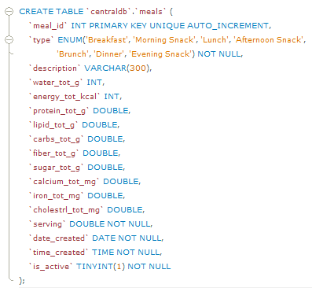

Figure 121: Create meals table (CDB).

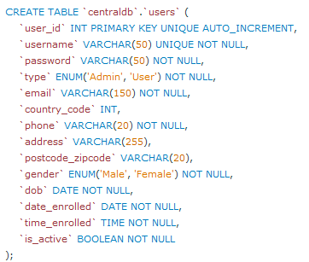

Figure 122: Create users table (CDB).

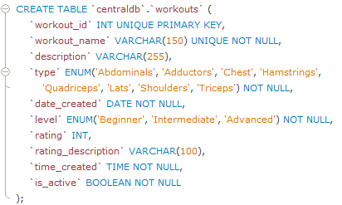

Figure 123: Create workouts table (CDB).



Figure 124: Create food items table (CDB).

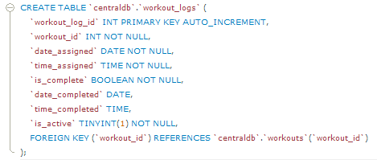

Figure 125: Create workout logs table (CDB).

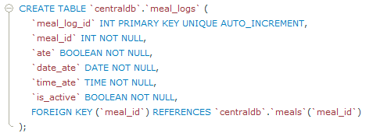

Figure 126: Create meal logs table (CDB).

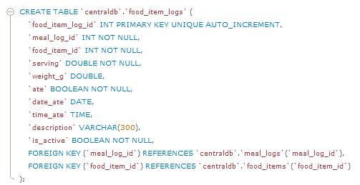

Figure 127: Create food item logs table (CDB).

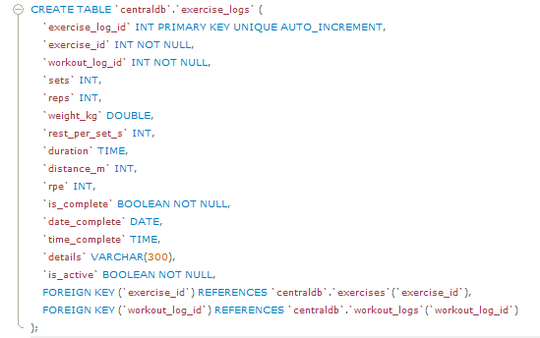

Figure 128: Create exercise logs table (CDB).

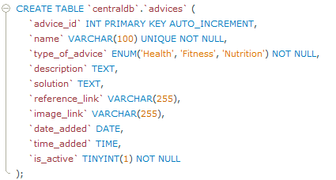

Figure 129: Create advices table (CDB).